Statement of Authenticity
I have read the University Regulations relating to plagiarism and certify that this dissertation is all my own work and does not contain any unacknowledged work from any other sources.

Word Count: 12.275

RUMEYSA CAMUR
Abstract and keywords
This research investigates the tension between sustainability and affordability in fashion purchasing decisions through analysis of real-time consumer sentiment on Reddit. The study collected and analysed approximately 19,900 posts across 14 fashion-related subreddits using natural language processing techniques. Sentiment analysis revealed that affordability discussions showed predominantly negative sentiment (82.54%), while sustainability topics demonstrated slightly more positive reception (28.09%), highlighting the sustainability-affordability paradox consumers face. Five key sentiment themes emerged: brand ethics, materials/fabric quality, customer support, pricing/value, and fit/style/usability. Using Latent Dirichlet Allocation (LDA) topic modelling and Multi-Criteria Decision Analysis, the research translated these consumer insights into strategic recommendations for fashion businesses. Top-ranked strategies included promoting an ethical brand reputation, highlighting quality eco-friendly materials, emphasizing value-for-money propositions, and integrating circular economy practices. Sensitivity analysis confirmed the robustness of these recommendations across various weighting scenarios. This study bridges the gap between consumer sentiment research and organizational strategy, providing fashion brands with a practical framework to balance environmental responsibility with commercial viability in response to evolving consumer expectations.

Keywords
Sustainability, Affordability, Fashion Industry, Consumer Sentiment, Natural Language Processing, Topic Modelling, Multi-Criteria Decision Analysis, Reddit, Strategic Framework, Circular Economy

BALANCING SUSTAINABILITY AND AFFORDABILITY IN FASHION: A SENTIMENT ANALYSIS OF CONSUMER PERSPECTIVES ON REDDIT
by
RUMEYSA CAMUR
UB NUMBER: 23040281

In the Partial Fulfilment
of the Requirement for the Degree of
Master of Science

Applied Artificial Intelligence and Data Analytics
University of Bradford, UK
(2024-2025)

Preface
This dissertation emerged from my professional experience in the textile industry, where I observed a critical gap between sustainability aspirations and commercial realities. Having worked as a Corporate Sales Specialist managing relationships with over sixty international clients in the fashion sector, I witnessed the daily challenges companies face when attempting to balance environmental responsibility with market competitiveness. This background provided essential context for understanding the "sustainability-affordability paradox" explored in this research.
The selection of this research topic was motivated by practical concerns I encountered while facilitating negotiations between fabric producers and fashion brands. Many manufacturers expressed frustration at being caught between increasing regulatory pressures for sustainability and consumers' price sensitivity. I noted that despite extensive literature on sustainable fashion, there was limited research using real-time consumer sentiment to develop actionable business strategies. This observation defined both the focus and limitations of my research—examining authentic consumer discussions rather than relying on potentially biased survey responses.
The scope of this investigation encompasses consumer sentiment analysis through natural language processing techniques applied to Reddit discussions, followed by the development of a strategic framework for fashion companies. This methodology was chosen to capture unfiltered consumer perspectives on sustainability and affordability in fashion purchasing decisions. The framework addresses material selection, organizational transformation, and consumer education strategies based on these insights.
Several challenges emerged during this research process. Technical difficulties in sentiment analysis included accurately detecting sarcasm and context-dependent expressions in informal online discussions. Additionally, the demographic limitations of Reddit users created a potential bias toward younger consumers from developed economies. While recognising these constraints, I sought to mitigate their impact through rigorous methodological approaches detailed in Chapter 9.
This research relates directly to practical matters in the fashion industry by providing a data-driven basis for balancing sustainability initiatives with commercial viability. The strategic recommendations developed through this study offer fashion companies tangible approaches for aligning their sustainability practices with authentic consumer preferences, potentially bridging the gap between environmental aspirations and market realities.
I wish to express my sincere appreciation to my supervisor, Dr. Vadim Grinevich, whose guidance was instrumental in shaping this research. His expertise in sustainability and consumer behaviour helped refine my methodological approach and analytical framework. I am also grateful to Dr. Takao Maruyama for his technical assistance with sentiment analysis and natural language processing methods. Their combined support enabled me to transform my industry observations into structured academic research while maintaining practical relevance.
Rumeysa Camur
March 2025
Bradford, United Kingdom
Dedication
First and foremost, I would like to express my deepest gratitude to my supervisor, Dr. Vadim Grinevich, for his invaluable support, guidance, and patience throughout this journey. Before coming to university—and even after completing earlier stages of my degree—I had little understanding of what academic research truly involved. Dr. Grinevich not only helped me grasp the foundations of research but also encouraged me to refine my ideas and build a stronger structure and context at every stage. His thoughtful feedback and commitment to helping me grow academically were instrumental, and I am genuinely thankful for all his support.
I would also like to thank Dr. Takao Maruyama, whose kind and prompt assistance on technical aspects helped me immensely. His calm and thoughtful communication made a significant difference, especially when navigating challenging parts of the analysis. I truly appreciate his care and encouragement throughout this process.
To my dear friend Montaha Afana—thank you from the bottom of my heart. While others distanced themselves or disappointed me during this time, you remained a constant source of strength. Your presence and support through every step of this dissertation meant the world to me. I will always be grateful for your genuine friendship.
I would also like to thank my friends from London for their encouragement and moral support during this demanding period. Even from a distance, their belief in me helped keep me going.
A heartfelt thank you goes to my manager, who showed patience and understanding throughout the final months of this dissertation. Their flexibility and support allowed me the time and space to focus when it mattered most.
Finally, I want to thank my family, who supported me emotionally and financially even from afar. Because of the intensity of this project, I couldn’t work as I normally would. Their unwavering belief in me and willingness to carry me through this period made this accomplishment possible.
To everyone mentioned here—thank you, sincerely.

Contents
Keywords 2
List of Tables 9
List of Figures 10
1. Introduction 12
1.1. Background 12
1.2. Research Problem 12
1.3. Research AIM, Objectives, and Research Questions 14
1.4. Methodology Overview 14
1.5. Key Contributions 14
2. Literature Review 16
2.1. Empirical Studies 16
2.2. Consumer Sentiment on Purchasing Behaviour 17
2.2.1. Dominant Sentiment Themes in Sustainable Fashion Discussions 17
2.2.2. Financial Preferences and Sustainable Fashion Choices 17
2.2.3. The Role of Online Platforms in Sentiment Analysis 18
2.2.4. Topic Modelling in Consumer Discourse Analysis 19
2.2.5. Challenges in Sentiment Analysis 19
2.2.6. Ethical Considerations in Sentiment Analysis 19
2.2.7. Real-Time Consumer Sentiment for Strategic Decision-Making 19
2.3. Strategic Applications for Balancing Sustainability and Profitability 20
2.3.1. Data-Driven Material Selection and Business Strategy 20
2.3.2. Organisational Transformation Based on Consumer Insights 20
2.3.3. Consumer Education and Motivation Strategies 21
2.4. Summary of Literature Review 22
2.5. Limitations of the Literature Review 22
2.6. Synthesis and Gap Identification 22
3. Methodology 24
3.1. Research Design 24
3.2. Research Philosophy 24
3.3. Research Approach 24
3.3.1. Research Approach and Justification 24
3.3.2. Why AI-Based Methods Work Best for This Research 25
3.2. Data Collection Methods 26
3.2.1. Data Sources Selection (Reddit and Other Platforms) 26
3.2.2. Web Scraping Methodology 27
3.2.3. Ethical Considerations in Data Collections 29
3.3. Sampling Strategy 30
3.3.1. Sampling Approach 30
3.3.2. Methodological Process Flow 30
3.4. Data Pre-processing and Cleaning 31
3.4.1. Text Processing Techniques 32
3.4.2. Quality Check on Process 32
3.5. Feature Engineering 33
3.6. Model Training, Sentiment Analysis, and Topic Modelling 35
3.6.1. Model Training and Fine-Tuning 35
3.6.2. Sentiment Analysis Framework 35
3.6.3. Topic Modelling-Models Selection and Justification 36
3.7. Multi-Criteria Decision Analysis Framework 38
3.7.1. MCDA Methodology Selection 39
3.7.2. Criteria Development Process 39
3.7.3. Strategy Evaluation Implementation 39
3.8. Methodological Limitations and Mitigation Strategies 41
3.8.1. Data Source Limitations 41
3.8.2. Analytical Methodology Limitations 41
3.8.3. Mitigation Approaches 41
3.9. Evaluation Metrics 42
3.9.1. Performance Metrics Selection 42
4. FINDINGS AND ANALYSIS 46
4.1. Exploratory Data Analysis (EDA) Results 46
4.1.1. Corpus Overview 46
4.1.2. Word Frequency Analysis 46
4.1.3. Keyword Coherence Analysis 48
4.2. Sentiment Analysis Results 49
4.2.1. Ensemble Method Sentiment Analysis 50
4.2.2. Trained Model-Based Method Sentiment Analysis 53
4.3. Confusion Matrix Interpretation 55
4.4. Impact of Hyperparameter Tuning 56
4.4.1. Justification for Trained Model 57
4.5. Topic Modelling Results 58
4.5.1. Optimal Topic Configuration 58
4.5.2. Justification for Choosing LDA Model 62
4.5.3. Topic Sentiment Analysis 62
4.6. Strategic Recommendation Analysis 63
4.6.1. Strategy Evaluation Criteria 63
4.6.2. AHP Weights Calculation 64
4.6.3. TOPSIS Results and Rankings 65
4.6.4. Sensitivity Analysis 65
4.7. Synthesis of Research Findings and Implications 67
4.7.1. Overview of Key Insights 67
4.7.2. Strategic Framework and Evaluation 67
4.7.3. Theoretical Contributions 68
4.8. Practical Applications 68
4.9. Limitations 70
4.10. Conclusion 70
4.10.1. Future Research Directions 70
4.10.2. Conclusion 71
4.11. Ethical Considerations 71
APPENDIX A 72
APPENDIX B 73
APPENDIX C 82
References 7

List of Tables
Table 1: The Deductive Method and Its Benefits, Created by Author. 25
Table 2: Why AI-Based Methods Work Best for This Research, Created by Author. 26
Table 3: Feature Engineering Steps, Created by Author. 34
Table 4: Comparative Analysis of Topic Modelling: LDA vs BERTopic, Created by Author. 37
Table 5: Validation Features, Created by Author. 38
Table 6: MCDA Framework, addressing: Consistency Verification (RQ2.2), Sensitivity Analysis (RQ2.1), Created By Author. 40
Table 7: Sentiment Analysis Evaluation Metrics, Created By Author. 43
Table 8: Topic Modelling Evaluation Metrics, Created By Author. 44
Table 9: Additional Topic Modelling Evaluation Metrics, Created by Author. 45
Table 10: Pairwise Agreement Between 3 Models, How Often Each Pair Agrees, Overall Adapted by Author. 51
Table 11: Confidence Chart, It was measured through 5 samples, Adapted By Author. 52
Table 12: Evaluation Metrics for Ensembled Method, Created by Author. 52
Table 14: Evaluation Metrics Results for Sentiments, Created By Author. 55
Table 15: Strategies Sentiment Analysis, Created By Author. 62

List of Figures

Figure 1: Literature Review Structure, Created by Author. 15
Figure 2: Consumer Sentiment Themes in Sustainable Fashion, adapted by Pires et al. (2024) 16
Figure 3: Cross-Platform Sentiment Analysis Performance, Adapted by Sun et al. (2023) 17
Figure 4: Sustainable Fashion Research on Reddit Communities, Created by Author. 26
Figure 5: Search Query Categories: Sustainability vs Affordability, Adapted by Author 27
Figure 6: Sustainability vs Affordability Queries Used in Analysis, Adapted by Author 28
Figure 7: Research Methodology Process Flow, Created by Author. 29
Figure 8: Data Cleaning and Pre-processing Flow Chart, Adapted by Author. 30
Figure 9: Text Processing Techniques NLP, Special Character Removal” cited by Sanjithkumar(2023), “Tokenisation Approach” cited by Deepanshi (2021), “Lemmatisation” cited by Plisson(2004), “Part-of-Speech” cited by Toutanova et al.( 2003), Created By Author. 31
Figure 10: Ensemble Sentiment Analysis Framework, Created by Author 35
Figure 11: Pie Chart Showing Distribution of Posts Between Sustainability and Affordability Categories, Adapted by Author 45
Figure 12: Top 10 Word Frequency in General, For Sustainability and Affordability with Unlabelled Dataset, Created by Author 46
Figure 13: Top 5 Words in General, for Sustainability and Affordability with Unlabelled Dataset, Created by Author 46
Figure 14: Top 10 Sustainability-Related Words Coherence Score: 2.811352 47
Figure 15: Top 10 Affordability-Related Words Coherence Score: 1.747944 48
Figure 16: Coherence Score for Sustainability and Affordability Words, Adapted By Author 48
Figure 17: Ratio of Affordability and Sustainability Based on Binary Sentiment Categories, Adapted by Author 49
Figure 18: Sentiment Agreement Distribution, Adapted by Author. 50
Figure 19: ROC Curve Analysis, Trained Model-Based Approach, Created by Author. 52
Figure 20: Sentiment Distribution Based AUC Score, Created by Author. 53
Figure 21: Trained -Model Confusion Matrix, Created By Author 55
Figure 22: Hypermeter Tuning Trained-Model Performance Results, Created by Author 56
Figure 23: LDA Coherence Score vs Number of Topics, Created by Author. 57
Figure 24: LDA Topic Modelling Keywords, Topic 14 Highest Coherence, Created by Author. 58
Figure 25: Theme Distribution by Bert, Created by Author. 59
Figure 26: LDA Coherence Score vs Number of Topics, Created by Author. 60
Figure 27: BERTopic Overall Evaluation Metrics, Created by Author. 60
Figure 28: Fashion Strategy Evaluation Criteria, Created by Author. 62
Figure 29: AHP Confusion Matrix for Strategies, Created By Author. 63
Figure 30: Sustainability Strategy Rankings, Created by Author. 64
Figure 31: Affordability Strategy Rankings, Created by Author. 64
Figure 32: Sensitivity Analysis for Sustainability, Created by Author. 65
Figure 33: Sensitivity Analysis for Affordability, Created by Author. 65
Figure 34: Combined Strategy Ranking Through TOPSIS, Created By Author. 68

Introduction

Background
The fashion industry faces mounting global pressure to adopt sustainable practices while maintaining profitability. Contributing approximately 10% of global carbon emissions alongside significant water consumption and waste production, the textile sector ranks among the world's most environmentally damaging industries (Filho et al. 2022; European Parliament, 2020). The rise of fast fashion has exacerbated these issues through increased production, cost minimization, and unsustainable cycles generating excessive waste (Abbate et al. 2023).
Recent legislation has intensified pressure on fashion brands to transform their practices. The European Union has established comprehensive regulations mandating environmental responsibility across product ranges and requiring waste reduction in production materials by 2025 (Lüttin 2024).
Consumer perspectives on eco-friendly fashion create a significant dilemma for companies (Tran 2021). McKinsey & Company research reveals that while consumers express interest in sustainable products, only 31% are willing to pay premium prices, with 67% prioritising lower costs regardless of sustainability credentials. This fundamental gap challenges fashion brands attempting to incorporate sustainability while maintaining competitive pricing.
Despite these challenges, companies have developed varied responses. Luxury brands like LVMH and Kering have invested in innovative materials such as banana skin yarn and established supplier sustainability standards (Kunz et al. 2020), creating the perception that sustainability premiums deliver value. Mainstream retailers including Zara and H&M have introduced specialised sustainable collections at higher price points while maintaining their core business. Meanwhile, newer entrants like Reformation and Everlane have positioned themselves as inherently sustainable and transparent from inception (Fiorani 2022).
Consumer expression regarding sustainable fashion on social media has evolved, with increasing opinion-sharing on platforms like Reddit, where users engage in thoughtful discussions about environmental and social influences on fashion choices (Vladimirova et al. 2023).
This study addresses a critical research gap by analysing these real-time consumer discussions to identify factors influencing sustainable purchasing decisions and their practical business applications. Through advanced computational analysis of authentic online conversations, this research aims to provide fashion companies with actionable frameworks for balancing environmental responsibility with commercial success in a rapidly evolving industry landscape.

Research Problem
Globally, as sustainability has become imperative, businesses are under pressure to align their system with sustainability, and it is challenging for them, especially when it comes to balancing it with affordability in the market, which is extremely competitive. Even though awareness of customers on sustainability is increasing, there is a consistent gap between so-called values and how people are behaving in purchasing habits. Consequently, sustainability secures its place as a priority only when affordability doesn't overshadow it, which means customers care about prices over sustainability, and this issue is a fundamental challenge for fashion companies who especially try to create relative practices to sustainability.
Up-to-date research is only able to enhance partial insight into this challenging issue. Based on survey-based research, people tend to give more artificial, desirable, or enthusiastic answers over answers that show their true feelings, which are crucial to providing a healthy decision-making process. Additionally, methods such as surveys, interviews, etc., give a more static view of consumer behaviour rather than discovering how emotions are built through conversations on platforms. According to industry reports, there are a bunch of articles and reports about the importance of sustainability, but there are very limited suggestions about how companies can conduct these applications by aligning with their goals.
This study addresses these limitations by analysing real-time consumer discussions about sustainable fashion on social media platforms. By applying sentiment analysis and natural language processing techniques to these unfiltered conversations, this study aims to detect the dominant themes of sentiment, concerns, and dilemmas that customers face when they evaluate their preferences with particular attention to how financial considerations shape these attitudes.
Based on the findings that we will reach at the end of this research; fashion companies will be able to take actionable insights for developing effective strategies that align with genuine consumer preferences. By understanding how consumers see the priorities of sustainability and affordability in authentic contexts, fashion brands will have a chance to improve their products, refine their communication strategies, and implement organisational changes that enable them to achieve both environmental responsibility and commercial success in a challenging market environment.

Research AIM, Objectives, and Research Questions
This research proposal aims to investigate real-time consumer sentiment regarding sustainability and affordability in the textile industry. Unless traditional studies rely on historical datasets or surveys, this research will leverage sentiment analysis and natural language processing (NLP) techniques to extract and analyse data from various online platforms, such as Reddit, Trustpilot, and e-commerce websites. By analysing real-time consumer feedback, this study will explore the key decision factors that affect purchasing behaviours and will provide a wide perspective on balancing sustainability and profitability for fashion brands. The research objectives and corresponding research questions are as follows:
Research Objective 1: To explore how consumer sentiment analysis about affordability and sustainability affects purchasing behaviours in real time.
1.1 Research Question: What dominant sentiment themes emerge in online discussions when consumers evaluate sustainable fashion options, and how do these themes reflect purchasing considerations?
1.2 Research Question: In what ways do consumer expressions about financial constraints shape attitudes toward environmentally friendly fashion choices in real-time conversations?
Research Objective 2: To supply knowledge to companies that will enable them to plan their strategies for balancing sustainability and profitability.
2.1 Research Question: What strategies can fashion brands apply to their production processes to align with consumer preferences for sustainability and affordability?
2.2 Research Question: Which key business areas need to change to utilise the sentiment of customers online when trying to be both sustainable and profitable?

Methodology Overview
In the above section, we have mentioned the objectives of this project. This research will use sentiment analysis and natural language processing (NLP) techniques to analyse consumer feedback in real-time by using Reddit to achieve these objectives. The methodology involves data collection through web scraping tools to gather reviews, comments, and discussions related to affordability and sustainability in fashion from Reddit, rather than using ready-to-use historical data. The collected data will be analysed using NLP techniques to sort consumer sentiments as positive, negative, or neutral, helping determine key factors affecting purchasing decisions (Liu, 2012). Topic modelling is essential for advancing sentiment analysis effectively; techniques such as Latent Dirichlet Allocation (LDA) or BERTopic will identify recurring themes and key discussion topics, enabling a deeper understanding of consumer preferences (Blei et al., 2003). Based on the findings, the research will provide actionable recommendations for fashion companies to balance sustainability and profitability, creating a better system focusing on material selection, pricing strategies, and consumer communication (Deloitte, 2023).

Key Contributions
Various studies have been done regarding this topic through different methods and based on multiple other sources. For instance, the study of Niinimäki et al. (2020): "The Environmental Price of Fast Fashion", discusses the environmental impact of fashion products on the world, while this study focuses on giving an understanding and perspective to the brands to balance profitability and sustainability based on real-time data. Accordingly, this research contributes to the existing literature by addressing real-time consumer behaviour analysis and providing decision-making based on the real-time data gap in the fashion industry. By leveraging AI and data analytics through sentiment analysis and NLP techniques applied to Reddit discussions, this study offers a dynamic and up-to-date understanding of consumer preferences, enabling fashion brands to make data-driven decisions that align with sustainability and profitability goals (Ramos et al., 2023). Accordingly, for companies that seek to balance economic and environmental priorities in a rapidly changing market, the findings will provide actionable insights. The dissertation begins with a Literature Review examining existing research on sustainability in fashion, consumer purchasing behaviours, and sentiment analysis for understanding real-time preferences. The Methodology section details the research design, Reddit data collection methods, and analytical techniques used. The Ethical Considerations addresses the important questions about using public Reddit discussions, while the Recommendations part gives fashion companies practical steps, they can take based on what we found. The final section brings together what we learned, talks about what we couldn't do in this study, and suggests what researchers should look at next. By focusing on the pressing need for more sustainable fashion and studying what consumers are saying on Reddit, this research tries to create a clear plan to help brands be both environmentally responsible and financially successful. The integration of sentiment analysis and real-time data offers a novel approach to understanding consumer behaviour, paving the way for a more sustainable and profitable future in fashion.

Literature Review

Empirical Studies
This research aims to examine real-time consumer behaviour in purchasing fashion products, specifically focusing on the relative importance of sustainability versus price to give companies a wider perspective for strategy determination. Consumer purchasing decisions are influenced by various factors, including economic conditions, affordability, and product quality. However, in recent years, sustainability and cost have emerged as critical factors in the fashion industry. These two elements serve as key drivers in consumer decision-making, appealing to different market segments. This section explores key determinants of consumer purchasing behaviour and analyses past studies to assess whether sustainability or cost holds greater weight for consumers in the fashion market, how sentiment analysis can explore consumer behaviours, how machine learning analyses consumer sentiment, and how companies can balance sustainability with profitability.
The general structure will be followed in this section as in below Figure 1.

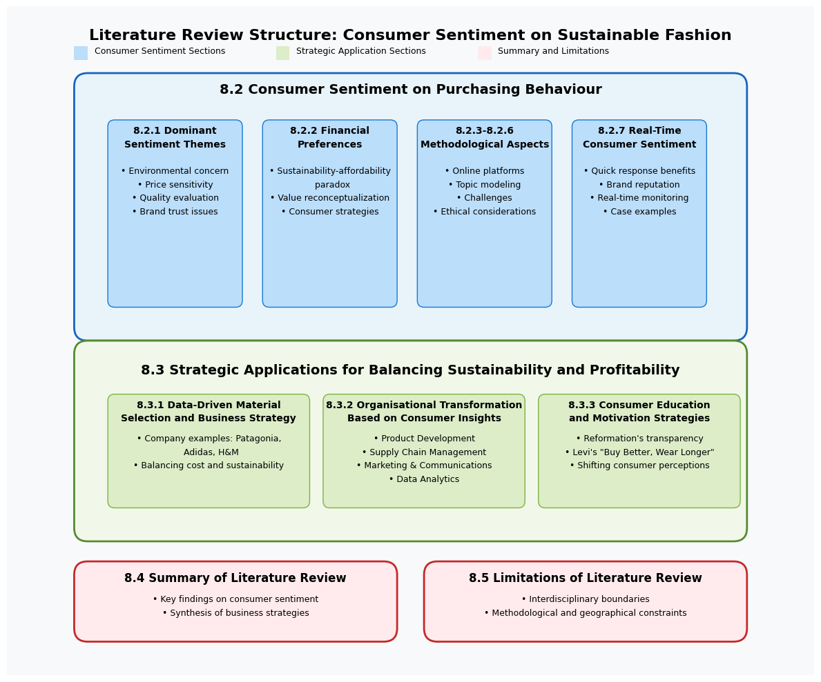
Figure 1: Literature Review Structure, Created by Author.

2.2. Consumer Sentiment on Purchasing Behaviour

2.2.1. Dominant Sentiment Themes in Sustainable Fashion Discussions
Sustainable fashion discussions have become widespread in online consumer communities, showing complex opinion patterns as people consider their buying choices. The fashion industry's environmental impact—contributing significantly to global pollution as documented by the European Parliament (2020)—provides an important context for reactions observed in digital forums. Analysis of these conversations reveals five main sentiment themes: environmental concern, social status, price sensitivity, quality evaluation, and brand trust issues (Pires et al., 2024).
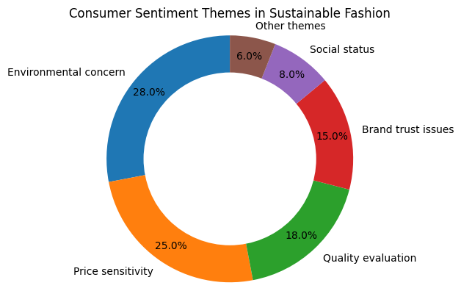
Figure 2: Consumer Sentiment Themes in Sustainable Fashion, adapted by Pires et al. (2024)
Consumers express personal responsibility when discussing environmental impacts, frequently sharing internal conflicts between environmental protection and budget constraints. Price sensitivity manifests as frustration over higher costs of eco-friendly options. The social status theme emerges when discussing how sustainable clothing choices reflect personal identity, while quality assessment involves debates about whether sustainable items' durability justifies their premium pricing. Brand trust concerns appear when consumers question companies' authentic commitment to sustainability versus "greenwashing" for premium pricing (Frey et al., 2023).
These themes influence purchasing behaviour by illustrating how consumers balance competing priorities, often leading to practical compromises such as second-hand purchasing, occasional investment in high-quality sustainable items, or seeking affordable brands with genuine environmental credentials.

2.2.2. Financial Preferences and Sustainable Fashion Choices
Fashion and textiles form a massive global economic force, ranking seventh among world industries (Fashion United 2022). This enormous market position depends heavily on how and what consumers buy. The business model thrives on making huge quantities of clothing using cheap materials and streamlined manufacturing, making shoppers' habits crucial to industry success (Scamans 2016). Materials like polyester and cotton remain the go-to choices for most mainstream clothing because they're inexpensive to process, allowing brands to keep producing affordable, fast fashion that meets consumer demand for cheap, trendy items (Fletcher 2012).
Research shows this profit-focused approach is increasingly questioned as shopper priorities evolve. Chen and Burns (2006) found that as people learn more about environmental issues, they begin weighing sustainability alongside price when making purchases. This shift evolves what researchers identified as a fundamental tension in consumer behaviour—people want to buy fashion products that don't harm the world, but simultaneously, they are not willing or able to pay more for them (Morgan and Birtwistle 2009). This "sustainability-affordability paradox" presents a main challenge for both consumers directing their values and companies trying to meet these competing demands.
Financial concerns significantly influence attitudes toward sustainable fashion, as revealed in real-time consumer discussions. In daily online conversations, many consumers express frustration over prices associated with ethical fashion, creating tension between environmental aspirations and budgetary realities (Joy et al. 2012). Analysis of unfiltered Reddit threads reveals consumers openly discussing emerging strategies to navigate this tension, including second-hand purchasing, fashion rental services, and discounted sustainable brands (Bly et al. 2015). Moreover, unmoderated forum discussions show some consumers perceive sustainable fashion as an; I would say, exclusive market catering to higher-class citizens, reinforcing scepticism about its accessibility (Stiving and Winer 1997).
The concept of "value" has evolved beyond simple cost considerations, as revealed in real-time digital discourse analysed by McNeill and Moore (2015). Their examination of live consumer conversations demonstrates that value now encompasses quality, durability, and ethical production. This reconceptualisation reflects what researchers describe as a fundamental shift in consumer value assessment frameworks, particularly in authentic online exchanges where consumers candidly express financial concerns (Lundblad and Davies 2016).

2.2.3. The Role of Online Platforms in Sentiment Analysis
People express more honest opinions online than in person, making platforms like Reddit valuable for studying genuine consumer sentiment (Joinson, 2001). The "online disinhibition effect" encourages truthful sharing of thoughts on topics where social desirability bias might otherwise prevail (Suler, 2004; Bargh et al., 2002).
Fashion forums capture consumer feelings in their natural context without researcher-imposed limitations (Kozinets, 2010; Ramos et al., 2023). Reddit and similar platforms offer particularly unfiltered consumer viewpoints, especially regarding higher prices often associated with sustainable fashion items (Huang et al., 2024). Reddit data offers particularly reliable sentiment analysis results (83.4% reliability compared to Twitter's 76.2% and Facebook's 69.8%) (Sun et al., 2023).
,
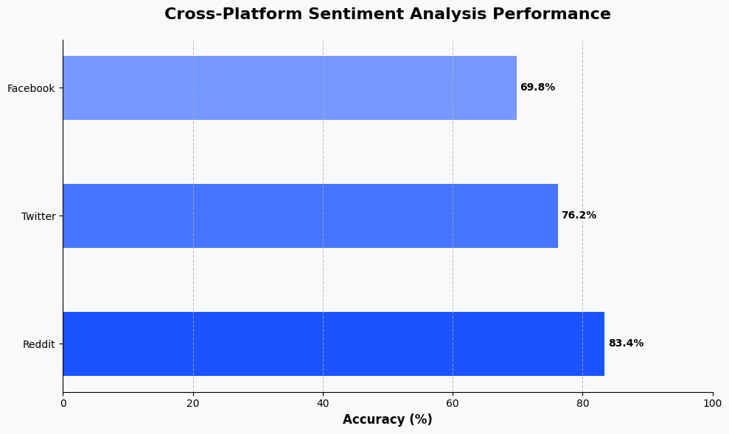
Figure 3: Cross-Platform Sentiment Analysis Performance, Adapted by Sun et al. (2023)

Kunst (2022) found significant variation in how consumers justify price differences between conventional and sustainable options. Unlike brand-dominated platforms like Instagram, community forums feature a more critical evaluation of sustainability claims (Lundblad & Davies, 2016).
Reddit is a platform that provides flexibility that allows people to be brutally honest in ways other social platforms don't. People are hiding behind their anonymous usernames and reflect their unfiltered thoughts without worrying about what other people say. Thus, it could be said that Reddit is a goldmine platform for understanding the hidden thoughts of people by being, free from the social filters of Instagram or Facebook. Reddit's conversation structure reveals how opinions evolve through extended dialogue (Li et al., 2025), with communities collectively evaluating corporate sustainability initiatives to distinguish meaningful commitments from "greenwashing" (Schiaroli et al., 2024).

2.2.4. Topic Modelling in Consumer Discourse Analysis
Topic modelling allows themes to emerge naturally from data rather than imposing researcher-created categories. Chen et al. (2021) found fashion discussions clustered around environmental impacts, production ethics, materials, consumption habits, and corporate behaviour. DEKHILI et al. (2024) identified conversation themes about quality, price justification, and product sustainability; they noticed certain sustainability features consistently triggered specific emotional responses, helping explain how consumers evaluate these products. Taking this further, Gordon et al. (2011) applied the more sophisticated BERTopic approach to social media conversations, showing how environmental concerns connect with personal identity and shopping habits.

Choi et al. (2021) demonstrate that combining sentiment analysis with topic modelling creates a comprehensive picture of consumer feelings and their values, providing valuable information for companies aligning sustainability efforts with customer priorities.

2.2.5. Challenges in Sentiment Analysis
Despite its advantages, sentiment analysis faces multiple challenges that can influence accuracy and reliability. These difficulties arise from various limitations including data constraints, biases, sarcasm, inappropriate language, and challenges in detecting tones. These challenges can be grouped as follows:
First, sarcasm and inferable ideas cause misinterpretation of feelings in sentences and detecting them accurately is difficult due to context limitations, varied writing styles, and absence of verbal cues. Topic modelling helps reduce these issues by providing contextual understanding (Ahmed Derbala Yacoub et al. 2024).
Second, fashion-related sentiment analysis specifically encounters challenges from vague language and industry-specific terminology, complicating accurate results. BERT models offer potential solutions to address these challenges through their contextual understanding capabilities (Vasapollo, 2024).
Third, bias introduced by classifiers presents ongoing concerns. These machine learning models, when trained on imbalanced datasets, may overemphasize negative or positive sentiments, potentially falsifying results (Venugopal et al., 2024).
2.2.6. Ethical Considerations in Sentiment Analysis
Social media research must adhere to data protection regulations like GDPR (European Union, 2016). Reddit's publicly available but contextually private discussions create what Nissenbaum (2011) terms a "context problem" - using information for purposes unintended by its creators (Markham & Buchanan, 2012).
Research approaches focus on preventing harm through anonymisation and selective topic inclusion (Williams et al., 2017). Demographic platform biases affect representation, as age, income, and education influence online participation (Kurnaz et al., 2018). Language analysis models may misinterpret diverse community discussions because of cultural biases (Kiritchenko & Mohammad, 2018). Transparency about these limitations is essential for the proper interpretation of findings (Metcalf and Crawford, 2016).

2.2.7. Real-Time Consumer Sentiment for Strategic Decision-Making
Fashion brands value real-time data for consumer sentiment analysis due to advantages over traditional methods. Unlike surveys, promptly updated information from online discussions helps brands predict trends, identify customers’ preferences, and quickly respond to market changes (Hennig-Thurau et al. 2010).
Research on real-time sentiment by Martínez García de Leaniz et al. (2019) shows real-time data provides approximately 60% quicker responses to customers than traditional methods. Accordingly, brands increase their reputation and customer loyalty. Furthermore, these methods enable brands to promptly identify sustainability accusations and protect themselves from negative effects (Astoul 2024).
Some retailers have revised their organizational structure, creating dedicated teams for monitoring online platforms in real-time to receive feedback and make immediate reactions and strategic decisions (Tu et al. 2024). Brands applying these methods may face challenges including technology limitations or difficulty distinguishing temporary from meaningful opinions (Cutler and Culotta 2016).
Successful applications include Patagonia adjusting messaging to customers about environmental initiatives based on real-time consumer reactions, while ASOS uses customer sentiment to test price acceptance for sustainable products (Doshi and Noble, 2023; ASOS, 2024).

2.3. Strategic Applications for Balancing Sustainability and Profitability

2.3.1. Data-Driven Material Selection and Business Strategy
Companies face challenges balancing ecological responsibility with economic viability. Dangelico and Pujari (2010) highlight cost tensions between sustainable materials/manufacturing and consumer price expectations. Data-driven material selection can identify options balancing environmental impact with cost-effectiveness by analysing both technical properties and consumer value perceptions.
Several companies have successfully addressed these concerns. Patagonia created the Worn Wear program illustrating effective material choices balancing sustainability and affordability. Based on their research, extending product lifecycle through resale or repair reduces environmental impact while creating new revenue streams. Their repair teams serviced over 100,000 products in 2019, building strong customer loyalty (Patagonia 2025).
Similarly, Adidas partnered with Parley to create sneakers using ocean-recovered plastic. This project has produced 30 million pairs since 2015, offering higher-priced but higher-quality, high-performance products (Tariqul 2025).
H&M's Conscious Collection takes another approach. By analysing consumer preferences and sales data, H&M identified cost-effective sustainable materials, enhancing their product strategy through feature labelling and moderate pricing, providing opportunities for consumers to make lower-commitment sustainability choices (H&M 2019).

2.3.2. Organisational Transformation Based on Consumer Insights
Real-time consumer sentiment analysis enables environmentally responsible and economically viable solutions customised to market preferences (Peattie and Crane, 2005). Bhattacharya and Sen (2004) found integrating sustainability with product excellence builds robust customer loyalty through value alignment. Implementing these insights requires organisational adaptation across multiple departments:
Product Development must incorporate sustainability criteria while maintaining affordability (Van, 2017), shifting toward regenerative design philosophies considering ecological footprints throughout product lifecycles. This includes the procurement of regenerative materials, resource-efficient fabrication, and extended product longevity (Niinimäki and Hassi, 2011). Enterprises pursuing certification compliance must establish comprehensive documentation protocols confirming adherence to certification parameters, including GOTS' chemical prohibitions and Fairtrade's workforce standards (Die Seitenwerkstatt et al. 2021).
Supply Chain Management requires diligent sourcing based on both cost and environmental impact. Certifications like GOTS, Fairtrade, and OEKO-TEX provide credible verification mechanisms enhancing transparency and standardising sustainability requirements (Nath et al., 2024). Małgorzata Koszewska (2018) argues companies must balance supplier monitoring costs against consumer willingness to pay for sustainable products.
Marketing and Communications teams must effectively communicate sustainability initiatives to prevent greenwashing accusations (Delmas and Burbano, 2011). Certifications serve as communication tools for simplifying complex sustainability attributes (Walker Reczek et al., 2016), though note effective communication requires consumer education about certification standards.
Data Analytics capabilities are essential for interpreting real-time consumer behaviour to inform strategic decisions (Davenport, 2020), providing sentiment evaluation of company and competitor sustainability positioning, and correlating ecological and commercial performance (Decker and Stummer, 2017).
Companies like Unilever have successfully transformed operations by establishing affordability criteria for product development and implementing supplier evaluation systems that balance cost efficiency with sustainability, reducing carbon emissions by 56% while maintaining competitive pricing (Unilever, 2024). Inditex (Zara) focused on communication transparency with its "Join Life" labelling system, increasing sales by 21% through detailed sustainability information (Yevin, 2021). LVMH developed systems to analyse consumer sentiment across customer segments, enabling customised "nuanced luxury sustainability" approaches (LVMH, 2023).

2.3.3. Consumer Education and Motivation Strategies
Carrington et al. (2014) show that despite increased sustainability awareness, economic concerns often override environmental considerations in purchasing decisions. Companies must develop innovative strategies to encourage environmentally responsible choices. Mohapatra et al. (2021) found significant negative sentiment regarding sustainability price premiums alongside positive reception of innovative consumption models like rental programs and recycling initiatives.
Reformation addresses these challenges through "transparent sustainability math," providing specific environmental impact information for products, helping consumers understand concrete benefits beyond abstract concepts (Reformation, 2024). Levi's "Buy Better, Wear Longer" campaign emphasizes durability and cost-per-wear value, portraying sustainability as a long-term investment that yields returns over time, increasing sustainable denim sales by 25% annually (Staff, 2022).
Effective consumer education initiatives highlight long-term product value, shifting perceptions from viewing sustainability as an additional cost to seeing it as an investment in quality and environmental well-being (Peattie and Crane, 2005; Bhattacharya and Sen, 2004).
Companies should design creative campaigns motivating consumers to prioritise environmentally friendly choices, as price considerations often outweigh environmental concerns due to economic constraints (Carrington et al., 2014). Educational initiatives highlighting long-term sustainable product value can shift consumer perceptions from viewing sustainability as an additional cost to seeing it as an investment in both product quality and environmental well-being.

2.4. Summary of Literature Review
This review examined two key areas: consumer sentiment regarding sustainability and affordability in fashion and strategic business applications of these insights. Analysis of Reddit conversations revealed complex, often conflicting consumer priorities—balancing environmental values with budget constraints. Financial limitations significantly influence attitudes toward eco-friendly fashion choices.
The review also explored how companies can leverage these insights to develop balanced strategies through sustainable material selection, organisational transformation, and consumer education. Fashion brands face significant challenges meeting both environmental and financial demands, but analysing authentic consumer discussions enables more effective approaches through sentiment understanding and strategic business adaptation.
This foundation connects consumer attitudes with practical business applications, revealing both challenges and opportunities in the sustainability-affordability paradox for fashion brands willing to adapt based on consumer feedback.

2.5. Limitations of the Literature Review
According to the literature review, we highlighted a few significant limitations. First, there are borders between disciplines since this research doesn’t give insight from the perspective of environment science, materials engineering or policy on regulations while focusing on the examination of the behaviour of consumers and business strategy research. In addition, the diversity in methodology is restricted to sentiment analysis coming from one source, such as Reddit, rather than using other platforms with different techniques. It causes less diverse results since demographically used by over %70 Genz and Millennials. (Connell 2025)ç Geographically, this research focuses on more developed countries since they are conducting more sustainable plans and strategies for their country. However, that means it ignores the countries that have been developing. It also gives priority to academic research more than real-life scenarios and ignores industry reports and practitioner perspectives that might offer complementary insights into real-world applications. These limitations suggest opportunities for more comprehensive and integrated approaches in future research.

2.6. Synthesis and Gap Identification
This literature review has searched two different dimensions of sustainable fashion as to be consumer sentiment factors and companies adapting with which strategies. Current studies show that main tensions occur between consumer expectations of sustainable products and economic purchasing power, leading to what researchers term the "sustainability-affordability paradox" (Jung and Suh, 2024; Lundblad and Davies, 2016).
Having certifications based on sustainability, like Oeko-tex, GOTS and Fairtrade, supports companies to display their sustainability functions (Grimm et al., 2016), however, utilising these functions effectively requires shifts along the whole organisation. From designing the product to purchasing sustainable products and having an agreement with their suppliers, everything needs to be aligned with sustainability aims (Seuring and Müller, 2008).
Key research gaps include technical limitations in analysing fashion sustainability discussions (Zhang and Liang, 2022), Western consumer focus excluding global perspectives (Ramos et al., 2023), and disconnection between consumer sentiment research and organisational change strategies (Peattie and Crane, 2005). Additionally, demographic factors affecting certification response remain understudied (Henninger, 2015).
This study addresses these gaps by developing a framework connecting consumer sentiment analysis with practical business strategies.

Methodology
This research combines several computer-assisted techniques and mixed methods to understand what people are saying about sustainable fashion r. Instead of creating surveys where people might give answers, they think sound good, we will be looking at actual conversations happening on Reddit where people speak more freely about their true thoughts on balancing environmental concerns with their budgets.

3.1. Research Design
This research employs a mixed-methods approach to investigate the sustainability-affordability paradox in fashion consumption. To address RQ1.1 and RQ1.2, natural language processing analyses Reddit conversations to extract sentiment patterns around sustainability and price discussions. For RQ2.1 and RQ2.2, topic modelling identifies consumer priorities, followed by Multi-Criteria Decision Analysis to evaluate strategies against environmental impact, consumer appeal, and implementation feasibility. This progression from sentiment understanding to strategic application ensures recommendations emerge from authentic consumer perspectives rather than predetermined assumptions, overcoming limitations of survey-based approaches in capturing complex decision-making processes.

3.2. Research Philosophy
My study adopts pragmatism because it focuses on practical solutions rather than philosophical abstractions (Morgan, 2014). This approach lets me bypass the quantitative-qualitative divide and choose methods that directly address my research questions about consumer sentiment in a sustainable fashion.

3.3. Research Approach
I'm combining computational analysis with interpretive methods to fully understand online discussions. The quantitative side uses machine learning for sentiment analysis and topic modelling (Blei, 2012), while the qualitative component explores contextual meanings in Reddit conversations. This mixed approach provides both statistical patterns and deeper insights into consumer opinions, leveraging what Creswell and Plano Clark (2018) identify as complementary strengths.

3.3.1. Research Approach and Justification
This study uses a deductive research method, which begins with existing theories (about consumer opinions and decision-making tools) and then tests ideas using real data collected from Reddit conversations. In Table 1, the advantages of deductive research and why it is suitable for this research are illustrated.
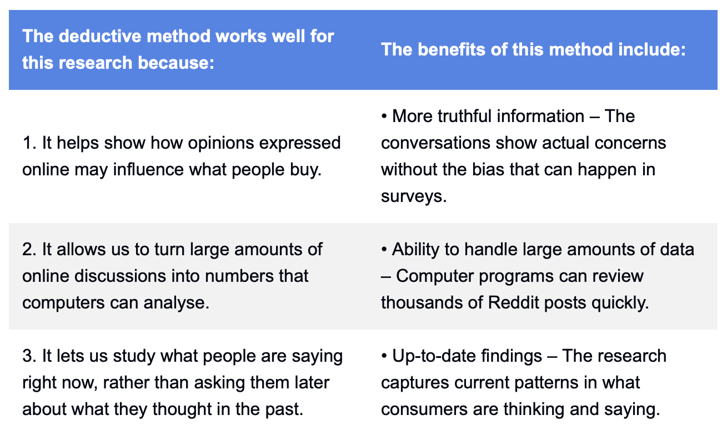
Table 1: The Deductive Method and Its Benefits, Created by Author.

3.3.2. Why AI-Based Methods Work Best for This Research
Using computer-assisted methods is particularly well-suited to answer the research questions. This is further demonstrated in Table 2, where each objective is addressed with the corresponding AI method best suited for it.
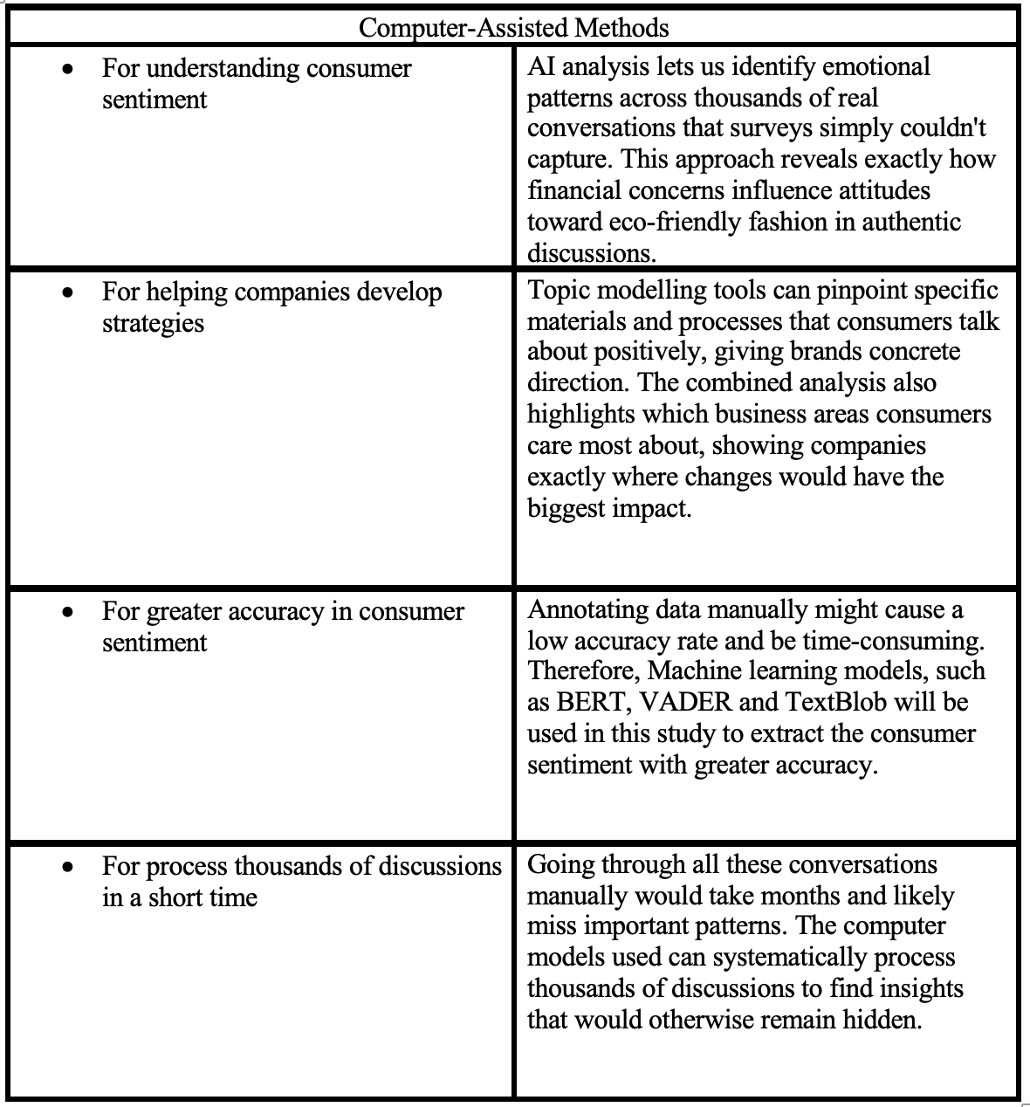
Table 2: Why AI-Based Methods Work Best for This Research, Created by Author.

3.2. Data Collection Methods

3.2.1. Data Sources Selection (Reddit and Other Platforms)
This study uses extensive and up-to-date research based on Reddit discussions. The reason why this platform has been chosen as a primary data source is Reddit—a public and free platform where users share genuine opinions on sustainable and affordable fashion (Suler, 2004). Multiple subreddits are targeted based on their activity, topic relevance, and the diversity of consumer perspectives, ensuring a comprehensive dataset that reflects the sustainability–affordability paradox (Filho et al., 2022).
The subreddits used to collect data were categorised into four main themes and indicated by different colours as illustrated in Figure 4.
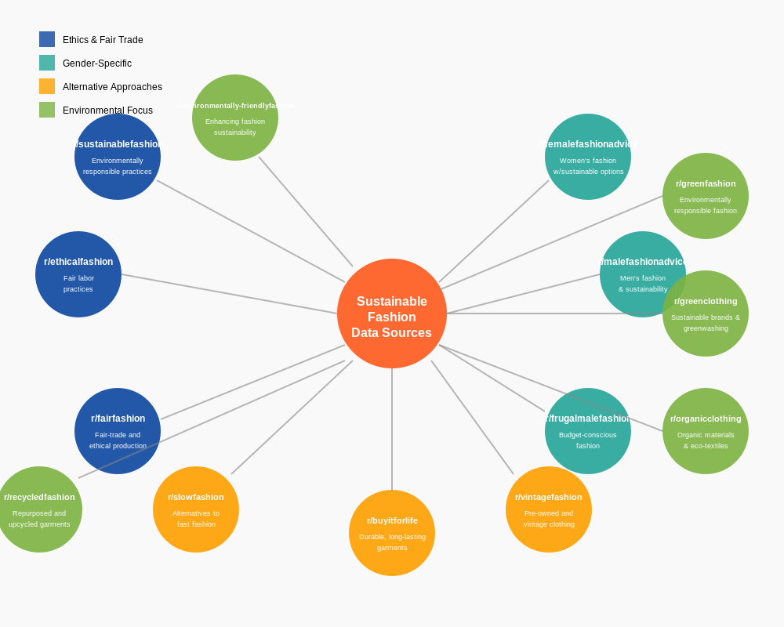
Figure 4: Sustainable Fashion Research on Reddit Communities, Created by Author.

.
These subreddits show many different consumer perspectives, from people involved in slow fashion movements to those looking for affordable, ethical clothing choices. By including many different communities, this study ensures a balanced and complete dataset for analysing opinions and identifying discussion topics.

3.2.2. Web Scraping Methodology
Using the Reddit API via PRAW, data is collected through two complementary approaches:

Query-Based Data Extraction: To ensure relevant data collection, we defined a set of queries related to sustainable and affordable fashion. These queries were executed across 14 subreddits to extract consumer discussions. The queries were categorised into four main types: comparison queries, brand-focused queries, quality/value assessment queries, and process/method queries, as illustrated in Figure 5.

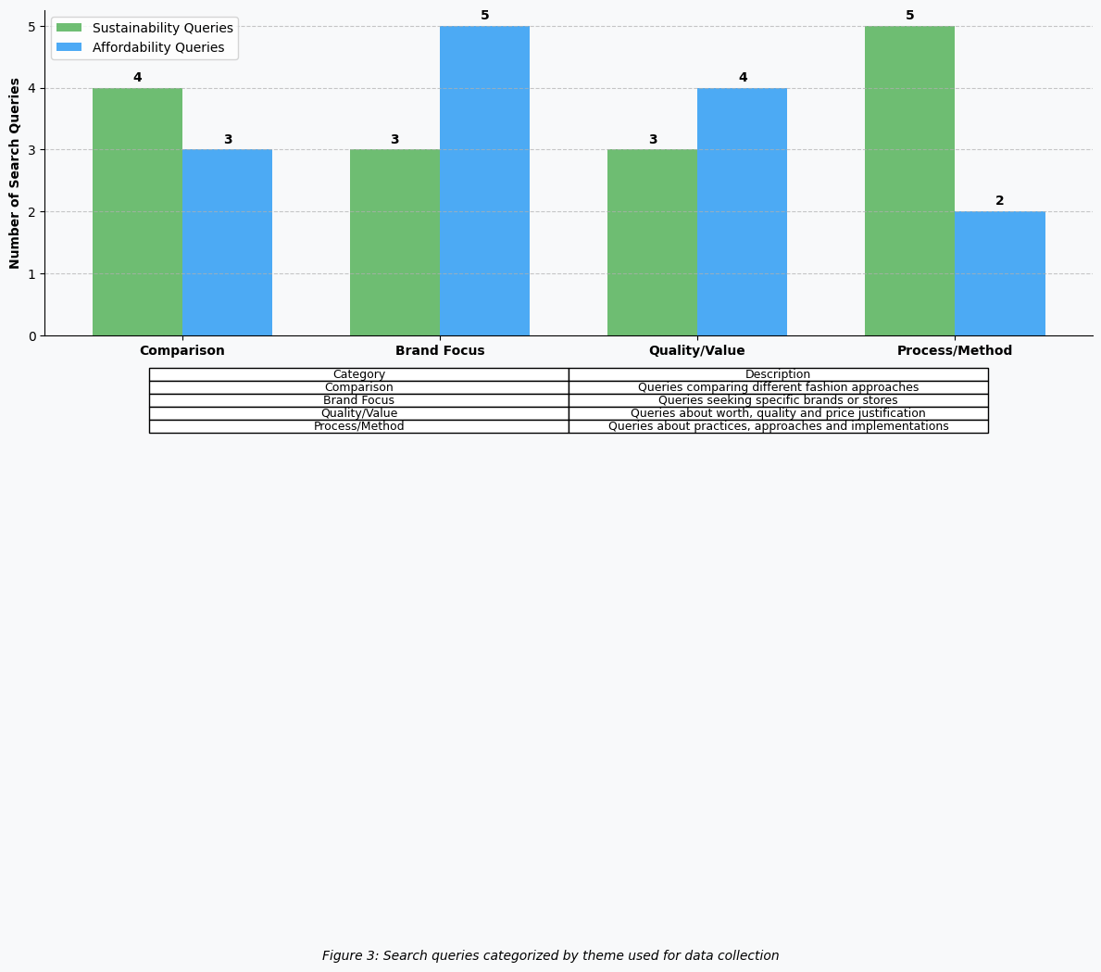
Figure 5: Search Query Categories: Sustainability vs Affordability, Adapted by Author

Figure 6 shows specific queries used in this analysis related to sustainability and affordability.
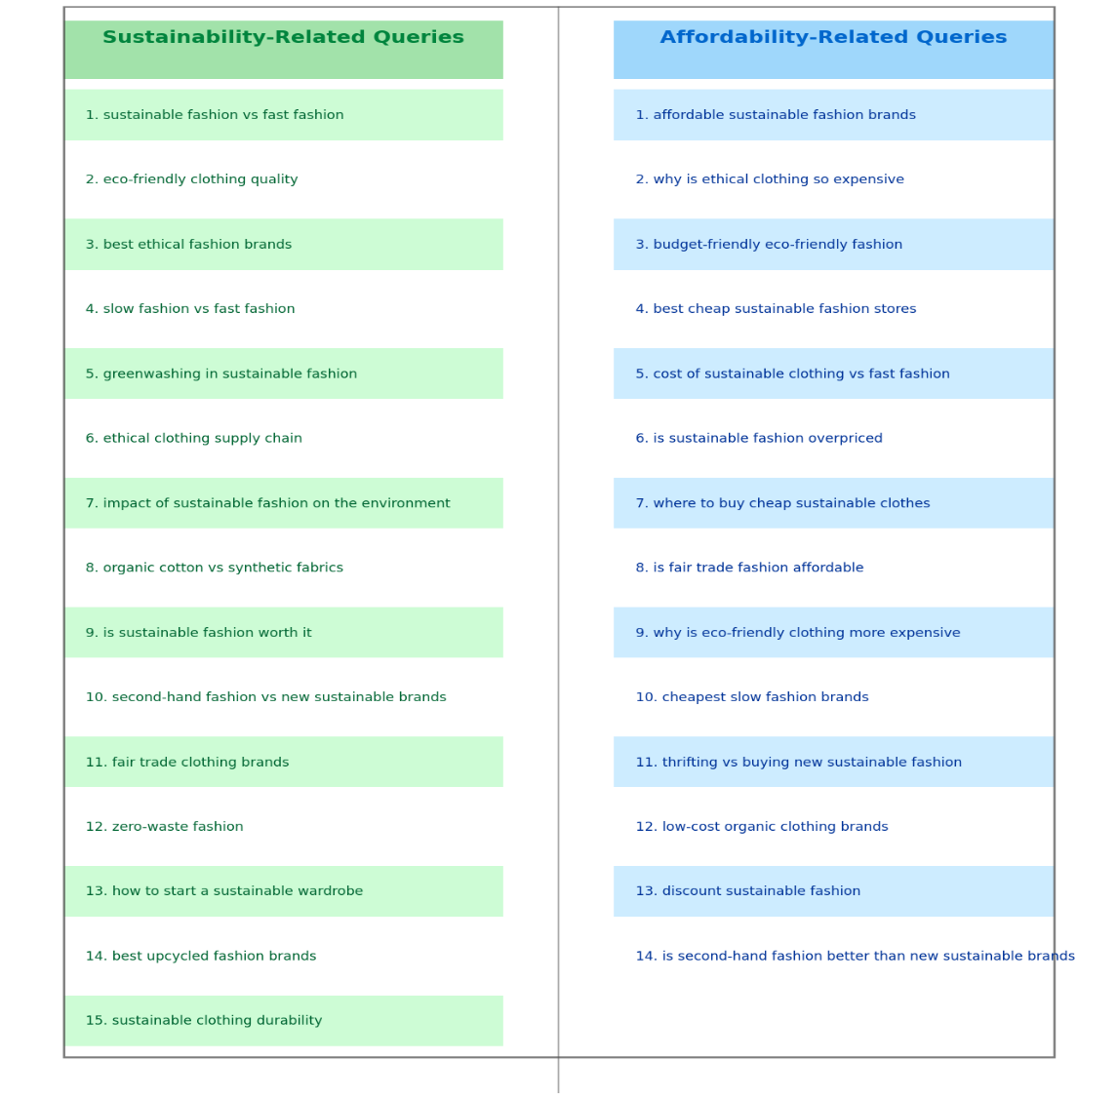
Figure 6: Sustainability vs Affordability Queries Used in Analysis, Adapted by Author

The PRAW API was used to search these queries within the selected subreddits, retrieving up to 500 posts per query.
Section-Based Extraction: To capture both trending and emerging discussions, up to 300 posts per subreddit are collected from the “hot” and “new” sections.

3.2.3. Ethical Considerations in Data Collections

Anonymisation: No personally identifiable information (e.g., usernames) was collected.
Rate Limiting Compliance: The API requests included a 5-second delay between queries to avoid excessive API calls and ensure ethical data extraction (European Union, 2016).
Publicly Available Data: Only publicly accessible Reddit posts were collected, ensuring compliance with GDPR and ethical research guidelines.

3.3. Sampling Strategy

3.3.1. Sampling Approach
A purposive sampling approach is applied to include only posts that meet specific criteria: a minimum word count (50 words), sufficient engagement (at least five comments or 10 upvotes), and English language content. The final dataset consists of approximately 19,900 posts, balanced across sustainability and affordability topics, supporting robust quantitative and qualitative analyses (Scamans, 2016).

3.3.2. Methodological Process Flow
The research methodology, illustrated in Figure 7 covers the five main steps: data collection, data pre-processing, sentiment, topic modelling, and strategic analysis. This demonstrates the methodological process flow, including what is inputted at each stage.
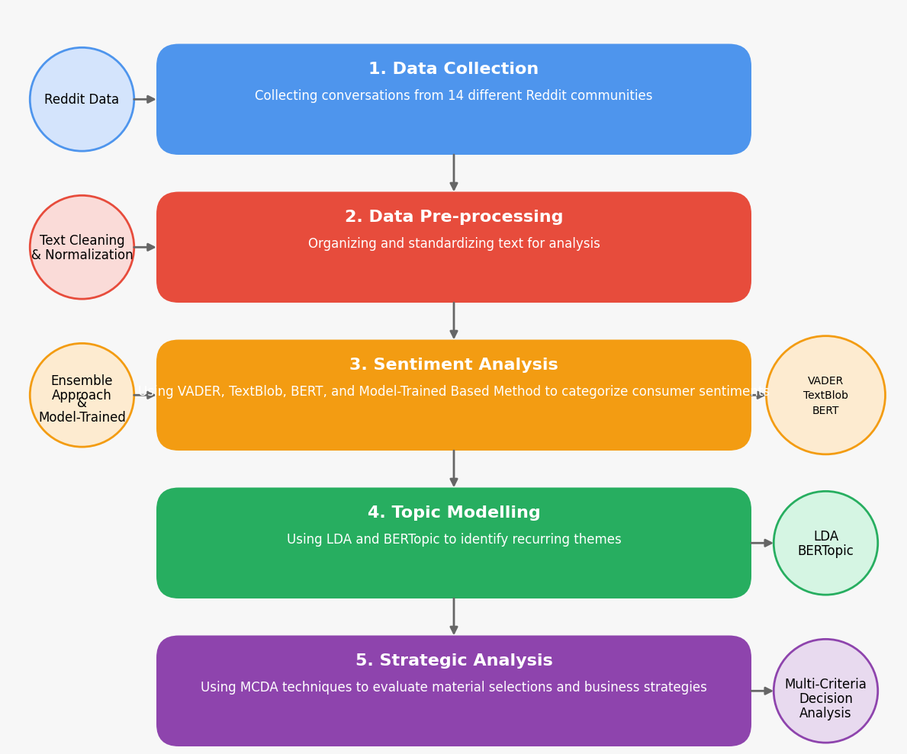
Figure 7: Research Methodology Process Flow, Created by Author.

3.4. Data Pre-processing and Cleaning
Data pre-processing is a process that goes through different stages, as illustrated in Figure 8, that cleans the raw data and turns it into a useful format. The reason for making this application is to attain more quality data, remove the symbols, remove nonsense words such as pronouns, prepositions, etc., duplicate, and point out the missing values, accordingly reaching higher accuracy (Jain 2019).
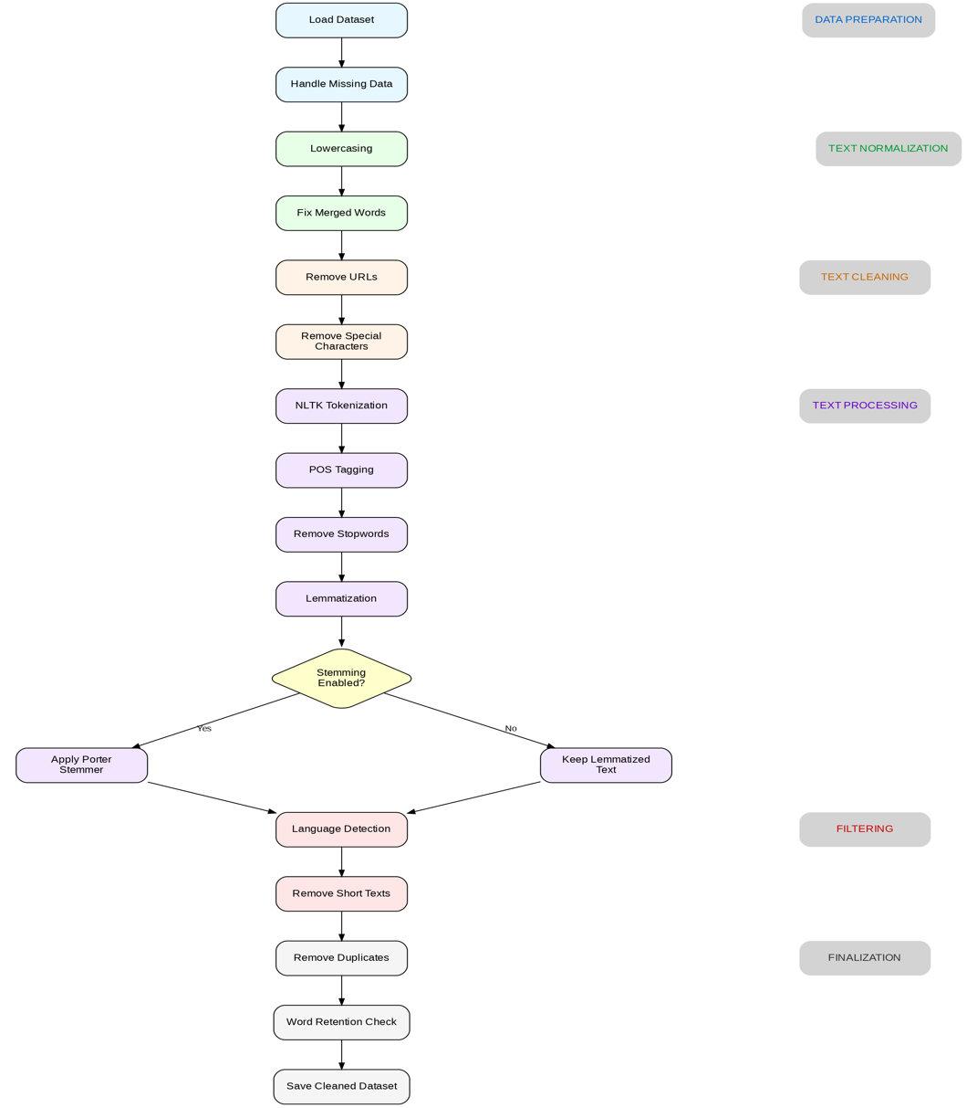
Figure 8: Data Cleaning and Pre-processing Flow Chart, Adapted by Author.

3.4.1. Text Processing Techniques

In the analysis process, we need to use cleaned data to achieve a higher accuracy in results. Accordingly, in Figure 9, Text Processing Techniques are displayed step by step: Text Cleaning Techniques and Normalisation, Tokenisation and Stop Word Removal and Advanced Processing. After applying these processes, we will check the quality of the process if it is applied correctly which will be discussed in the next chapter.

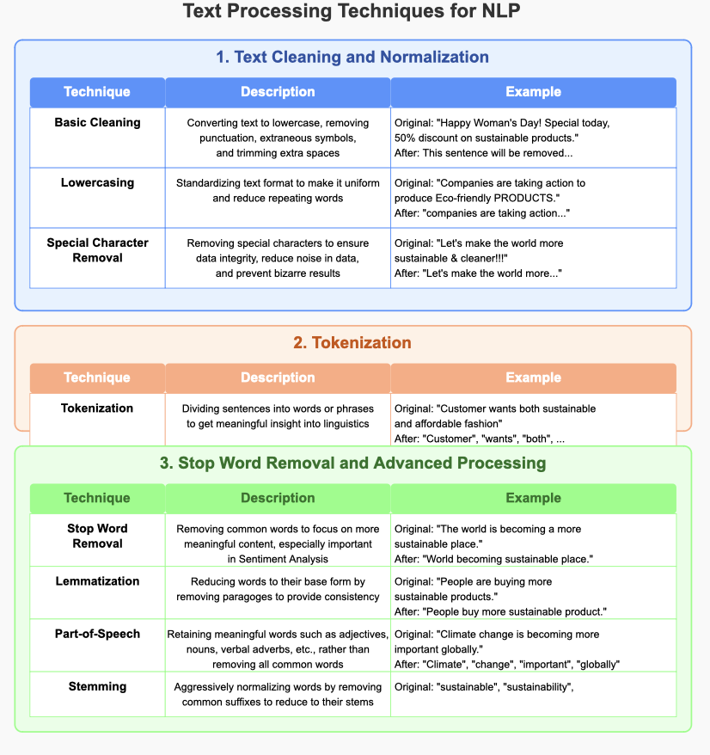
Figure 9: Text Processing Techniques NLP, Special Character Removal” cited by Sanjithkumar(2023), “Tokenisation Approach” cited by Deepanshi (2021), “Lemmatisation” cited by Plisson(2004), “Part-of-Speech” cited by Toutanova et al.( 2003), Created By Author.

3.4.2. Quality Check on Process
Following the pre-processing section, we applied some quality-check options to measure to make sure dataset integrity:
- Content-Length Filtering: We removed posts containing fewer than five tokens after processing since they don’t provide sufficient material.
- Processing Validation: We compared word counts before and after processing to identify any transformations that are not normal that might influence analytical accuracy.
- Duplicate Elimination: We applied different detection methods to identify and remove data that is duplicated or near duplicated that could skew our results.
- Language Consistency: We confirmed that is in English to maintain consistent NLP processing.
These quality control measures resulted in a refined dataset containing only substantive, unique, and standardized content appropriate for our subsequent sentiment and thematic analyses.

3.5. Feature Engineering
Once the online discussions regarding sustainability in the fashion industry were analysed, Reddit posts and comments needed to be transferred into well-structured data so that we could use analysis tools to proceed effectively. Accordingly, feature engineering is significant in determining patterns in people’s way of expressing themselves on sustainability and affordability.
Feature Engineering steps combine basic metrics, sentiment tools, pattern analysis, and statistical methods as shown in Table 3. This comprehensive approach creates detailed text profiles that power real-world applications from content recommendations to automated grading. Together, these engineered features enable a robust analysis of consumer sentiment and thematic content in sustainable fashion discussions.

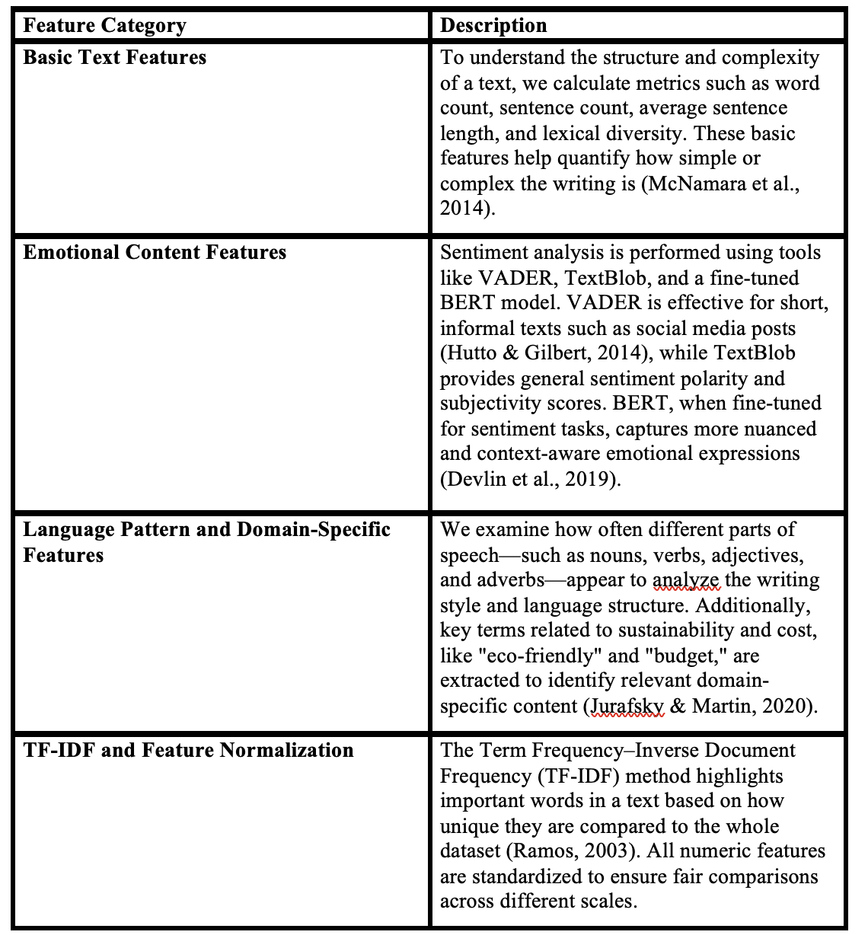
Table 3: Feature Engineering Steps, Created by Author.

3.6. Model Training, Sentiment Analysis, and Topic Modelling

3.6.1. Model Training and Fine-Tuning
The dataset that we annotated comprises text and corresponding sentiment labels, which means it is prepared and cleaned. In the following step, the dataset is distributed by 80% to be trained and by 20% to be validated and converted into a Hugging Face Dataset. We fine-tune a pre-trained DistilBERT model using properly labelled mappings and training parameters (Devlin et al., 2018). This process uses a cross-entropy loss function, and the model’s performance is validated using metrics such as accuracy, precision, recall, and F1-score (Venugopal et al., 2024).
Enhancements in Hyperparameter and Threshold Tuning:
Hyperparameter Search: Improving model tuning involves expanding our hyperparameter search strategy. By increasing the number of trials and exploring additional parameters like warmup steps and weight decay, we can find the best comprehensive model configuration. This approach comes with trade-offs that mean it needs to use more computational resources to have a widespread search to improve the model. For larger datasets, we might start with a more focused approach—using fewer trials or subsets—to balance exploration and computational efficiency.
Threshold Tuning for Multiple Classes: Other than standard settings, the threshold for decision for each class is customised—to have better results in neutral and positive sentiments—using advanced multi-class threshold tuning. This adjustment is for the sensitivity of our classification to ensure that sentiment categories are well distributed.
Class Weighting and Data Balancing: To address imbalanced distribution in the dataset, class samples are combined with oversampling or under-sampling techniques, ensuring that minority classes are adequately represented during training.

3.6.2. Sentiment Analysis Framework

3.6.2.1. Sentiment Analysis Techniques Selected
In this analysis, determining the most appropriate classification models is crucial for accurate sentiment extraction. Since we will focus on human language, Natural Language Processing (NLP) will be the core technique supporting our sentiment analysis. To address research questions regarding dominant sentiment themes and how financial constraints shape attitudes, we employed three sentiment analysis models to get maximum accuracy and nuance in sentiment detection as illustrated in Figure 10.
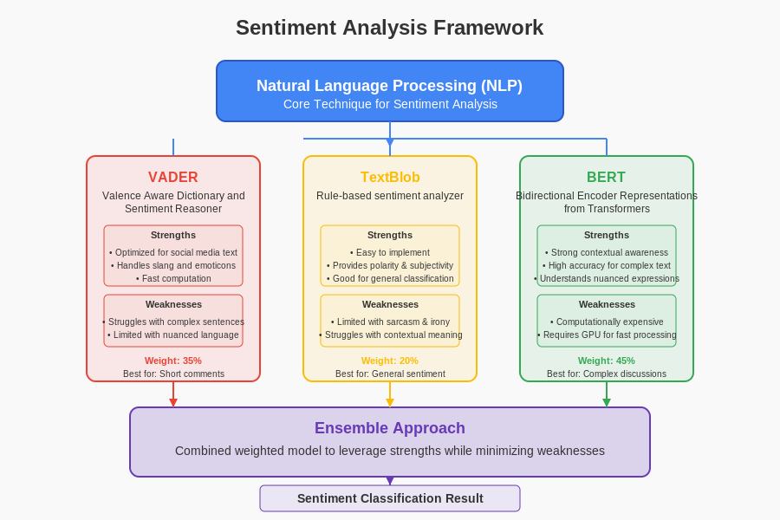
Figure 10: Ensemble Sentiment Analysis Framework, Created by Author

3.6.2.2. Ensemble Sentiment Analysis
To achieve a more robust and accurate sentiment classification, we adopt an ensemble approach. This combines the strengths of three different sentiment analysis methods: VADER, TextBlob, and the fine-tuned BERT model. VADER is well-suited to short, informal text such as Reddit comments, and provides compound scores reflecting overall sentiment polarity (Hutto & Gilbert, 2014). It generates a sentiment score ranging between -1 (extremely negative) to +1 (extremely positive). TextBlob offers straightforward implementation for tasks including tagging, noun phrase extraction, classification, and sentiment analysis, so it adds complementary insight by offering both polarity and subjectivity measures. The BERT-based model is a deep learning model, BERT analyses text bi-directionally, examining words about the surrounding context in all layers. It captures contextual nuances that simpler rule-based tools often miss. BERT provides higher accuracy for complex sentiment expressions (Devlin et al., 2018).
Each tool is assigned a weight reflecting its role: 35% for VADER, 20% for TextBlob, and 45% for BERT. This weighted ensemble ensures balanced performance across different sentence types and improves both overall accuracy and class-specific recall. The ensemble is particularly useful in managing edge cases, such as sarcastic or ambiguous statements, where a single model might struggle to make reliable predictions.

3.6.3. Topic Modelling-Models Selection and Justification
To uncover the major themes emerging in consumer discussions, we use two complementary unsupervised topic modelling techniques: LDA (Latent Dirichlet Allocation) and BERTopic.
LDA groups words that frequently co-occur into topics and is well suited for identifying general themes in longer texts (Blei et al., 2003). However, it struggles with short or contextually ambiguous posts, which are common on Reddit. To address this, we also apply BERTopic, a modern method that combines transformer-based embeddings with clustering algorithms to produce coherent, meaningful topics without requiring predefined topic numbers (Egger & Yu, 2022; El-Gayar et al., 2024).

3.6.3.1. LDA and Bertopic Topic Modelling Approach
Table 4 compares LDA Topic Modelling and BERTopic approaches. LDA uses traditional statistical methods—straightforward but limited with short texts—while BERTopic leverages embeddings for deeper semantic understanding, offering more powerful but computationally intensive nuanced topic capture.

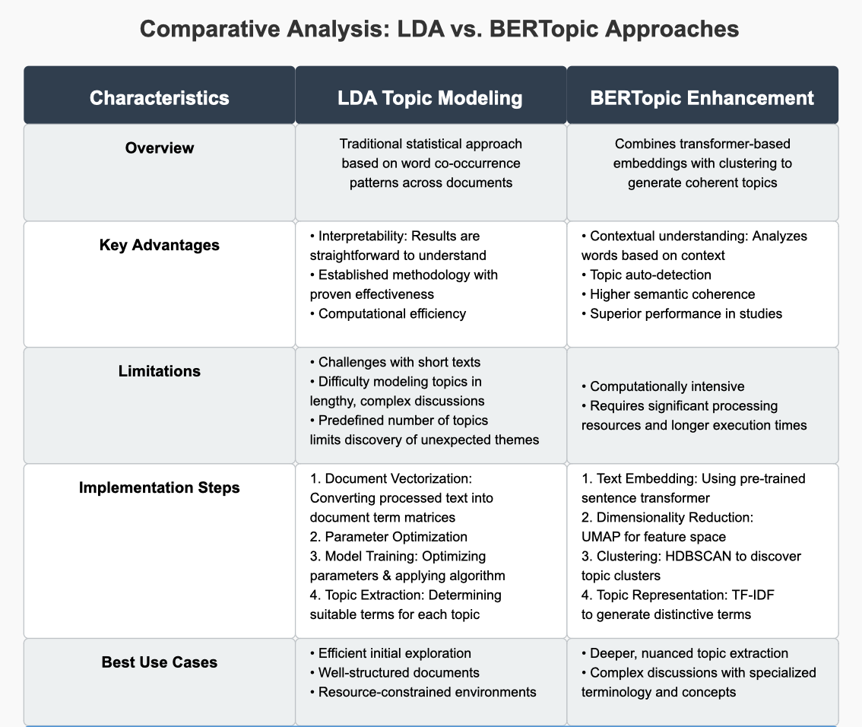
Table 4: Comparative Analysis of Topic Modelling: LDA vs BERTopic, Created by Author.

3.6.3.2. LDA Topic Modelling
LDA requires the above parameter to specify the optimal number of topics through experimentation. Following the conclusion of topic modelling, it makes the distributions of terms that are likely to have relationships and determines patterns such as "material durability concerns" and "price-quality evaluation discussions". LDA does present certain limitations for our research, including challenges with short texts and difficulty modelling topics in lengthy, complex discussions (Zhu, 2015). - themes.

3.6.3.3. BERTopic Enhancement
This research applied the BERTopic technique as a solution to the contextual understanding generation function that LDA cannot implement. This technique combines transformer-based embeddings with traditional clustering to generate more meaningful and coherent topics holistically. BERTopic has demonstrated superior performance in several comparative studies. For instance, El-Gayar et al. (2024) found that BERTopic provided better insights for interpreting and clustering topics in healthcare reviews compared to LDA. Similarly, Egger and Yu (2022) determined that BERTopic delivered more effective results in understanding consistent topics from social media content.
The primary drawback of BERTopic is its computational intensity, requiring significant processing resources and longer execution times (Gan et al., 2024). However, this trade-off is justified by the improved quality of topic extraction, particularly for complex discussions about sustainability and affordability.
Briefly, By employing both LDA and BERTopic, we will leverage their complementary strengths—using LDA for efficient initial exploration and BERTopic for deeper, more nuanced topic extraction—ensuring comprehensive identification of themes in consumer discussions.

3.6.3.4. Topic Validation and Fine-Tuning
As in illustrated Table 5, This validation system makes sure that the computer-found topics match real customer conversations. It works by using math scores to check the topic quality, having people review the topics to make sure they make sense, comparing results from different computer methods, and organising topics into groups. This helps researchers trust that they're seeing real patterns in how customers talk, not just random computer outputs.
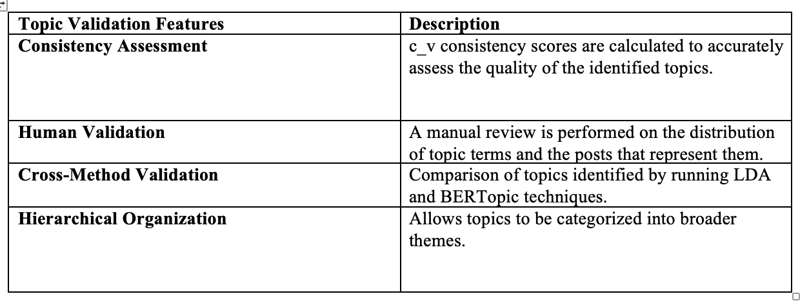
Table 5: Validation Features, Created by Author.

3.7. Multi-Criteria Decision Analysis Framework
In the final phase of this research, Multi-Criteria Decision Analysis (MCDA) is utilised to transform consumer insights into practical recommendations for fashion companies. This approach addresses the research questions about production strategies and business areas requiring change through three key functions:
- Different materials are examined by focusing on both the environmental impact of them and how consumers feel about them. This gives a greater picture than just focusing on technical sustainability alone.
- Different ways businesses try to balance being sustainable and, at the same time, keeping costs low are compared. The MCDA method helps consider some reasons at once so decisions aren’t too simplified.
- Possible changes are ranked based on at which level they might have an impact. This helps companies minimise their focus on the most important sustainability steps to get more efficient results instead of trying to change everything at once.

3.7.1. MCDA Methodology Selection
In this research, the Analytical Hierarchy Process (AHP), which provides a criterion-based decision-making approach, was used so that brands or companies can make more effective decisions and plans by transforming evaluations containing many different criteria into a more easily interpretable structure. The reasons for choosing this methodology are detailed below.
- Transforming complex decisions into an easily interpretable hierarchical format and ensuring effective management decision-making.
- Using both quantitative and qualitative measurements as sources while conducting the process.
- Performing systematic sensitivity analysis according to the impact level of the changing criterion.
- Arranging the inputs according to the priority order to determine alternative strategies.

3.7.2. Criteria Development Process

Within the scope of MCDA, the identified complementary criteria were created according to three different criteria:
Consumer Derived Criteria: Obtaining topics that show the priorities and concerns of customers from conversations shared on the Reddit platform.
Environmental Impact Measurements: Making comparative measurements by looking at environmentally friendly conversations where sustainability is considered as a metric.
Business Implementation Factors: Practical issues such as cost, schedule, and resource requirements, which are basic functions of running a business.
These criteria are organized into a hierarchical structure reflecting the importance of implementation and consumer priorities, with the categories of greatest impact.

3.7.3. Strategy Evaluation Implementation
These evaluation approaches ensure our strategic recommendations effectively address RQ2.1 and RQ2.2 regarding business strategies and organizational areas requiring change:
The value of this method lies in its ability to bridge the gap between consumer sentiment analysis and actionable business strategies. Rather than merely reporting consumer perspectives, these insights are transformed into specific recommendations regarding materials, production methods, and business strategies that could be implemented by fashion brands.
The AHP application systematically considers the strategies that can be implemented as in Table 6 below:
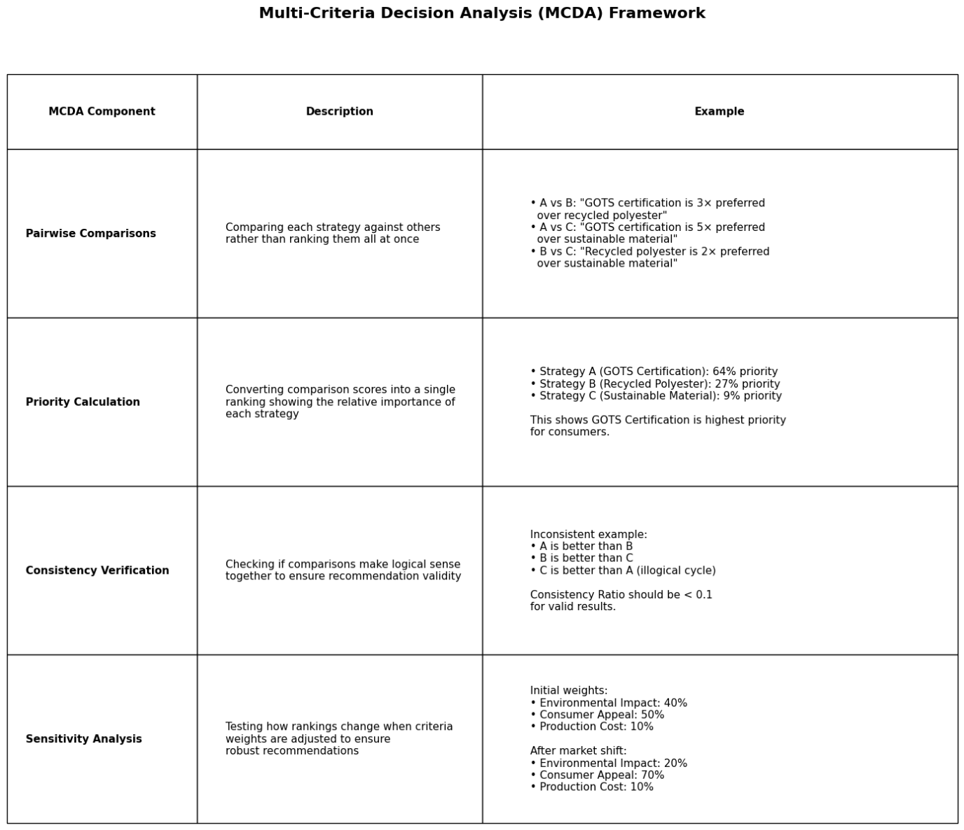
Table 6: MCDA Framework, addressing: Consistency Verification (RQ2.2), Sensitivity Analysis (RQ2.1), Created By Author.

This structured approach generated prioritised recommendations for fashion companies seeking to balance sustainability initiatives with financial considerations. Based on that, the ranking should be changed and If rankings stay same although weight changes, you can be more confident in your recommendations.

3.8. Methodological Limitations and Mitigation Strategies

3.8.1. Data Source Limitations
Demographic Bias on Platform: Many active users on Reddit are younger in demographic terms, between the ages of 18-29, and since the elderly use this platform less, it potentially cannot adequately reflect the perspectives of older consumers.
Representation Bias Geographically: The people on the platform predominantly speak English, which causes the conversations to overrepresent Western perspectives. This limitation directly affects the choice of the marketplace to be active.
Self-Selection Effects: Reddit users select and follow influential views on sustainability and pricing as representatives. Accordingly, the concept of bias may arise in the interpretation of the results.

3.8.2. Analytical Methodology Limitations
Sentiment Analysis Limitations: One of the biggest challenges in sentiment analysis, despite technological advances, is understanding the context of the sentence, recognising irony, and capturing culturally variable tones. To overcome these challenges:
- 200 discussions were manually checked.
- The given sentiment intensity was carefully interpreted.
- 3 different techniques were used to perform the analysis.
Topic Modelling Variability: Topic models may give different results each time they are run, which indicates that the identified themes are likely to change. Accordingly, the reliability of the model is affected. To solve this:
- A consistency function was added while running the models.
- Two modelling techniques, LDA and BERTopic, were used.
- The topics were selected manually.

MCDA Subjectivity Concerns: When performing multi-criteria decision analysis, it may inevitably deviate from objectivity when valuing the criteria. To reduce this problem:
- Sensitivity analysis was performed more comprehensively by using different scenarios with different weights.
- Documented all weighting decisions and their rationales diligently.
- Stable recommendations were determined at different weight ratios.

3.8.3. Mitigation Approaches
Different strategies were applied for the limitations mentioned in the research:
Methodological Triangulation: Cross-validation was performed using multiple analytical approaches in the procedures performed, and this reduced methodological biases.
Transparency in Reporting: Throughout the research, limitations were acknowledged exaggerated claims were avoided, and appropriate interpretation was ensured.
Validation Procedures: Systematic validation techniques were applied to ensure the reliability of numerical analyses and to identify potential concerns.
Contextual Attribution: Within the scope of the research, the results were interpreted in the context of the subject by focusing on the subject rather than making general claims.
These mitigation strategies ensured that, despite the limitations as happening in all research, the effects of these limitations on the results were minimized and transparently acknowledged.

3.9. Evaluation Metrics
Evaluation is crucial in terms of ensuring that the model or technique is working well for that specific dataset. Therefore, it measures how the model is accurate, reliable, and interpretable for findings. For different models, different evaluation metrics are applied. These metrics were chosen based on their relevance to sentiment analysis, topic modelling, and decision-making frameworks.

3.9.1. Performance Metrics Selection
Three figures below demonstrate the metrics used to assess how effective the sentiment analysis was in identifying the dominant themes and financial constraint expressions, as posed by RQ1.1 and RQ1.2.

3.9.1.1. Sentiment Analysis, Topic Modelling and MCDA Evaluation Metrics

In the following table, it shows the evaluation metrics that have been used to do sentiment Analysis.

3.9.1.2. Sentiment Analysis Evaluation Metrics
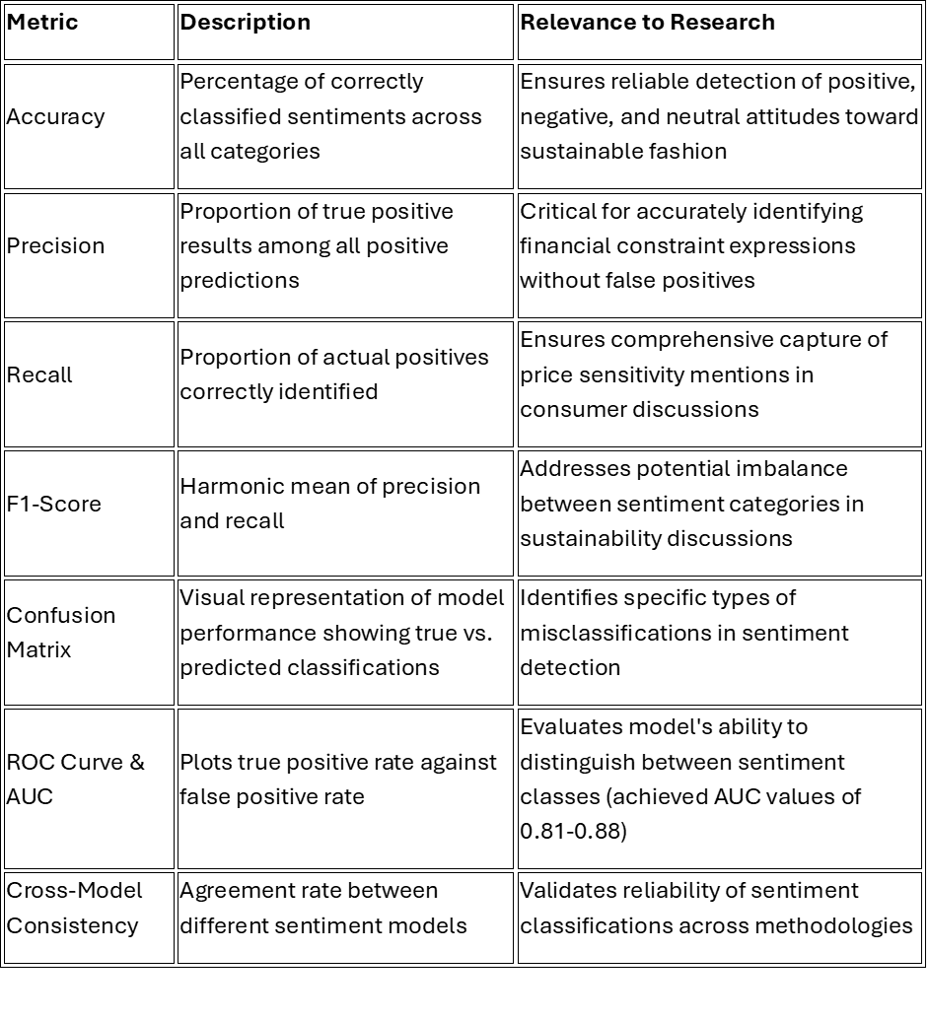
Table 7: Sentiment Analysis Evaluation Metrics, Created By Author.

Table 7 demonstrates the metrics used for topic modelling, which effectively reveal the pattern in consumer discussions, addressing RQ1.1 and providing strategic insights for RQ2.1.

This table presents key classification metrics for sentiment analysis in sustainable fashion research. Accuracy shows overall correctness in sentiment identification, while precision ensures quality predictions and recall captures actual positives. F1-Score balances these metrics for imbalanced classes. Confusion Matrix reveals misclassification patterns between sentiment categories. ROC Curve/AUC measures class separation ability, with values above 0.80 indicating strong performance. Cross-model consistency evaluates agreement between sentiment models, confirming robust findings.

3.9.1.3. Topic Modelling Analysis Evaluation Metrics

The following table shows the evaluation metrics below that have been used to do sentiment Analysis.

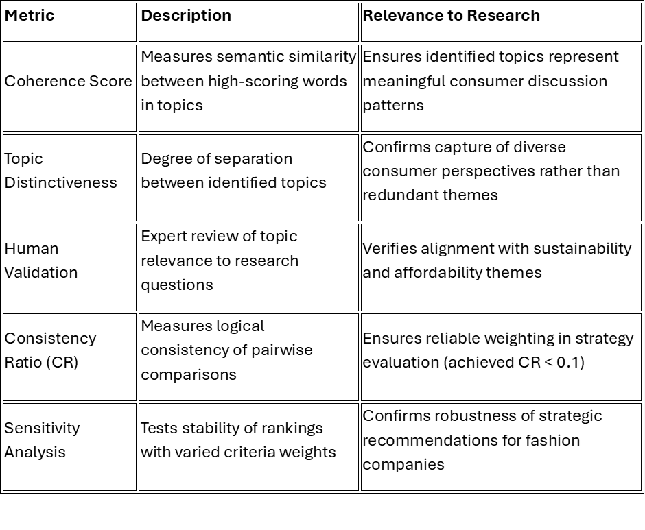
Table 8: Topic Modelling Evaluation Metrics, Created By Author.

Table 8 outlines essential topic modelling metrics for sustainability research. Coherence Score measures semantic similarity within topics, ensuring meaningful groupings. Topic Distinctiveness evaluates theme separation without overlap. Human Validation verifies alignment with research questions through expert review. Consistency Ratio ensures reliable strategic evaluations. Sensitivity Analysis confirms recommendation robustness when parameters change.

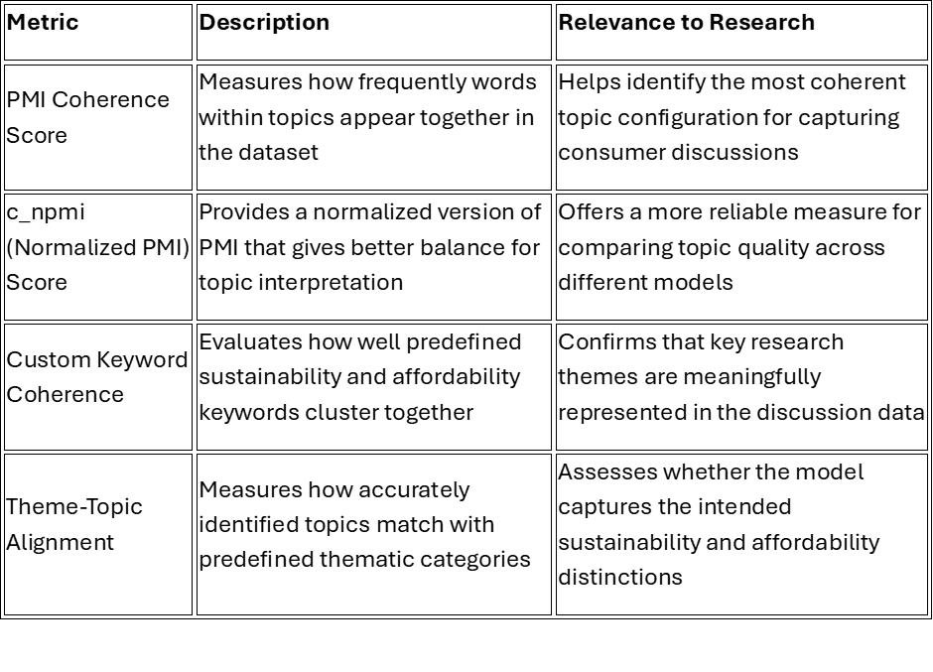
Table 9: Additional Topic Modelling Evaluation Metrics, Created by Author.
Table 9 presents key topic modelling metrics for fashion discourse analysis. PMI Coherence Score measures word co-occurrence within topics, identifying optimal topic configurations. c_npmi normalises PMI for word frequency, enabling standardised model comparisons. Custom Keyword Coherence evaluates the clustering of predefined terms, confirming genuine research theme representation. Theme-topic alignment assesses how accurately topics map to predefined categories, determining if the model captures intended distinctions in consumer discussions.

FINDINGS AND ANALYSIS

4.1. Exploratory Data Analysis (EDA) Results

4.1.1. Corpus Overview
The original dataset file created through web scraping contained 19898 posts, and following the final pre-processing step, the number of posts was decreased to 6485 posts about fashion-related subreddits. Data scraped based on the category of sustainability and affordability to distinguish the posts easily and, in addition, prepare already filtered files in terms of category. The distribution of these notions is % 45,3, with 7474 words for sustainability, and % 54,7, with 9015 words for affordability. This imbalance shows that the affordability topic is more popular than sustainability-related conversations. The numbers are illustrated in the below figure 16:
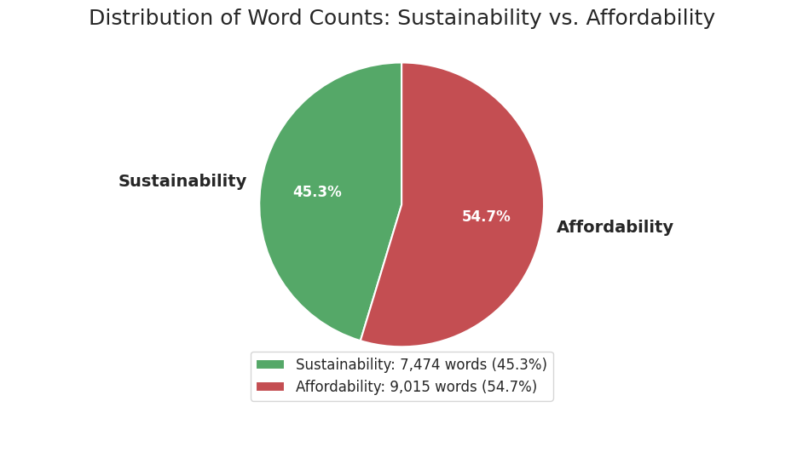
Figure 11: Pie Chart Showing Distribution of Posts Between Sustainability and Affordability Categories, Adapted by Author

4.1.2. Word Frequency Analysis
The top ten words have been analysed after several cleaning and processing phases to remove stop words, and the model was pushed to reveal the words related to sustainability and affordability rather than repeating random or casual words overall. The numbers for each category to be words in general, more related to sustainability and affordability were illustrated as in the figures below. The most repeated terms for sustainability were "sustainable," "ethical," "natural," "organic," and "impact", point out the aspects of environment and ethics in sustainable fashion conversations.
Regarding affordability, the words mostly consist of “price, cheap, costs, etc.”, reflecting consumer ideas based on the financial aspects of fashion choices illustrated below based on ensemble-based method in Figure 17 and Figure 18.
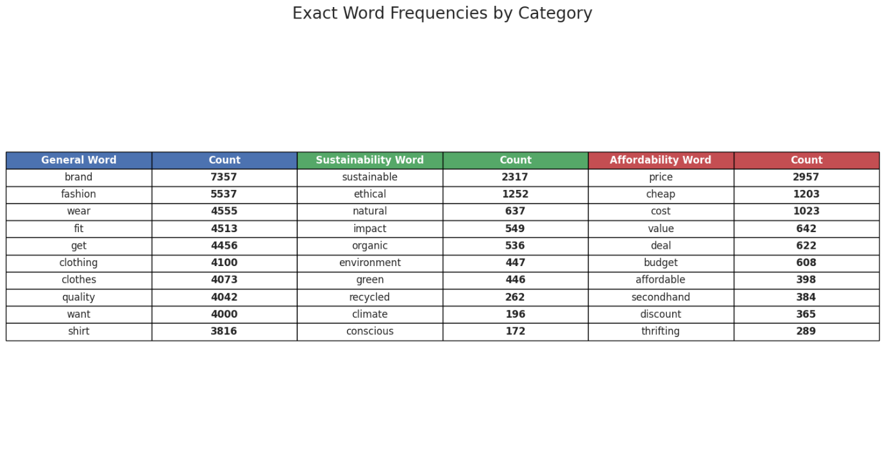
Figure 12: Top 10 Word Frequency in General, For Sustainability and Affordability with Unlabelled Dataset, Created by Author

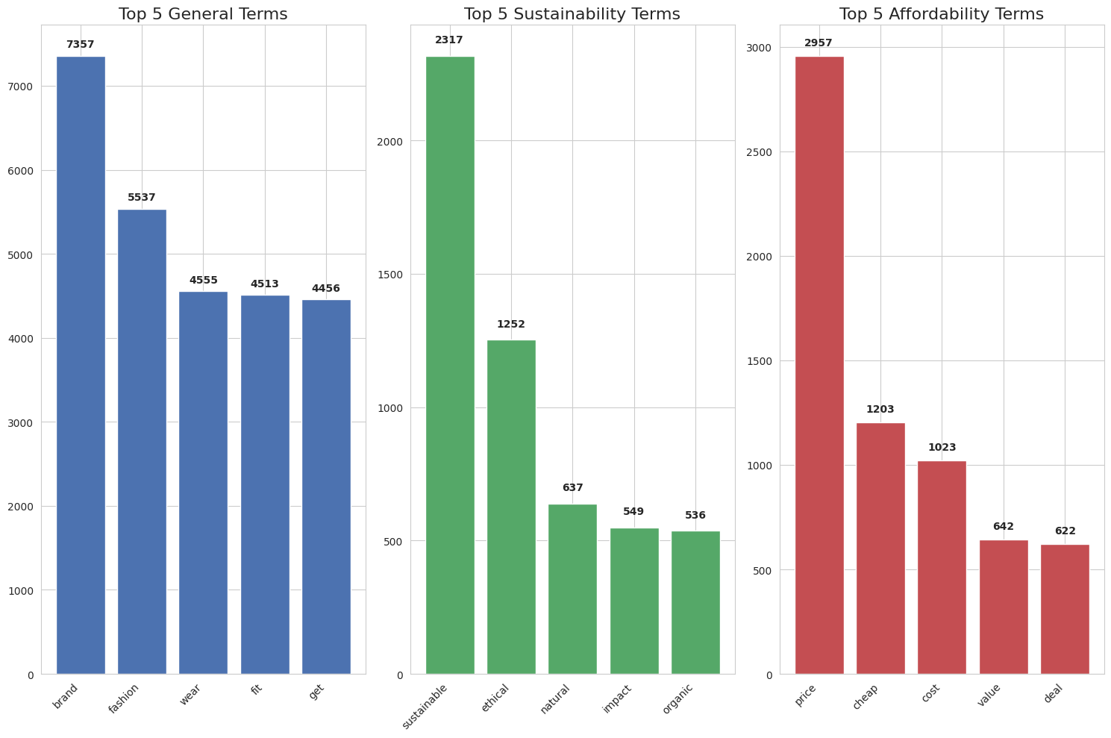
Figure 13: Top 5 Words in General, for Sustainability and Affordability with Unlabelled Dataset, Created by Author

4.1.3. Keyword Coherence Analysis
The coherence score analysis is crucial to proceed with the topic modelling. It reveals unhidden and undiscovered patterns in which frequency and related terms appear together. By using this technique, it was assessed the clarity of topics and strongly provided sustainability and affordability-related words.
The coherence calculated is PMI-based since it detects the words as pairs appear more than expected. Briefly, it focuses on more consistency in a pair of words than the frequency of words. Accordingly, it has been reached to below numbers could be reviewed in below figures:
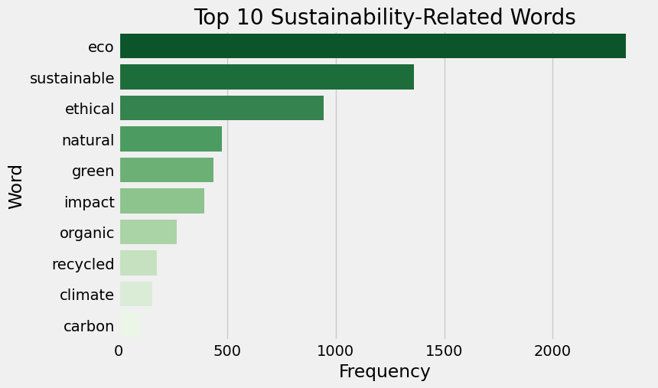
Figure 14: Top 10 Sustainability-Related Words Coherence Score: 2.811352
The higher coherence score of sustainability-related words which is 2.756769, reveals that the topics are occurring consistently around specific concepts such as “organic, ethical, sustainable, etc.” even though the frequency of these words is higher than affordability.

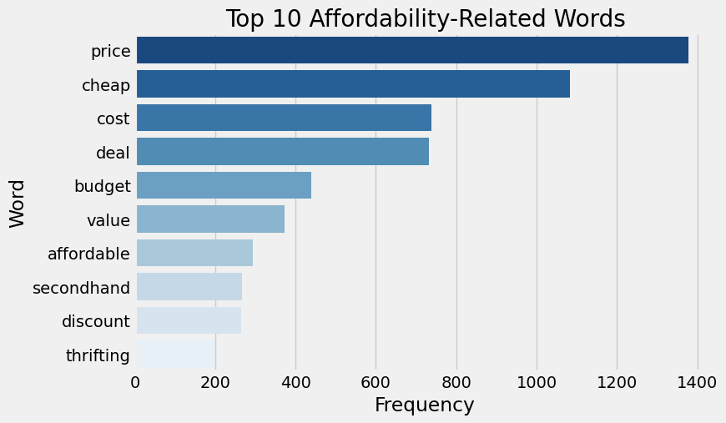
Figure 15: Top 10 Affordability-Related Words Coherence Score: 1.747944
The lower coherence score of affordability-related words, which is 1.695774, shows that the topics are more diverse, and people have a less structured conversation, which reveals that people have different concerns about financial situations. Figure 21 displays the comparison of the coherence score.
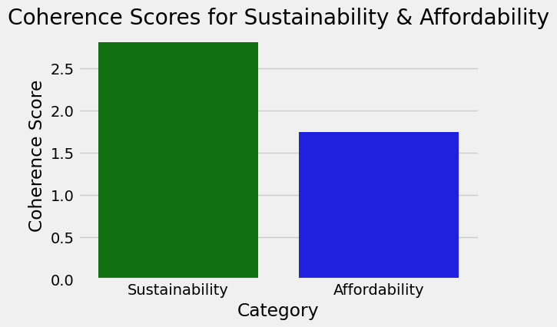
Figure 16: Coherence Score for Sustainability and Affordability Words, Adapted By Author

4.2. Sentiment Analysis Results
In sentiment analysis, we used two different approaches the ensemble method and the trained model-based method.

4.2.1. Ensemble Method Sentiment Analysis
We transitioned from three sentiments (Positive, Negative, Neutral) to binary classification due to the minimal percentage of Neutral sentiment (below 4%), which indicated strong consumer opinions rather than ambivalence, despite initially keeping it to detect unique consumer themes.
The binary sentiment analysis reveals that while affordability shows 82.54% negative sentiment (17.46% positive), sustainability performs slightly better with 28.09% positive against 71.91% negative responses—a 10.63% difference suggesting consumers prioritise environmental concerns over current pricing, challenging companies to create affordable yet sustainable products.
Related the numbers could be reviewed in below Figure 26:
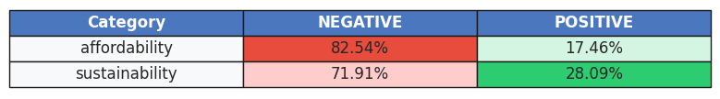
Figure 17: Ratio of Affordability and Sustainability Based on Binary Sentiment Categories, Adapted by Author

4.2.1.1 Model Agreement Analysis

VADER and TextBlob showed 67.02% agreement as dictionary-based models using similar rule-based methods, while BERT frequently contradicted both models, with only 26.29% full agreement across all three models; in binary classification, VADER and TextBlob agreed on positive sentiment (90.54%) but diverged on negative text (38.93%), while BERT and VADER aligned strongly on negative sentiment (92.39%).
Using BERT as ground truth due to its contextual awareness and high confidence score (0.943), evaluation metrics showed BERT's high precision (0.880) but low recall (0.392), with TextBlob matching BERT's results more frequently than VADER (69.4% vs 61.7%) and achieving a better F1 score (44.2% vs 37.0% for VADER), revealing how BERT's advanced AI captures sentiment nuances that simpler dictionary-based tools miss. These values could be found in Table 10, 11, 12 and Figures 24.

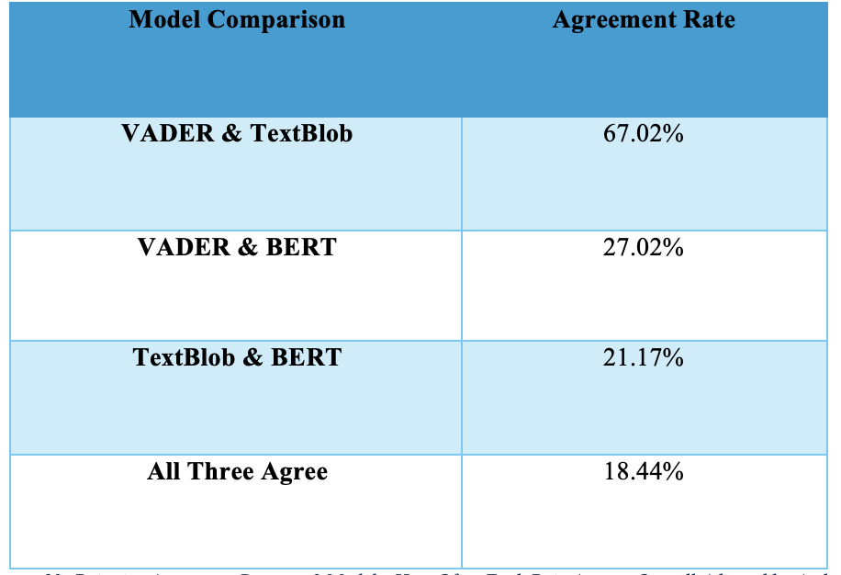
Table 10: Pairwise Agreement Between 3 Models, How Often Each Pair Agrees, Overall Adapted by Author.
:

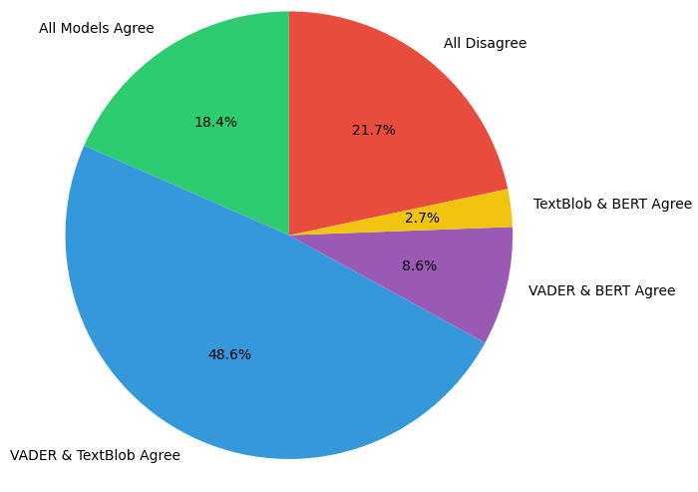
Figure 18: Sentiment Agreement Distribution, Adapted by Author.

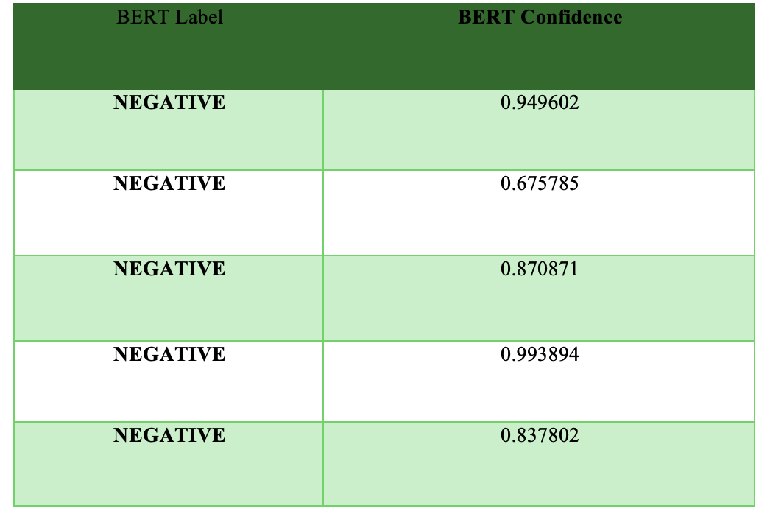
Table 11: Confidence Chart, It was measured through 5 samples, Adapted By Author.

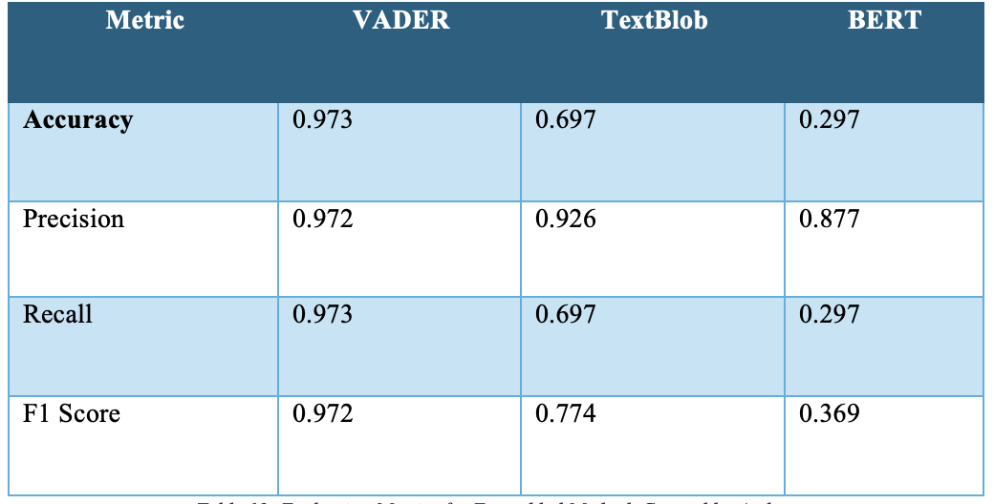
Table 12: Evaluation Metrics for Ensembled Method, Created by Author.

4.2.2. Trained Model-Based Method Sentiment Analysis
To achieve better results from the fine-tuned DistilBERT model, we proceeded with the annotated dataset. The analysis consists of different evaluation metrics, including ROC curves, sentiment classification, and confusion matrix visualisations. Furthermore, thanks to hyperparameter tuning, class balancing and threshold optimisation, the performance was systematically explored to improve classification outcomes.

4.2.2.1. ROC Curve Analysis
The ROC curve (Receiver Operating Characteristic) visualises the model’s ability to distinguish between the three sentiment classes: Negative, Neutral, and Positive, as in Figure 19 below.
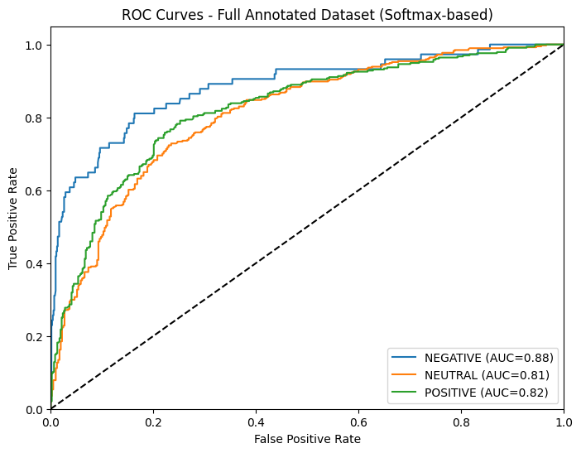
Figure 19: ROC Curve Analysis, Trained Model-Based Approach, Created by Author.
The Area Under the Curve (AUC) numbers show if the classifier can distinguish between classes well:
- NEGATIVE: AUC = 0.88
- NEUTRAL: AUC = 0.81
- POSITIVE: AUC = 0.82
According to these results, the model performs very well in detecting negative sentiment, with a high true positive rate and a low false positive rate. This also proves that prior literature shows that emotionally charged content—especially negative sentiment—is often more distinct and linguistically explicit (Hutto & Gilbert, 2014; Vasapollo et al., 2024).
Distinguishing neutral and positive content is also strong but slightly lower. It is common for neutral expressions in social media content to be difficult to detect and tend to go both ways, with both positive and negative tones illustrated in below figure 20.
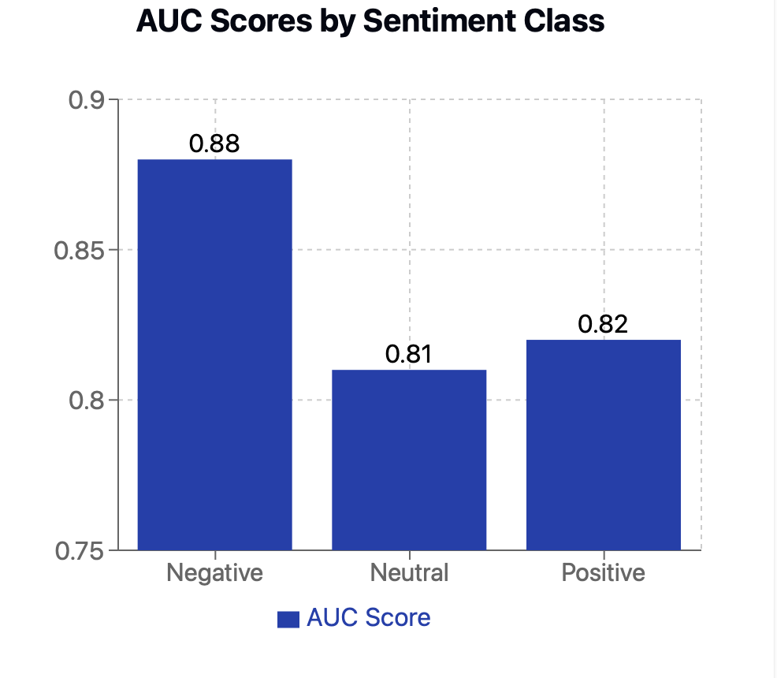
Figure 20: Sentiment Distribution Based AUC Score, Created by Author.

4.2.2.2. Classification Report and Threshold Tuning

To proceed with the classification, we adjusted a decision threshold to 0.46 for the Negative class; we achieved a balanced performance with 72% overall accuracy. The F1 scores of 0.68 macros and 0.71 weighted revealed that our model works properly for all sentiment categories. The breakdown for sentiments is as below Table 13:

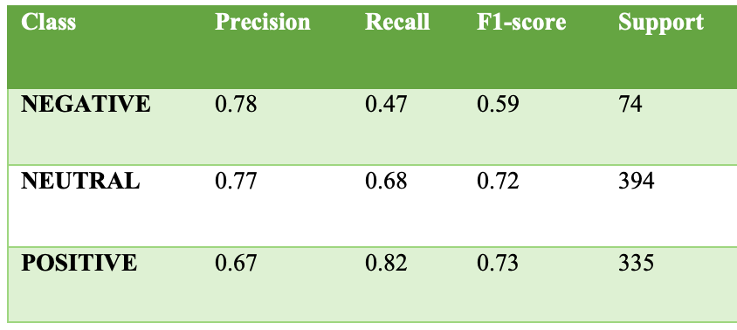
Table 14: Evaluation Metrics Results for Sentiments, Created By Author.

For negative content, the model’s precision value is 0.78, which is quite high, but a lower recall value of 47% shows that it missed many truly negative posts. That means it is highly accurate in the detection of whether it is positive or negative but hard to catch expressions. For neutral content, the model performed more balanced by 0.77 precision and 0.68 recall. The model is very responsive to positive sentiment by 82%. Moreover, it could detect the other content with over sentiment by 0.67 precision. These results highlight a common challenge in sentiment analysis - negative sentiments are often expressed in subtle ways that can be difficult to capture consistently.

4.3. Confusion Matrix Interpretation
The threshold-tuned was used for the confusion matrix further illustrated as in below figure 21:
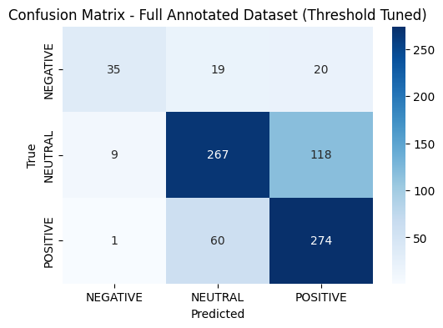
Figure 21: Trained -Model Confusion Matrix, Created By Author

The confusion analysis revealed several patterns. Our model's confusion analysis revealed several patterns. Even though sometimes it misclassified the neutral content as negative (19 predictions), the issue is that the model might fail to distinguish neutral from positive content (118 neutral examples). This confusion matrix is sensible for sustainability-related discussions where statements are often hard to understand the context. For example: "expensive but worth it", there is one negative and one positive word. Despite these challenges, the model was successful in identifying positive sentiment, correctly distinguishing and grouping 274 out of 335 positive posts, suggesting that positive phrases in conversations about sustainable fashion tend to be more easily detected by the algorithm as they use more specific language patterns.

4.4. Impact of Hyperparameter Tuning
The final model was trained using the best parameters found via Optuna. We fine-tuned our model by testing different settings and found the best combination: a tiny learning rate of 2.28e-5 (0.0000228), running for four training cycles, and processing 8 examples at once.
The model improved gradually during training. The accuracy increased from 50% to 61%, meaning it got better in prediction by 6 out of 10 predictions correct. Its F1 score (a balanced measure of performance) improved from 0.43 to 0.59. The best part is the validation results stay constant, revealing that the model was smartly learning useful patterns rather than just memorising examples.
These results confirm that getting these technical settings right has a direct, positive impact on the model’s learning, just like finding the right temperature and cooking time for a recipe.
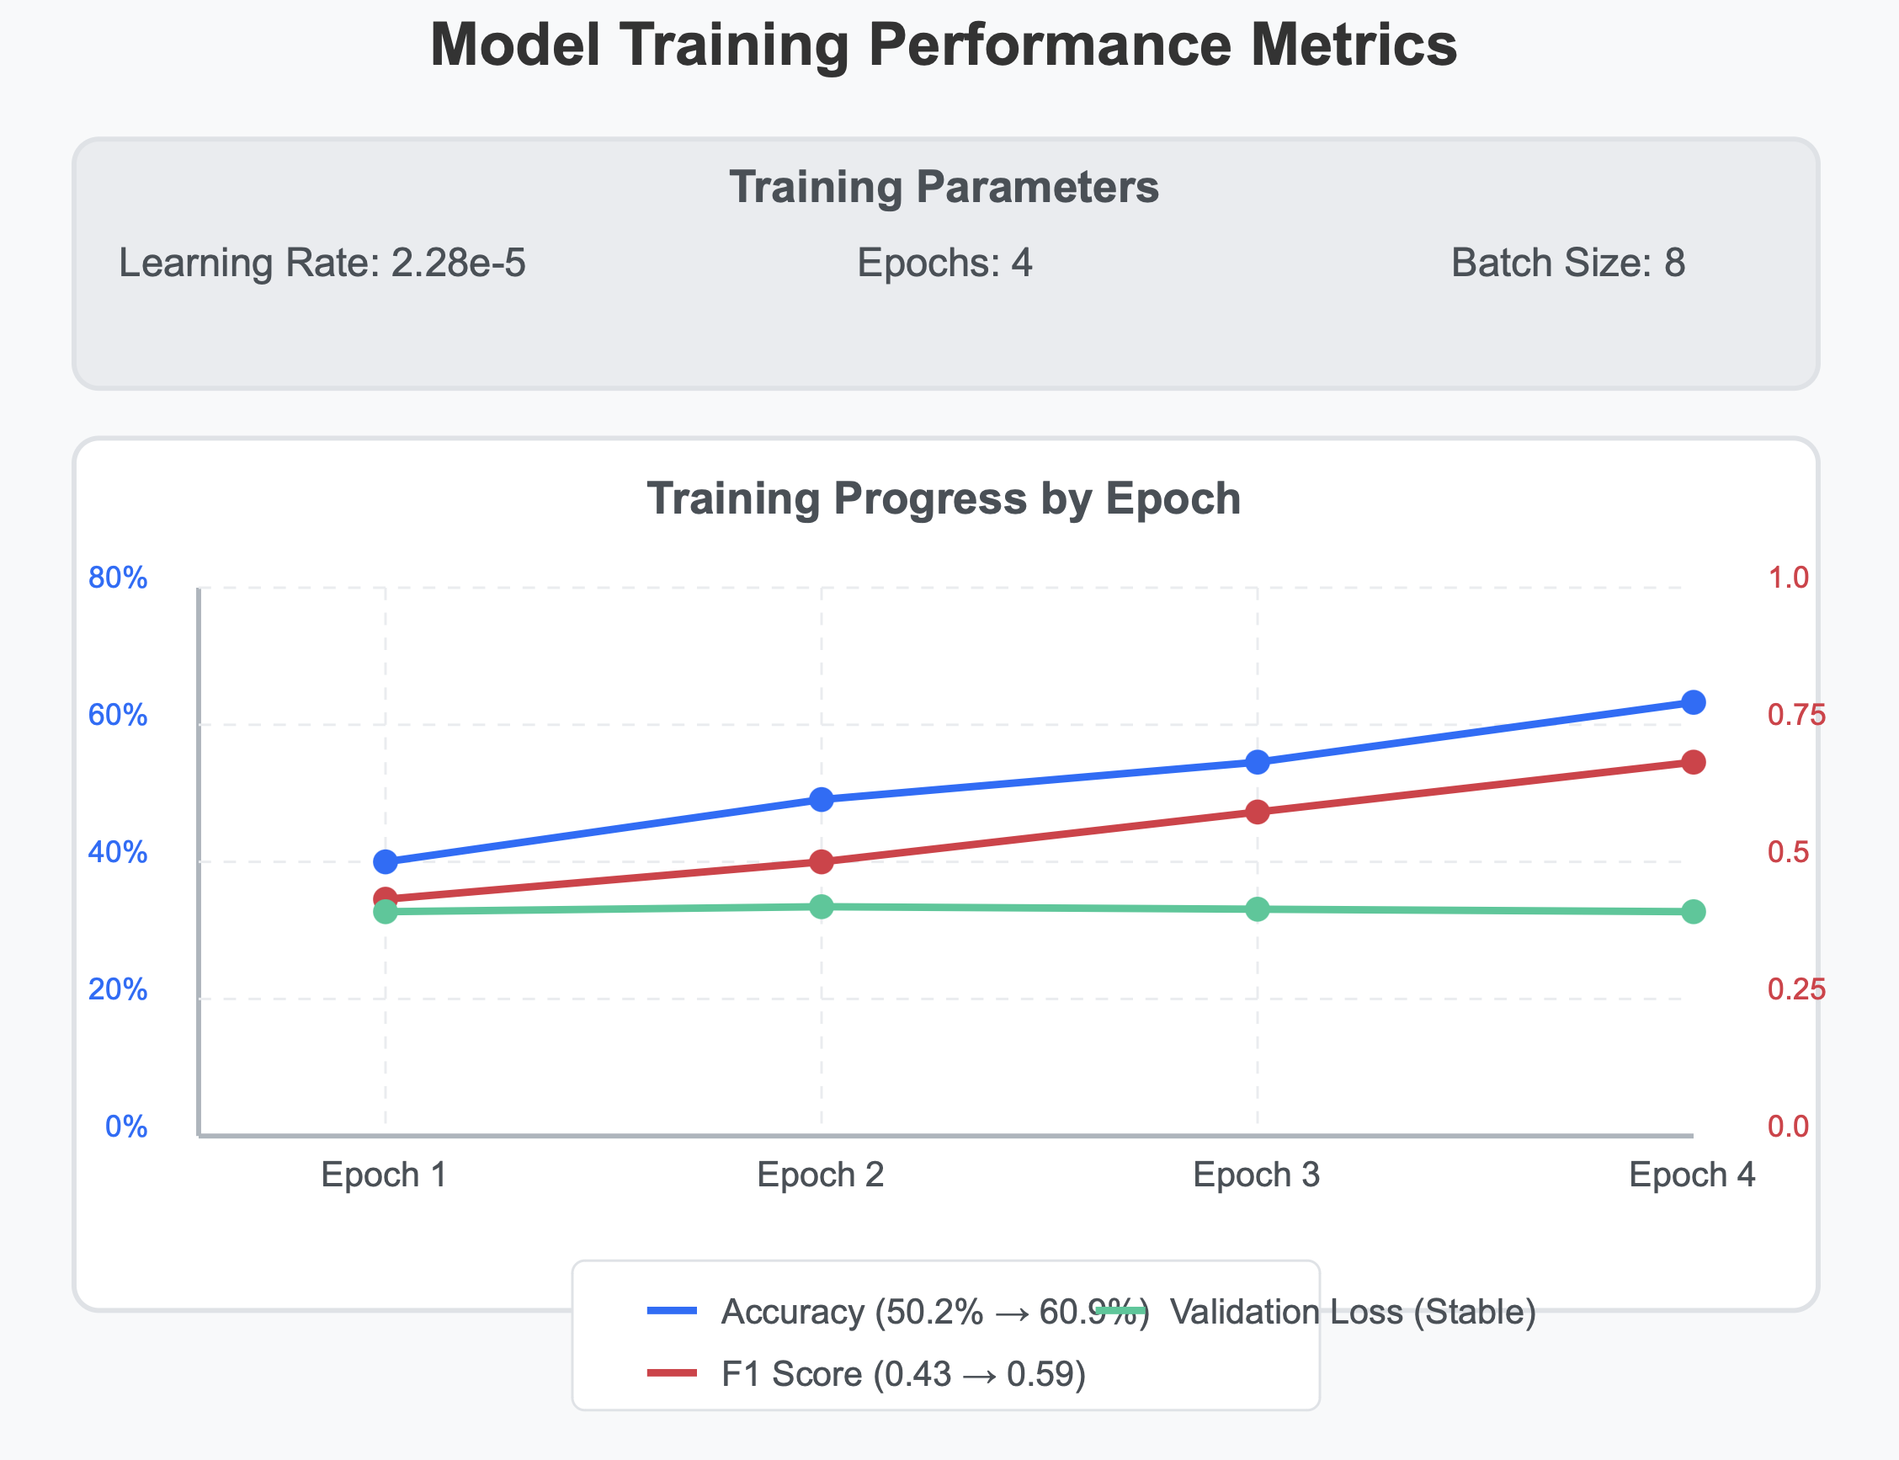
Figure 22: Hypermeter Tuning Trained-Model Performance Results, Created by Author

4.4.1. Justification for Trained Model
We chose the trained model approach over the ensemble method for its superior performance and consistency. While the ensemble showed high VADER accuracy (97.3%), the three models rarely agreed (18.4%), raising reliability concerns. Our trained DistilBERT achieved 72% accuracy with balanced metrics and effectively captured neutral sentiment. The ROC curve analysis confirmed its excellent discriminative ability (AUC values of 0.88, 0.81, and 0.82 for negative, neutral, and positive classes), showing strength in detecting negative sentiment. Through hyperparameter-tuning, we improved accuracy from 50% to 61%, making it better equipped to understand the complex language in sustainability discussions.

4.5. Topic Modelling Results

4.5.1. Optimal Topic Configuration
Based on my LDA model testing, the 14-topic model showed the highest PMI coherence score at 1.1873. Yet when I looked at c_npmi scores (which I find gives a better balance for topic interpretation), the 7-topic model performed best with a score of 0.0479.
As illustrated in below Figure 23, custom keyword lists proved quite effective, too. The sustainability-related terms clustered particularly well with a PMI coherence score of 2.2894, while the affordability terms also demonstrated good coherence at 1.0684. These strong scores confirm that these themes are genuinely present and meaningfully structured within the text collection I analysed.
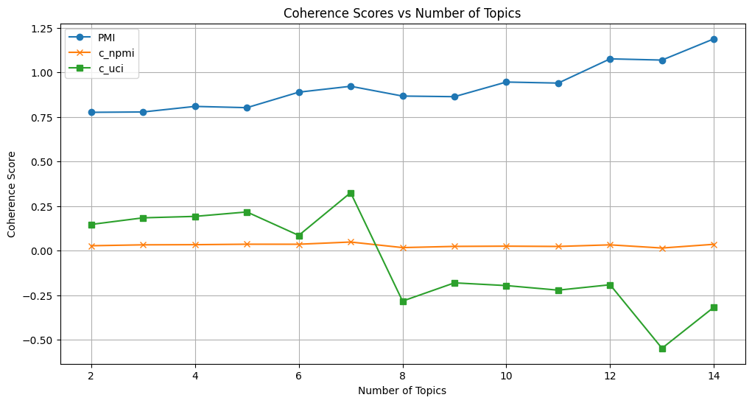
Figure 23: LDA Coherence Score vs Number of Topics, Created by Author.

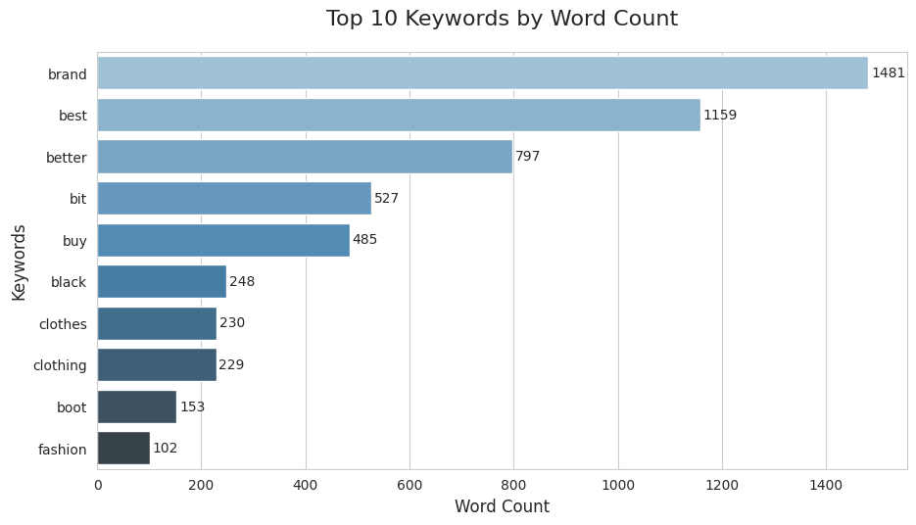
Figure 24: LDA Topic Modelling Keywords, Topic 14 Highest Coherence, Created by Author.

Based on BERTopic Modelling, we did different analyses. Accordingly, the interpretation of the results is as below.
As displayed Figure 26, our keyword analysis yielded mixed results. The theme-topic alignment accuracy was only 23.92% overall. Category-specific alignment rates were dismal for sustainability topics (0.82%), non-existent for affordability (0% alignment), yet perfect for general themes (100% alignment), likely due to their broader language. This demonstrates how basic keyword matching falls short when analysing complex subjects like sustainable fashion. While simple to implement, this approach struggles with the nuanced language people use when discussing these multi-layered topics.
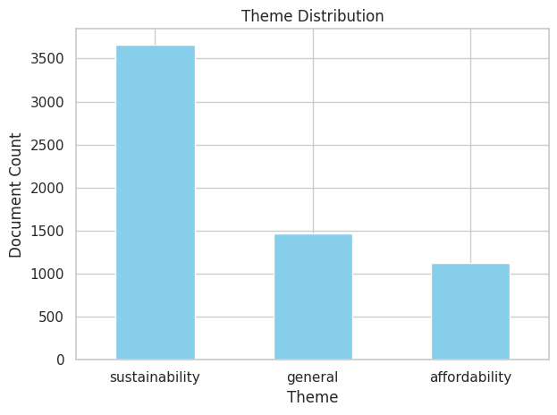
Figure 25: Theme Distribution by Bert, Created by Author.

As indicated in Figure 33, The BERT results reveal imbalances: as topics increase, PMI rises (0.85→1.20) showing stronger word co-occurrence, while c_npmi and c_uci decrease (0.15→0.05 and 0.30→0.17), indicating reduced semantic coherence. Selecting the optimal topic count requires balancing these competing metrics based on your analytical priorities.

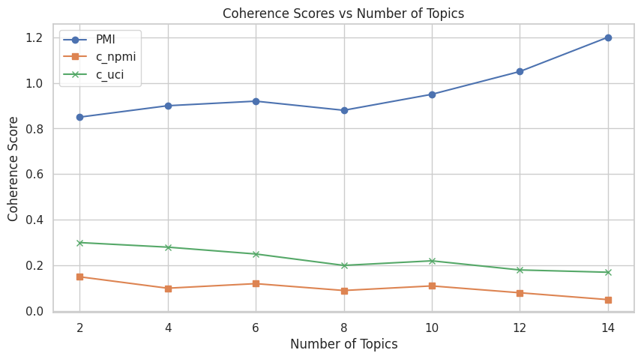
Figure 26: LDA Coherence Score vs Number of Topics, Created by Author.
Figure 27, as illustrated below, the BERT sentiment model performed poorly with only 28% overall accuracy. While showing decent recall (77%) for negative sentiment, it misclassified most neutral and positive texts as negative, demonstrating a strong negative bias. For neutral texts (the largest class), precision was mediocre (0.58) with extremely low recall (0.16), while positive sentiment recall reached just 29%. The confusion matrix confirms this pattern—most neutral and positive messages were incorrectly labelled negative.
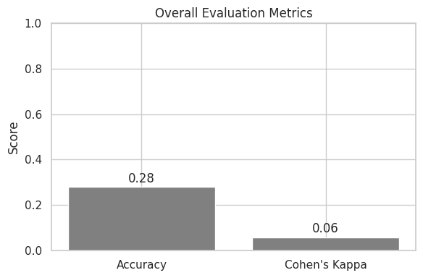
Figure 27: BERTopic Overall Evaluation Metrics, Created by Author.

4.5.2. Justification for Choosing LDA Model

After detailed analysis with BERTopic and LDA, we reached the different results for each model and decided to continue with the LDA model. In the literature review and methodology, it has been mentioned that BERT works better with a large dataset.
However, we selected the LDA model over BERTopic based on compelling performance metrics. BERTopic's coherence declined dramatically with c_npmi plummeting from 0.15 to 0.05 and c_uci dropping from 0.30 to 0.17, while delivering an unacceptably low 28% accuracy in sentiment analysis with critically poor neutral class recall (0.16).
In contrast, our 7-topic LDA model demonstrated superior interpretability with an optimal c_npmi of 0.0479. Most impressively, our custom keyword lists achieved exceptional PMI scores - 2.2894 for sustainability terms (more than double BERTopic's best performance) and 1.0684 for affordability terms - definitively confirming LDA's superior ability to capture meaningful topic structures in our sustainable fashion dataset.

4.5.3. Topic Sentiment Analysis
When integrating sentiment analysis with topic modelling, distinct sentiment patterns emerged across topics as illustrated below Table 14:
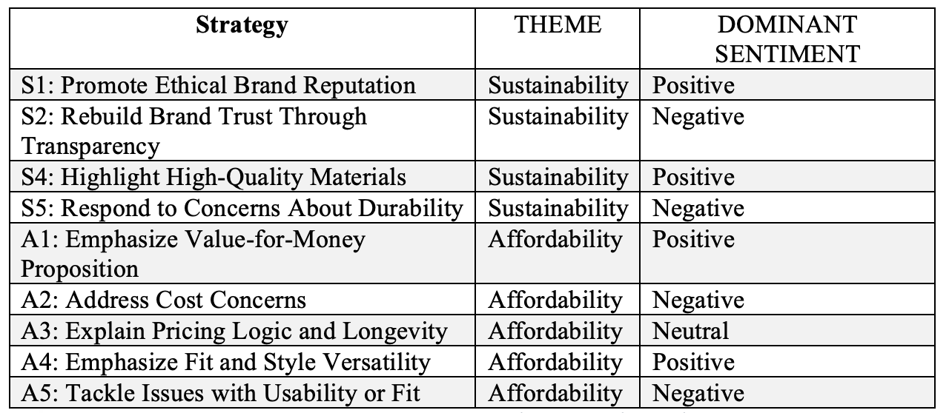
Table 15: Strategies Sentiment Analysis, Created By Author.
Sustainability strategies: positive messaging on ethics/quality, negative responses to trust/durability concerns. Affordability strategies: positive focus on value/versatility, negative responses to cost/fit issues, neutral pricing explanations. Both balance proactive brand messaging with reactive problem management.

4.6. Strategic Recommendation Analysis

4.6.1. Strategy Evaluation Criteria
Based on the insights from topic modelling and sentiment analysis, to evaluate sustainability strategies, five key factors were considered as demonstrated below Figure 28:
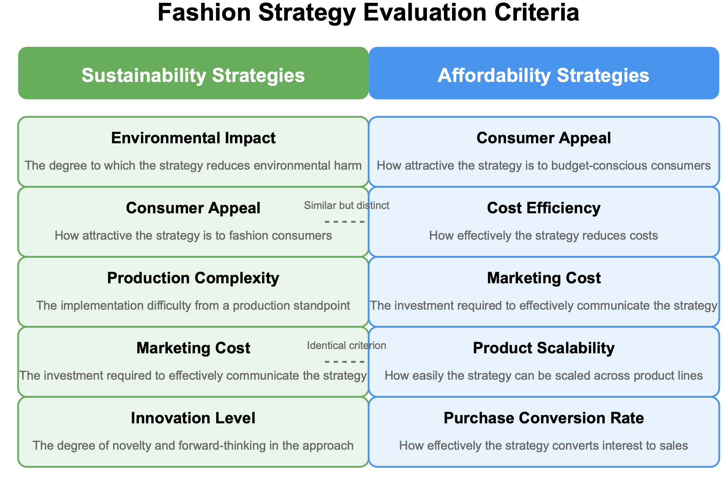
Figure 28: Fashion Strategy Evaluation Criteria, Created by Author.

The framework uses distinct metrics for each strategy type. Sustainability criteria measure environmental impact, consumer attraction, production difficulties, marketing costs, and innovation. Affordability metrics assess budget-conscious appeal, cost reduction, marketing investment, scalability, and sales conversion. Both share consumer appeal and marketing cost considerations, though with different emphasis and applications.

4.6.2. AHP Weights Calculation
AHP turns complex statements into understandable values, checks the context If it is sensible, and balances multiple factors reflecting both customer needs and business realities.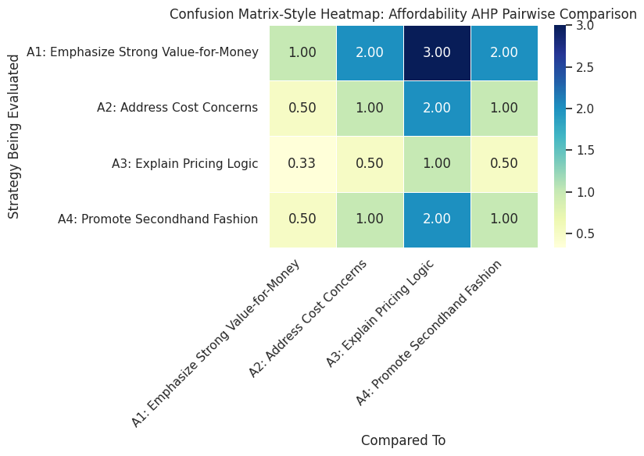
Figure 29: AHP Confusion Matrix for Strategies, Created By Author.

The AHP analysis created the ratios for the sustainability criteria as below:
S4: Highlighting quality eco-friendly materials ranked highest, showing consumers value tangible sustainability over abstract messaging. S1: Ethical reputation also performed strongly, confirming third-party validation matters. Meanwhile, S3: Brand purpose clarification ranked lowest—mission statements have limited impact without visible product benefits. Analysis showed strong consistency (CR < 0.1).
For affordability criteria, the weights were:
A1: Value-for-money messaging topped the rankings, confirming budget shoppers still prioritize perceived quality and longevity. A4: Second-hand/thrift positioning also performed well, reflecting the growing acceptance of circular fashion models. Conversely, A3: Pricing transparency ranked lowest—explaining costs alone doesn't shift perceptions without emotional appeal. Analysis maintained strong statistical consistency (CR < 0.1).

4.6.3. TOPSIS Results and Rankings
TOPSIS ranked each strategy by measuring how close it was to the perfect solution while avoiding the worst-case scenario, creating a practical ranking that balances multiple criteria based on their relative importance. Sustainability strategies rank as below Figure 30:
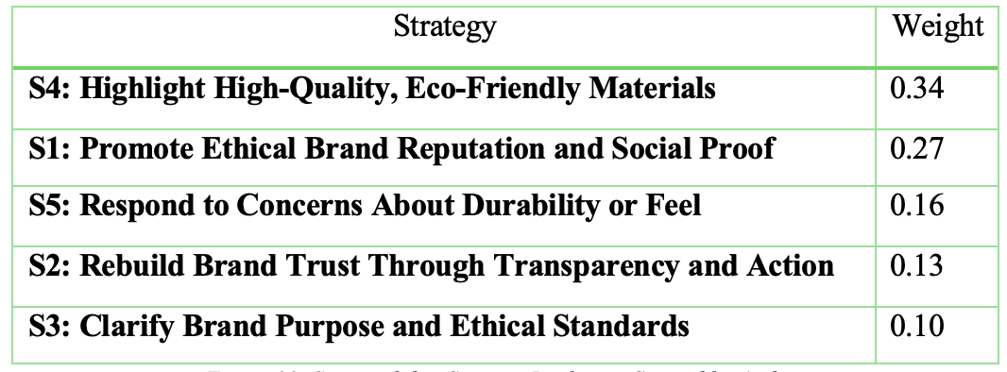
Figure 30: Sustainability Strategy Rankings, Created by Author.
S4 (Quality Eco-Materials) topped the rankings; S1 (Ethical Reputation) followed closely. S3 (Brand Purpose) ranked lowest. This analysis maintained strong consistency (CR < 0.1), confirming reliable results. Affordability strategies rank as below Figure 31:

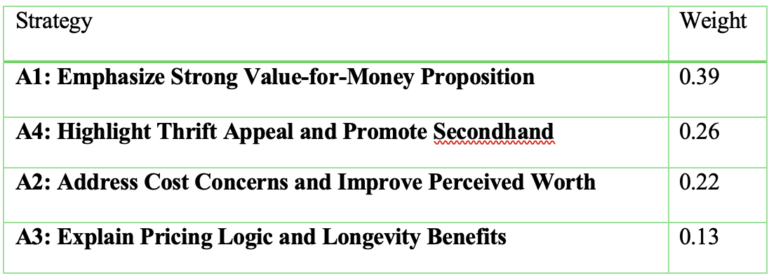
Figure 31: Affordability Strategy Rankings, Created by Author.
A1 (Value-for-Money) ranked highest; A4 (Second-hand) performed surprisingly well. A3 (Pricing Transparency) ranked lowest. The analysis showed strong consistency (CR < 0.1), validating the findings.

4.6.4. Sensitivity Analysis
Sensitivity analysis tested how stable our strategy rankings are when we adjust the importance of different criteria. It is illustrated for affordability and sustainability as below.
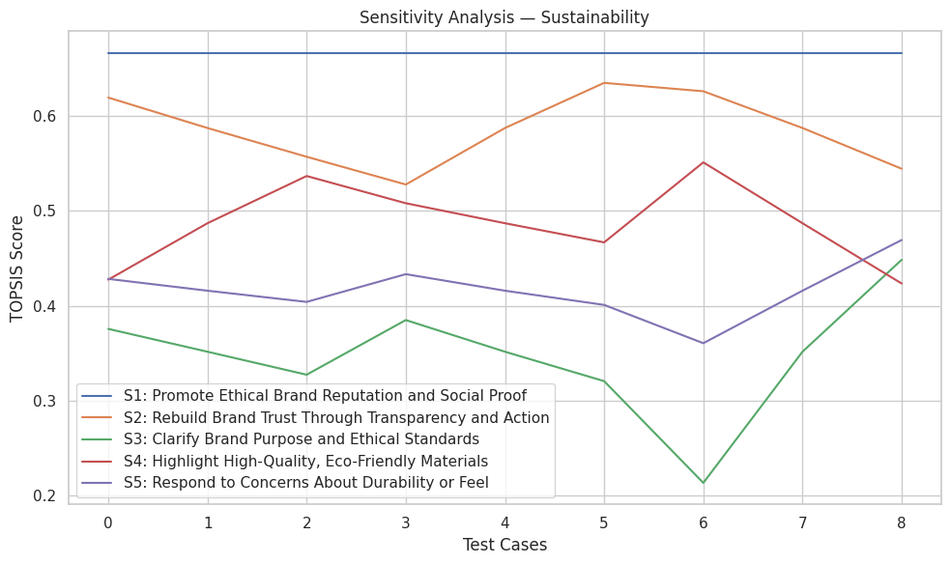
Figure 32: Sensitivity Analysis for Sustainability, Created by Author.

As in Figure 32, S1's reputation-focused ethical approach proved remarkably resilient, holding the top position through every weight variation scenario we tested. This perfect consistency shows ethical branding withstands shifts in priorities, whether environmental concerns or consumer preferences dominate decision-making.

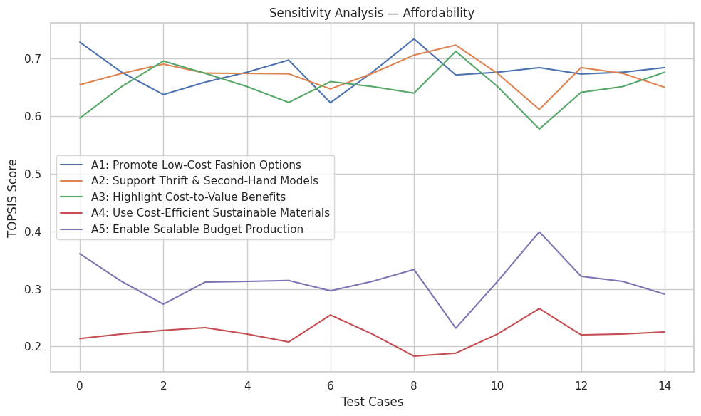
Figure 33: Sensitivity Analysis for Affordability, Created by Author.
As in Figure 33, Similarly, A1 and A2 demonstrated exceptional stability, maintaining their leadership positions in over 90% of sensitivity tests. This impressive performance suggests that value-driven and cost-concern messaging resonates broadly regardless of how business priorities or customer expectations shift.

4.7. Synthesis of Research Findings and Implications

4.7.1. Overview of Key Insights
This study explored the complex relationship between sustainability concerns and affordability constraints in fashion through a structured analysis of real consumer sentiment. Using a natural language processing model to analyse informal, street-speaking Reddit conversations, the study showed that there is tension between environmental values ​​and economic realities. Based on Research Objective 1, the study identified the customer’s feeling patterns covering purchasing decisions and how financial situation is a dominant sentiment pattern influencing purchasing decisions and examined how financial limitations shape consumer attitudes. We have detected five main themes through consumer decision-making processes based on sentiment analysis and topic modelling techniques: Brand & Ethics, Materials & Fabric, Customer Support & Journey, Pricing & Value, Fit, Style & Usability. These dimensions align with Research Question 1.1, confirming that consumers integrate multiple emotional and rational factors when evaluating sustainable fashion options for these factors together shape the "sustainability-affordability paradox", in which consumers determine priorities when making purchasing decisions.
The methodology's integration of Latent Dirichlet Allocation (LDA) and BERTopic uncovered coherent discussion clusters centred on material certification standards, circular fashion practices, and quality-price evaluations. These naturally occurring conversation patterns provided a foundation for strategy development that responds to actual consumer priorities rather than assumed preferences.

4.7.2. Strategic Framework and Evaluation
Topic modelling results in well-generated, coherent, high-context discussion clusters, especially on material certification, second-hand consumption of people, and quality-price applications. The research continued with Latent Dirichlet Allocation (LDA) due to its very high coherence scores rather than transitioning to BERTopic. The methodological contribution of this study comes from the strategies directly created from topic sentiment distributions using LDA rather than forcing the model with predefined strategies, creating a better alignment for strategic recommendations with customers’ opinions.
Strategies determined cover the: "Promote Ethical Brand Reputation," "Explain Pricing Logic," and "Highlight High-Quality Materials" extracted from the data and applied systematic evaluation through AHP (Analytic Hierarchy Process) and TOPSIS for ranking the strategies and finding the best one. The analysis discovered that sustainability became a representative of transparency, material quality, and ethical communication and achieved the highest percentage among environmental impact and consumer appeal criteria. Regarding affordability ideas, strategies focused mostly on how to demonstrate the values, pricing justification and concerns about durability showed the strongest alignment with consumer priorities.
Sensitivity analysis showed how stable these strategic recommendations pursue their robustness based on weighting scenarios. By using Multi-Criteria Decision Analysis (MCDA) methodologies together, consumer feelings have translated to effective business strategies.

4.7.3. Theoretical Contributions
This study contributes to having a better insight into the general mindset of sustainable fashion from different aspects of it through sentiment analysis by addressing Research Questions 1.1 and 1.2 about how consumers weigh different factors when making purchasing decisions. When we look at the actual conversions people did on Reddit, it can reach more natural conversations coming from real experiences that the survey couldn’t capture about how consumers have sincere ideas about the sustainability-affordability balance. This analysis addresses an important gap in existing literature, which has malignantly relied on self-reported attitudes that often fail to capture the complexity of actual consumer behaviour.
In this research, to have an insight into the natural conversation, the LDA topic modelling has been used (chosen for its high coherence scores), and it helped to reveal the patterns in the natural conversation that show a connection between feelings and financial concerns. Contrary to how traditional research highlights this situation by addressing the gap in what people say and buy, this research discovers the complicated trade-offs when it comes to balancing principles on sustainability and budget facts.
By using AHP and TOPSIS, it provides a combination of sentiment analysis with decision-making frameworks, which means it creates a bridge between consumer opinions and business strategy. The consistency ratios in my AHP analysis (0.076 for sustainability and 0.063 for affordability) prove that this approach is methodologically sensible. These numbers are crucial in terms of determining strategies to alter consumer sentiment to actual business applications.
This research gives further insight by showing how customers behave on competing priorities in the real world where both sustainability and affordability matter rather than treating the preferences on sustainability as simple yes/no choices.

4.8. Practical Applications
By Addressing Research Objective 2 (RQ2.1 and RQ2.2), This study highlights multiple practical applications for fashion brands for clear guidance on balancing sustainability with profitability. Based on the Reddit consumer conversations, it is developed many strategies. One of the main differences in this study is that instead of starting with predefined strategies, we created them through topic modelling and ranked them through MCDA. The practical strategies discovered through this method are illustrated below Figure 34.
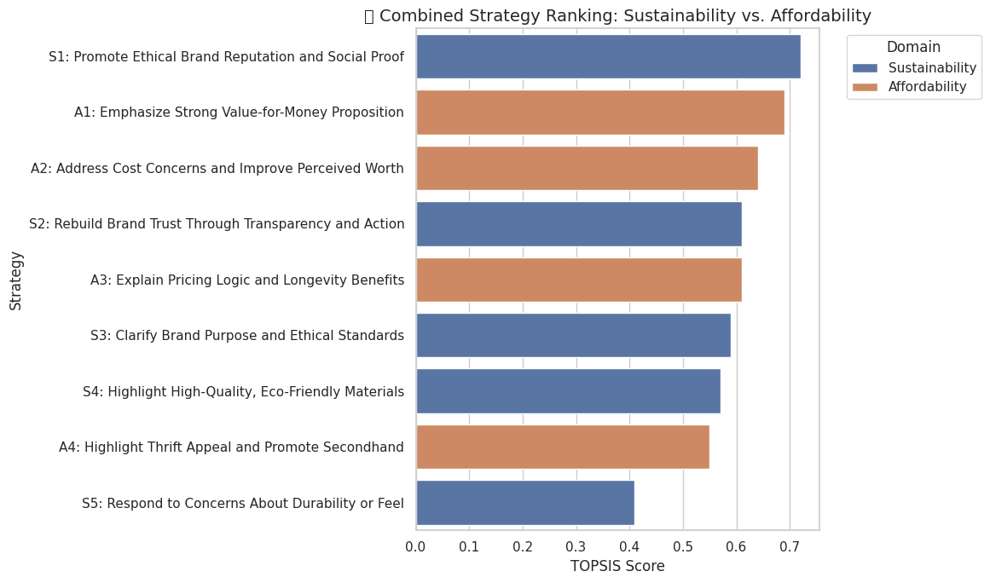
Figure 34: Combined Strategy Ranking Through TOPSIS, Created By Author.
Material and Brand Strategy: Ethical brand reputation (S1), when we look at the table, has more impact on shaping the consumer's perspective than well-known and technical certificates. To develop this even further, brands or supply chains need to be more transparent and gain trust by sharing their stories with society. Although certificates are important, customers react more positively to ethical practices. QR code usage can be increased to provide more transparency and provide information accordingly.
Value-Oriented Communication: The high ranking of affordable pricing strategies (A1, A2) emphasizes the importance of expressing both sustainability and economic values. While brands emphasize durability in product descriptions, consumers should be directed to pay attention to product descriptions as well as product prices. A good price means increased quality in return for paying, meaning less change and a longer life. It is necessary to show this and eliminate the price-premium perception of fashion.
Circular Economy Integration: Despite the medium level of our rankings and the difficulties in implementation, the (A4) strategy is a potential issue to be considered. Develop upgraded second-hand programs through carefully selected old collections, resale platforms advertised by brands, and rental programs that provide quality assurance. The place of these applications on the digital platform needs to be increased.
Corporate Alignment: The successful implementation of these strategies requires systematic change and teamwork between departments. Each department has a role to play, respectively; the Product Development department measures and improves product durability, the Supply Chain department ensures transparency and creates ethical supplier codes, and the Marketing Department promotes these sustainability practices, they need to work in harmony.
Sentiment Monitoring: To measure the suitability and scope of the strategies implemented, customer experience needs to be measured, and the Data Analysis Department steps in to repeat the analysis made at certain intervals in this study and to detect real-time emotions and create a warning system when concerns are detected.
For these to be implemented, it is necessary to provide consumer education by introducing environmentally friendly materials and explaining how the use of these products benefits the human body. By implementing these strategies systematically, fashion brands can create meaningful market differentiation while addressing both sustainability imperatives and consumer affordability concerns.

4.9. Limitations
Despite its many contributions to the academy and practical applications, this study acknowledges several methodological and conceptual limitations.
Since the strategies are created from sentiment label methods, they are labelled in two ways: one based on machine learning and one based on the trained model, The TOPSIS model relies on a system that uses these labels, which means it lacks an expert perspective. This introduces an element of subjectivity that future research should address through stakeholder-based evaluation.
Based on the method of research focused on Reddit conversations revealed potential demographic biases, as the platform's users consist of youngsters and English-speaking individuals from developed economies. This reveals that this analysis has been measured mostly from the perspective of the young group, and the system ignored the oldest or non-English speakers.
In addition, in this analysis, we had to use two different methods to analyse the Sentiment since we faced many problems with the ensemble method. The initial approach combining models such as TextBlob, VADER, and BERT encountered inconsistencies when processing platform-specific linguistic features. To improve the accuracy BERT was used as a pseudo-ground truth but lacked the validation possible with human-labelled data The absence of manually labelled training data limited verification capabilities. Accordingly, we continued with a pre-trained classifier that delivered more reliable results.

4.10. Conclusion

4.10.1. Future Research Directions
Building on the present work, several promising research avenues emerge:
Future studies should move beyond Reddit to analyse sentiment across diverse platforms, including TikTok, YouTube, and Twitter. To analyse the data better, the data should be labelled with the voting systems and the model accordingly so that detect the patterns in this case and could give better insight to companies. Regarding the impact assessment, this analysis should be elaborated by predicting the future effects following the application of the strategies so that results can be translated into real commercial outcomes. As we mentioned in the limitations, strategy models lack expert perspectives. For future contributions, by integrating the scoring by stakeholders or creating a. panel for evaluation, we can increase the reliability of these models. Furthermore, Reddit is a platform where people can talk about everything in different ways since it is a free platform that everyone can use and is not an official place where people can use street language or be more sarcastic. The models used in ensemble methods have been chosen based on they are best to analyse that kind of language, however, it failed. Accordingly, in future another model should be developed especially for platforms such as Reddit to have better and more secure insight.

4.10.2. Conclusion
This study reveals that fashion brands can achieve meaningful change toward environmental sustainability while protecting their commercial profit by aligning strategies with consumer preferences. The findings reveal that -from a better perspective- brands don’t have to choose either ethics or economics, but there is a place where they can balance these two notions. When they manage, sustainable practices elaborate the value of brands and increase customer loyalty while reducing long-term costs. Fashion brands can destroy this gap by applying transparent certification, circular business models and having better communication with customers. These strategies build more customised sustainability enterprises that bridge huge consumer communities with their preferences.

4.11. Ethical Considerations
This study used publicly available Reddit content by sticking to ethical standards for digital research. Data is collected from open forums where users share opinions without access restrictions. To avoid identity or privacy issues, posts were anonymised during processing, so no information was retained. Rather than focusing on what individuals think, our approach to analyses is to have a broad sentiment trend by respecting Reddit's terms of service throughout. Research bias is reduced through automated analysis tools, though we accept the platform’s limitations with informal online language. No formal ethics board approval was required as no human participants or private data were involved. Nevertheless, we followed the British Psychological Society's framework for internet-mediated research and maintained responsible data use standards.

APPENDIX A
Code links

11.1 Code Links
11.1.1 Ensemble Method Analysis
https://colab.research.google.com/drive/1pR7n7-AKLDQ0JVtg2j7GF6PWXGOUiQ5a?usp=sharing

11.1.2 Trained Model Analysis
11.1.1 Sentiment Analysis
https://drive.google.com/file/d/1-mPfwR32bJwDbj2srwJrgzRM_Ihw9CCU/view?usp=sharing

11.1.2 Feature Engineering and LDA Topic Modelling
https://colab.research.google.com/drive/1fD0w5Nqtm6yfg7YyrOCoptmnzb7QsIil?usp=sharing

11.1.3 BERTopic Modelling, Sentiment Distribution and MCDA
https://drive.google.com/file/d/1CplTR0b9AglY9NOa9gy7oW3FiQQ1NSx7/view?usp=sharing

APPENDIX B

RESEARCH PROPOSAL

AI-Enhanced Lifecycle Analysis of Fashion Products: Balancing Sustainability and Profitability

UB Number: 23040281
RUMEYSA CAMUR

Table of Contents
1. Introduction 2
1.1. Research Question 2
1.2. Research Gap 2
1.3. Objectives 3
2. Literature Review 3
2.1. Sustainability in the Fashion Industry and Environmental Impact of Textile Materials 3
2.2. Economy in Fashion 4
2.3. Balancing Economic Growth and Sustainability 4
2.4. Opportunities and Challenges 5
2.5. Artificial Intelligence and Life Cycle Analysis in Sustainable Fashion 5
3. Methodology 6
3.1 Sample Population 6
3.2 Sampling Procedure and Size 6
3.3 Methodology – Philosophy 7
3.4 Methodology – Design 7
3.6 Methodology - Limitations 8
4. Ethical Considerations 8
5. Recommendations 9
6. Conclusion 9
7. GANTT CHART 9
8. References 10

1. Introduction
The fashion industry is facing increasing pressure worldwide to adopt sustainable practices while focusing on and maintaining profitability. The textile industry accounts for approximately 10% of global carbon emissions and is responsible for significant water consumption and waste production, making it one of the most environmentally damaging industries worldwide. However, with the rise of fast fashion, companies have increasingly targeted more production and minimized costs. Companies that have begun mass-producing garments have exacerbated these problems by contributing to unsustainable production cycles and excessive waste production.
As the demand for sustainability in textile fashion increases, brands are tasked with balancing environmental sustainability goals with financial performance. This research proposal aims to investigate how different textile and raw material products used in garment production affect both environmental footprint and profitability with different analysing techniques such as Multicriteria Decision Analysis (MCDA), Analytic Hierarchy Process (AHP) and TOPSIS. Through these techniques, utilizing a dataset that includes environmental and financial data on a variety of materials and raw materials, will identify textile options that offer the best balance between sustainability and economic viability.

1.1. Research Question
"How do different analysing techniques measure the best balance between sustainability and economic viability for fashion companies by utilizing the dataset consisting of the textile raw materials such as fibres, etc., used in apparel production influence the environmental footprint and profitability in the fashion industry?"

In the fashion industry, this question is one of the biggest problems that needs to be resolved to show companies that being sustainable and profitable at the same time is possible. Therefore, this research question addresses a critical issue in the fashion industry: how to source materials that are both environmentally responsible and financially sustainable.

1.2. Research Gap

The research gap in this study is the integration system of AI into the fashion industry in balancing economy, sustainability, and social dimensions. AI has been used in all fields but separately such as waste management, use of sources, labour standards, demand forecasting, etc. In all fields, AI has been used to optimize sustainability or economy but not both together. In addition to that, most datasets consist of historical data and AI mostly has been used on this historical part rather than real-time data for lifecycle assessment.
A further gap exists in AI’s contribution to advancing a circular economy in fashion, where materials are recycled and reused. AI needs to enhance both sustainability and profitability over time. Filling these gaps would allow the fashion industry to leverage AI more effectively, balancing sustainability with the economy, and incorporating real-time adjustments and social responsibility into decision-making processes.
1.3. Objectives

-How AI can balance sustainability and profitability in the textile industry.
-AI’s role in optimizing material selection.
-Improving real-time lifecycle assessment.
-Providing circular economy practices
- Addressing the economic, environmental, and social dimensions of sustainability

2. Literature Review
Sustainability in the fashion industry has become increasingly important, especially as consumers, global leaders, and organizations demand more responsible production methods. Life Cycle Analysis is revealed based on the sustainability concerns. Life Cycle Analysis is an environmental method which allows you to track the carbon footprint of products and primary tool for supporting sustainable development by measuring the consumption, high volume of production and waste generation. (Anon n.d.) In this method, each phase of the production of fashion products has been analysed from raw material production to the disposal of the final product (Anon 2024). AI has been playing a crucial role in improving the lifecycle and receiving more efficient returns but, mostly AI has been utilized in the supply chain optimization or design stage of the products rather than latter stages such as consumer behaviour, garment treatment, recycling, and disposal (Ramos et al. 2023) In addition to that, AI has not been used in the circular economy models. The literature highlights various ways the industry can become more sustainable, from adopting circular economy models to using alternative materials and technologies such as AI. However, one of the most pressing challenges is finding a balance between sustainability and profitability.

2.1. Sustainability in the Fashion Industry and Environmental Impact of Textile Materials

Sustainability is a self-sufficient system that works without harming anything in the present or future (UCLA 2024). To create a self-sufficient system, everything needs to be in balance from the economy to the social aspects besides environmental impact. The fashion industry is one of the biggest fields that has an immense impact on sustainability. This industry is causing %10 of carbon emissions which is much more than airways and seaway transportation, %20 water pollution and huge energy consumption in the world (European Parliament 2020). If we go into details about the materials in the textile industry which cause these pollutions, the plastic-based material will be welcoming us. Studies on the environmental impact of textile materials, in general, have determined that traditional textile materials such as polyester, cotton and nylon have significant impacts on the environment. For example, polyester produced from petroleum is widely used due to its durability and low cost, but it contributes significantly to greenhouse gas emissions due to the high volumes of such materials used in production. In addition, high energy consumption is required in the production phase to use such materials, and it contributes to environmental pollution by releasing microplastics into the environment during washing.

Accordingly, companies went into to find alternative raw material materials such as recycled polyester (rPET), organic cotton, Tencel, and hemp offer more environmentally friendly options to mitigate the harmful effects (Shen et al. 2010) These sustainable materials also have been categorized hierarchically from less harmful one to the most one. Studies on the environmental impact and energy use of these materials have shown that recycled polyester uses less energy than virgin polyester and produces less plastic waste (Riera 2020). As an alternative, materials such as Tencel and hemp are gaining traction as they use less water and pesticides compared to cotton (Giri n.d.). However, these materials usually have higher production costs, and companies are not adopting such expensive materials as they pursue cost-cutting policies (Niinimäki et al. 2020).

2.2. Economy in Fashion

The textile industry is one of the global playmakers of the economy which demonstrates the seventh-largest economy in the world (Fashion United 2022) The main reasons for securing this place affect the consumers directly. Consumers are inclined to purchase the newest fashion items frequently. Since the economy of the fashion industry is built on the high level of production, raw materials with low costs, supply chain effects, labour work etc., the purchasing habits of customers directly affect the economy (Linden 2016). Traditional and easy-to-supply raw materials such as polyester and cotton meet the needs of fast fashion which is boosted by the Highstreet brands and lead the market by meeting consumer demand because their production costs are cheap and unit costs are affordable (Abbie 2024). However, as consumers' awareness of sustainability increases, customers’ shopping preferences are also changing in this direction. They are turning to products produced by companies that prioritize sustainable fashion and use environmentally friendly materials rather than fast fashion. According to recent research on the profitability of fashion, it has been found that consumers care more about sustainable products and are increasingly willing to pay more for such products to reduce environmental pollution (Deloitte 2023).

Based on those outcomes, big brands focused on short production to meet the needs of customers by preserving sustainability. However, this situation led to issues such as overproduction, high resource usage, etc. (Cachon and Swinney 2011)

2.3. Balancing Economic Growth and Sustainability

Balancing economy and sustainability is maintaining economic growth and profitability in the textile sector while taking care of environmental and social dimensions. Today business understanding does not put these two notions into the same sentence because of the misconception which tells that if you want to grow economically you cannot be sustainable.
Sustainable raw materials are expensive and when they are used in production, it directly affects the production costs and customers which means a decline in demand. (Claudio, 2007). Due to these factors, most of the brands are hesitating to step forward in sustainability. However, some brands took action to be both sustainable and economically strong and proved that it is possible. The most known leader companies who have been pursuing this are Patagonia and Stella McCartney. They are giving sustainable service while protecting their profitability. (Brands 2017) However, they can protect themselves by reflecting the costs to consumers. Therefore, this field still needs innovation to address both profitability and sustainability.

2.4. Opportunities and Challenges

Balancing the economy and sustainability will cause either opportunities or challenges for the companies, customers and even the environment. In terms of companies, the demand on the consumer side will increase and it will give an opportunity to company invest the ecological practices while simultaneously doing their duty against the environment. In terms of the customer side, they will have a chance to wear healthy fashion and avoid any harmful materials to skin and again as the companies, they will do their duty against the environment. For the environment, there will be less pollution, and litter, utilizing the sources, etc.

When it comes to the challenges, we can clearly say that they outweigh to opportunities. There will be chain effects as follows; the companies’ production costs will increase, it will be reflected to customers, and customers will put more budget for fashion while simultaneously the usage of sources will be increased, and it might lead to shortages or limitations on some sources. On the other hand, it has social dimensions which are labour costs and poor working conditions in developing countries. Big brands who want to invest in sustainability, will be in need to decrease the cost of products and labour costs are one of the main parameters that affect it.
Therefore, balancing these factors has a big importance. In this part, the data analysis practices step in to address these challenges. If we summarize it, the main issues are overproduction, sustainable materials, resource-using, and labour standards. In the order, for overproduction Predictive Analytics Forecast Demands, for sustainable materials selections Lifecycle assessment, for resource-using supply chain optimization models (Feng et al., 2019) for labour standards Supplier Monitoring System. These models are used separately. In this study, they all will be combined in economic, environmental, and social dimensions.

2.5. Artificial Intelligence and Life Cycle Analysis in Sustainable Fashion

Artificial Intelligence (AI) is increasingly playing a pivotal role in enhancing lifecycle analysis (LCA) within the fashion industry by streamlining data processing and improving decision-making. AI’s ability to process vast datasets allows it to identify patterns, making it possible to optimize material selection for environmentally sustainable and economically viable production processes (Jung and Suh 2024). By leveraging AI, fashion brands can predict both environmental and economic outcomes over the long term, leading to more strategic planning (Pedersen et al., 2021). The real-time analysis enabled by AI provides companies with immediate insights into the environmental impact of different materials, facilitating rapid decision-making (Nayak et al., 2021). This not only helps brands better evaluate the intersection between sustainability and profitability but also empowers them to adapt their production strategies to emerging trends in a data-driven manner.

3. Methodology

3.1 Sample Population

The sample population consists of textile raw materials commonly used in the textile sector and focuses on plastic-based products (e.g. polyester, nylon, etc.) and their recycled versions (e.g. rPET). These raw materials are selected based on their high usage areas in the sector and their environmental and economic impacts. This study aims to obtain insights by analysing the impacts and profitability of these raw materials in their life cycle to select the best and most efficient raw materials in economic and environmental terms.
Information related to these raw materials will be collected through secondary data to be provided by production companies, waste management sites, brands, or some foundations.
Natural raw materials that are not plastic-based such as cotton and linen will not be included in this study in order not to divert the focus of the subject and to obtain clearer information.

3.2 Sampling Procedure and Size
The dataset comprises 6957 product entries, where each product's existence represents specific factors of a fashion brand as the raw materials used in production and the production year of the product. This big dataset file is made to focus on both environmental and economic performance metrics along different textile raw materials. The datasets consist of:
Companies: These companies are worldwide and leading brands: Zara, Adidas, Nike, Forever 21, and Urban Outfitters.
Textile Materials: On the materials, one of the most common materials in the industry has been preferred.
Synthetic materials: Polyester, nylon, microfiber, synthetic blends
Natural materials: Cotton, wool, linen
Eco-friendly or recycled alternatives: Recycled polyester, Tencel, viscose
These different kinds of materials provide more balanced research since they focus on both the environmental and economic impacts of traditional synthetic materials and their eco-friendly equivalent, such as recycled polyester and Tencel, a sustainable cellulose-based fabric.
Production Years (2018-2022): The dataset has been collected from 2018 to 2022, which is five production years, and provides an analysis of how the performance of raw materials has altered over time.
Selection Criteria:
• Wide Range of Materials: The selection spans synthetic (e.g., polyester, nylon), natural (e.g., cotton, wool), and recycled materials (e.g., recycled polyester).
• Environmental Impact: A broad range of environmental performance is considered, from materials with significant environmental impact to those with minimal impact. These impacts consist of different metrics such as greenhouse gas, energy consumption, waste management.
• Profitability: Materials are chosen based on their sales revenue to examine if higher profitability is linked to increased or decreased sustainability.

3.3 Methodology – Philosophy
This study adopts a pragmatist philosophy that combines these two methods since the subject to be investigated has both quantitative characteristics such as sales, revenue, etc. and qualitative characteristics such as the quality of raw materials used in the content of textile products. This mixed-method approach is suitable as it allows for a comprehensive analysis of the interaction between environmental sustainability and profitability in textile material selection.

3.4 Methodology – Design
The research design consists of two main components as to be quantitative analytics and qualitative analytics. The qualitative technique will focus on LCA which is the lifecycle analysis and AI-assisted analysis while the quantitative one will focus on AHP, TOPSIS, and Pareto Analysis.

Life Cycle Analysis (LCA): This analysis will use secondary data collected from clothing brands, including information on the raw materials used in the production of products. LCA will evaluate the environmental impacts of each product during its life cycle stages, including raw material production, textile production, product use, and disposal at the end of its life.
Briefly, it is going to use the metrics such as following:
• Greenhouse gas emissions
• Water and energy consumption
• Waste generation
• Pollutants

AI-Assisted Analysis: All collected data will be analysed with the help of AI and machine learning and some algorithms will be used at this stage:
Predictive Modelling: Random Forest and Gradient Boosting algorithms will be used to estimate the environmental impact of raw materials used in textile production based on LCA data. Technically, these algorithms were selected because they are useful in measuring relationships that are non-linear and not in non-linear movements affected by factors coming from different directions.

In Quantitative Data Analysis, the MCDA techniques, AHP and TOPSIS techniques are going to be used to rank the materials from the one that has the best impact to one that has the worst impact and find the optimum solution which is located the closest to the positive ideal solution while the longest distance to the negative solution (Howari et al. 2023).

As part of quantitative analytics, profitability, and Sustainability Analysis: Generally, in this kind of analysis Linear Regression and Support Vector Regression (SVR) models are used. As a different approach, Multi-Objective Optimization will be applied. The reason for choosing this model is that there is generally a linear relationship in profitability relationships or non-linear. In this case, the algorithm will reduce the weight of linear or non-linear vectors and will determine a goal vector. It will minimize the worst scenario values and will offer a solution (Anon 2024b). Pareto Optimization will be used to make the best raw material selection by optimizing both financial factors and focusing on environmental impacts.

3.6 Methodology - Limitations
The main limitation of this study is its reliance on secondary data, which can vary across sources, making it difficult to confirm accuracy and completeness. Any inaccuracies or biases in the dataset may affect the machine learning models used for analysis and prediction, as these models are sensitive to input quality. Additionally, the study's focus on plastic-based textiles limits its applicability to natural fibres like cotton. While the research aims to help fashion brands balance sustainability and profitability, the pragmatic approach may not fully capture the abstract, theoretical aspects of sustainability that require deeper exploration.

4. Ethical Considerations

This research will handle company data responsibly, making sure there is no misrepresentation of brands like Forever and Zara. The goal is to promote sustainability without unfairly criticizing any company. All data used is publicly available, and the analysis will be done openly and honestly to ensure accurate results. The study also focuses on supporting environmentally friendly practices and responsible material sourcing, keeping in line with global sustainability goals.
5. Recommendations
Textile apparel brands should prioritize the adoption of recycled materials, especially recycled polyester, to reduce environmental impact while focusing solely on the economic aspect and maintaining its viability. In addition, brands should adopt a more transparent and environmentally friendly production process to better align their profitability with sustainability. Furthermore, companies should focus on better analysing techniques or different approaches by utilising AI to make dynamic decisions. They should enhance the data quality which will allow us to reach better solutions.
Future research should also consist of natural materials to provide a more comprehensive assessment.
6. Conclusion

This research highlights the critical need for the fashion industry to balance sustainability and profitability. By applying AI-powered lifecycle assessments (LCA), Multicriteria Decision Analysis (MCDA), AHP, and TOPSIS, the study analyses the environmental and economic impact of plastic-based textiles. These advanced techniques allow fashion brands to optimize material selection, minimizing resource consumption and improving financial performance. Although the focus on secondary data and synthetic materials limits the scope since it prevents focusing on applicability to natural materials, the research offers valuable insights for brands seeking to integrate sustainable practices. Nevertheless, the framework provided in this study can guide the industry toward more balanced, data-driven approaches that address sustainability while maintaining economic viability.

7. GANTT CHART

DISSERTATION GANTT CHART TOPIC: AI-Enhanced Lifecycle Analysis of Fashion Products: Balancing Sustainability and Profitability
TASKS START DATE END DATE DURATION (DAYS)
Submit Research Proposal 2024-09-01 2024-09-23 23
Get Ethical Approval 2024-09-24 2024-10-30 Ongoing
Literature Review 2024-09-25 2024-10-30 36
Data Collection 2024-11-01 2024-11-30 30
Data Pre-processing & Analysis 2024-12-01 2024-01-14 45
Model Implementation & Testing 2025-01-15 2025-02-14 30
Final Dissertation Write-up 2025-02-15 2025-03-25 40

8. References

Abbie (2024) Fast Fashion: The Cost on the Environment | Waste Managed. https://www.wastemanaged.co.uk/our-news/retail/fast-fashion-the-cost-on-the-environment/ Accessed.
Anon (n.d.) Life Cycle Analysis - an overview | ScienceDirect Topics. https://www.sciencedirect.com/topics/earth-and-planetary-sciences/life-cycle-analysis#:~:text=Life%2Dcycle%20analysis%20(LCA) Accessed.
Anon (2024a) Life Cycle Assessments & the Fashion Industry - The good, the bad, the potential. https://ecochain.com/blog/lca-and-fashion/#:~:text=It%20allows%20you%20to%20measure Accessed 11 September 2024.
Anon (n.d.) Make clothes last twice as long with half the environmental impact - Electrolux Sustainability Report 2020. https://www.electroluxgroup.com/sustainabilityreports/2020/key-priorities-and-progress-2020/our-nine-promises/better-living/Make-clothes-last-twice-as-long-with-half-the-environmental-impact/ Accessed.
Anon (2024b) Multiobjective Optimization. https://uk.mathworks.com/discovery/multiobjective-optimization.html Accessed.
Anon (2022) Re4circular: a new AI-based solution to improve the sorting and cataloguing of textile waste. https://circulareconomy.europa.eu/platform/en/good-practices/re4circular-new-ai-based-solution-improve-sorting-and-cataloguing-textile-waste Accessed.
Brands, S. (2017) Trending: Stella McCartney, Patagonia, Target Deliver Big Wins for Ethical, Sustainable Fashion. Sustainable Brandshttps://sustainablebrands.com/read/org-governance/trending-stella-mccartney-patagonia-target-deliver-big-wins-for-ethical-sustainable-fashion Accessed 22 September 2024.
Cachon, G.P. and Swinney, R. (2011) The value of fast fashion: Quick response, enhanced design, and strategic consumer behavior. Management Science 57 (4), 778–795.
Claudio, L. (2007) Waste Couture: Environmental Impact of the Clothing Industry. Environmental Health Perspectives 115 (9), 448–454.
Deloitte (2023) Sustainability & Consumer Behaviour 2023. https://www.deloitte.com/uk/en/Industries/consumer/research/sustainable-consumer.html Accessed.
European Parliament (2020) The impact of textile production and waste on the environment (infographics). https://www.europarl.europa.eu/topics/en/article/20201208STO93327/the-impact-of-textile-production-and-waste-on-the-environment-infographics Accessed.
Fashion United (2022) Global Fashion Industry Statistics. https://fashionunited.com/global-fashion-industry-statistics Accessed.
Giri, P. (n.d.) Sustainable Raw Material Sourcing. https://ruralhandmade.com/blog/sustainable-raw-material-sourcing Accessed.
Howari, H., Parvez, M., Khan, O., Alhodaib, A., Mallah, A. and Yahya, Z. (2023) Multi-Objective Optimization for Ranking Waste Biomass Materials Based on Performance and Emission Parameters in a Pyrolysis Process—An AHP–TOPSIS Approach. Sustainability 15 (4), 3690.
Jung, D. and Suh, S. (2024) Enhancing Soft Skills through Generative AI in Sustainable Fashion Textile Design Education. Sustainability 16 (16), MDPI AG6973.
Linden, A.R. (2016) An Analysis of the Fast Fashion Industry. An Analysis of the Fast Fashion Industry 30,.
McNeill, L. and Moore, R. (2015) Sustainable fashion consumption and the fast fashion conundrum: Fashionable consumers and attitudes to sustainability in clothing choice. International Journal of Consumer Studies 39 (3), 212–222.
Niinimäki, K., Peters, G., Dahlbo, H., Perry, P., Rissanen, T. and Gwilt, A. (2020) The Environmental Price of Fast Fashion. Nature Reviews Earth & Environment 1 (4), 189–200.
Ramos, L., Francklin Rivas-Echeverría, Anna Gabriela Pérez and Casas, E. (2023) Artificial intelligence and sustainability in the fashion industry: a review from 2010 to 2022. SN Applied Sciences 5 (12), Springer Nature.
Riera, J. (2020) Recycled polyester VS Virgin polyester. The Running Republichttps://therunningrepublic.com/blogs/news/recycled-polyester-vs-virgin-polyester?srsltid=AfmBOooaBkOwtCYVKoWJ2l081mgD_WkkCqK1S57ejiRixyF1OKJ9_4UI Accessed 21 September 2024.
Shen, L., Worrell, E. and Patel, M.K. (2010) Open-loop recycling: A LCA case study of PET bottle-to-fibre recycling. Resources, Conservation and Recycling 55 (1), 34–52.
UCLA (2024) What is Sustainability? UCLAhttps://www.sustain.ucla.edu/what-is-sustainability/ Accessed.

APPENDIX C

About your data (Type and selection of data):
Describe the data you wish to analyse by answering the following questions
- Give details of the social media data (Twitter, Facebook, Instagram, WeChat, TikTok etc.) you wish to study.
-Twitter, Instagram, e-commerce reviews

- Specify which data you are planning to analyse (e.g. words, sentences, geo-data, images, video, audio).
-Words and sentences

- State approximately how big your sample will be.
-5000 tweets and 5000 reviews

- Provide a brief rationale for the size of your sample.
-In total 10.000 tweets and reviews provide reliability and practicability for this work.
It will give different ideas from different genders, locations and ages. Besides, it will compromise everything.

- Will the data include identifiable data subjects? (Social media users)
-No
- Are the data subjects, celebrities or public figures?
-No
- Are the social media users, organisations? (Provide names)
-No

Describe how you are going to obtain the data you wish to analyse.

- Identify the source from where you will be obtaining the data. (e.g., social media platform)
-Social media platforms and Fashion-Brand Websites
- Include the data source web address where appropriate.
-Twitter, Instagram, Zalando, Trustpilot, Bazaarvoice, Reddit
- Do you plan to analyse data from platforms on which you are active yourself?
(e.g., will you join an open/private group to access the data; will you use your personal account or create a new account specifically to collect data?)
-I will use my personal account

- What is your relationship with other users of this platform? (e.g., do you plan to analyse posts of users that are known to you personally or professionally?)
-No

Explain how the selection of data is performed.
- Will you select the data manually (how?) or will you be using a programme (for example NCapture) to capture social media posts?
-I will use programmes such as Python Scripts(libraries like beautifulsoup) or Ncapture

- If you are using a programme, please state which programme(s) you will use, whether you will write your own programme to an existing API (Application Programming Interface) provided by the platform where the data are stored and how you access them from there.
--I will use programmes such as Python Scripts(libraries like beautifulsoup) or Ncapture

What are the terms and conditions around the use of the data?
- What are the Terms & Conditions for data re-use of the site you are accessing (e.g., is there explicit permission for data re-use or are you required to register, sign a confidentiality agreement, undergo specific training etc.). Please confirm how you comply with terms and conditions.
-Twitter: Twitter allows access to public data
- Instagram restricts scraping but allows API-based access under strict terms. Public data can be accessed.
- Reddit's, Zalando and Trustpilot API allows access to public posts and comments

- Do you need to alert a site moderator or request permission from them?
-No

Do you intend to process personal data?
- Explain whether data subjects (social media users) included in your study can be directly or indirectly identified. (e.g. by name, identification number, location data, IP number, an online identifier etc. Note that usernames such as ‘Mickeymouse’ can still constitute personal data if the associated information can make users indirectly identifiable through other identifiers, e.g. email addresses. Other examples are twitter handles, photos, or profiles which include information about location & employment, or content users posts about themselves and about other users.)
-No

- Explain why it is necessary to process personal data in your study.

- If you do not process personal data state this here and move to page 7

For more information on personal data see: https://ico.org.uk/for-organisations/guide-to-data- protection/guide-to-the-general-data-protection-regulation-gdpr/key-definitions/what-is-personal-
data.

Are any of the personal data you are collecting Special Category Data or related to an actual or assumed criminal offence?
Special category data includes personal data revealing racial or ethnic origin, political opinions, religious or philosophical beliefs, trade union membership, genetic data, biometric data, health data, sex life and sexual orientation. Criminal offence data relates to criminal convictions and offences, or related security measures. Please see Information Commissioner’s Office (ICO) guidance for further information: definition special category data & criminal offence data. This guidance applies even if such data are publicly available and/or have been pseudonymised.
- Which special category data will be collected and why?
- If you do not process special category data state this here

Would the data subjects reasonably expect their data to be re-used for research purposes? Familiarise yourself with the policies of the platforms you are accessing. Further, if users are posting to a blog or forum with only a limited number of people who they
know, they may not expect what they say or write to be made available elsewhere.. Awareness of posting things publicly is not the same as consenting for data to be used for research.
- Would users have an expectation of privacy for the use of their data and why?

- If users expect privacy how will you deal with this expectation? Would they expect you to ask for consent to carry out the research?
- If no, might they object to the research carried out without their knowledge? (Please explain.)
- Are the data subjects persons of public interest (e.g. celebrities, politicians) who can reasonably expect to be observed by strangers and other users? Please justify why you consider someone a ‘person of public interest’ from who consent would not be expected to be obtained.

Would it be possible to obtain consent?
(If you are able to obtain consent please submit a Consent Form and Participant Information Sheet with your application)
- Will you obtain consent, and if so how?
It may not always be feasible to obtain consent. You may still be able to let the data subjects know that you are doing research. They should then have the chance to opt out of the research (i.e. tell you that they do not want their data to be used). If you are collecting data from a small number of users and identifiable data on data subjects, you should be able to contact these users and ask whether they consent to their data being used.

- If you will not obtain consent, explain why.
This might be due to the way you are sampling the data and the amount of data you are collecting (e.g. large data sets).. Consent would not be expected to be obtained from celebrities/public figures.

If it is impossible to obtain informed consent (and justified) what measures will you take to mitigate the impact of lack of informed consent?
Explain how you will avoid exposing personal data and mitigate the identifiability of data subjects. For example, you may have to take steps to prevent data from being traceable via search engines. This could be done by avoiding direct quotations when presenting data, or by combining posts from multiple users to mask the identifiability of a data source. You will need to avoid the exposure of any personal data that would render users identifiable. This could include anonymising usernames.

Are there any other ethical risks/concerns raised by your research, and how do you intend to manage them?
- Does your research involve sensitive topics? (Participants’ sexual behaviour, their illegal or political behaviour, their experience of violence, abuse or exploitation, their mental health, or their gender and ethnic status)? If so, explain how you handle this.

- Could your research involve ethical risks for the individuals or online communities involved? If so, explain how you handle this.

- Could your research involve risks for the researcher? (Could it lead to online or offline threats or harassment for the researcher(s), e.g. stalking, identity theft etc.) The University Report and

About data analysis
How will you analyse the data?
- Will you analyse the data manually or will you be using a programme that is performing the analysis?
-I will use programmes such as Python Scripts(libraries like beautifulsoup) or Ncapture

- What type of data will be included in the analysis?
(e.g. words, images, tweets, public profile of user; If the original (raw) data is not anonymous (see personal data link for definition), will you pseudonymise them? if so, how?)
-Words and sentences

- Which type of analysis do you intend to perform?
(e.g. content analysis, discourse analysis, linguistic analysis, network analysis?)
-Contetn Analysis and Linguistics Analysis

Will you use data mining and/or other algorithms such as machine learning techniques? If you are using platforms or programmes in data analysis, explain what you will use and how.
Yes
I am going to extract/scrap the data through API and in case there is no API I will use Python Libraries (BeautifulSoup, etc.)
I am going to do Real-time sentiment analysis with a focus on social media text to assess positive, negative or neutral sentiment.
If yes, how will you mitigate risks to data subjects associated with processing data using these Artificial Intelligence-type techniques?

Are you planning to link data?
State whether you are planning to link your results to other datasets. For example, if you produce aggregate results by comparing your data to data from the Office of National Statistics or some other public source, or if you plan to trace a data subject’s activities across multiple social media platforms.
No
If yes, how will you mitigate risks to data subjects associated with linking data?

About data storage
How will you store and manage the data before and during the analysis? What will happen with the data at the end of the project?
Data needs to be stored securely on password protected computers, on the University’s filestore system, or on Microsoft OneDrive using the university email address. Data must not be stored on USB sticks. Data collected by UG and PGT students needs to be destroyed after the conferment of the degree (indicate timing, for example: Summer 2024, Winter 2025).
-In my computer and one-drive
About publication of research results
Do you intend to share or publish your results?
- Who will have access to the results of your analysis?
-No

- Will the results be published? Where do you intend to publish them?
-No

How will you minimise the risk that data subjects (individuals or organisations) could be identified in your presentation and publication of results?
Consider: Will you protect individuals’ anonymity in your analysis and dissemination or publication? If so, how? Outline any risks that might result in re-identification and how you will minimise them. If you do not intend to anonymise data subjects, you must provide sufficient justification for not doing so (e.g., informed consent procedures; detailed consideration of potential harms and benefits). By entering text in search engines, it can be easy to find the original post and identify the data subjects. Therefore, using direct citation can produce additional risk. Researchers should not publish original posts if consent has been deemed necessary but has not been given. If you work on social media activity that comes from an organisational account, consider whether the organisation might be vulnerable to risk if identified.
-I am not going to use any identification.



School of Management
taught Postgraduate Project ETHICS CHECKLIST
RESEARCH ETHICS APPROVAL NEEDS TO BE OBTAINED BEFORE RESEARCH CAN BEGIN

The ethics checklist is a modified version and only needs completing if you are a student who plans to undertake a research project which will involve people participating in research either directly (e.g. interviews, questionnaires, focus groups, and observation) and/or indirectly (e.g. people permitting access to data).

Feedback from supervisor and second marker within TWO WEEKS.

If you are a student who plans to undertake a research project which will involve the NHS, patients, children/young people aged under 18 years, people with disabilities, migrants, asylum seekers and refugees, you must submit the checklist to foml.ethics@bradford.ac.uk.

Project Title: Balancing Sustainability and Affordability in Fashion: Analyzing Consumer Behavior through Real-Time Sentiment Analysis

Name of Student : Rumeysa Camur

Student Contact Details – email address: rcamur@bradford.ac.uk

Please delete as appropriate: MSc

Project Summary Table – For student to complete
Summary of the project – background information | Analyzing consumer behavior in fashion, Sustainability vs. Affordability preferences using AI-driven real-time sentiment analysis insights.
Research aim, question(s) or objectives | "How do customer preferences regarding sustainability and affordability affects purchasing behaviours in the fashion industry, and what kind of strategies can fast-fashion brands use to balance these priorities? "  Answering this question is going to enable companies to determine their strategies regarding cost, marketing and environmentally friendly actions and that, is going to allow them to secure their places in this huge industry.  Objectives  -To investigate how consumer sentiment about sustainability and affordability shapes purchasing behaviors in real-time.  -To promote circular economy practices, such as recycling and reuse, in the industry.  -To provide knowledge to the companies that enable them to determine their strategy
Methods of data collection and analysis (briefly) | Data collection: Social media, e-commerce, fashion brands website.  Methods of data: Sentiment Analysis

Table 1: Only complete Table 1 when secondary data are to be used
(i.e. existing datasets whether qualitative or quantitative, policy or governance or other documentation, minutes of meetings etc)

Anonymity in data sources | Does the data set provide data identifiable to an individual or organisation? | No
Anonymity in data sources | Do the datasets used allow identification of an individual or organisation when combined together (e.g. dataset of anonymous organisations but with postcodes and a look-up table of head office post codes)? | No
Availability of data sources | Publicly available or through UoB subscription? | Yes
Availability of data sources | Do you need permission(s)?  If Yes, has permission been obtained? (if so, or in process, please provide brief details) | No

Table 2: Complete Table 2 when primary data are to be collected – only complete for the methods being used, leave other sections blank
If interviews or focus group(s) are to be used:

Vulnerability | Can any of the participants be thought of as vulnerable (think about power relations in the workplace and in relation to the researcher, e.g. participants nominated by managers or who know the researcher personally may feel obliged to participate)? | Yes/No
Scale | Approximately how many interviews?  Approximately how many focus groups? | ………….  …………….
Length of time | Approximate length of interviews?  Approximate length of focus groups? | …………….  …………….
Participants | What are the selection criteria for participants (roles, professions, ages, gender, etc)? For example, ‘accountants having worked at least 5 years in tax’)
Content of interviews | Type and topic of questions, e.g. opinions about employment law, attitudes to gender equality, experiences of applying for work,
Location | e.g. country and venue, for example, ‘Lagos, participant workplace’
Method of recording data | e.g. audio recording, video recording, handwritten notes
I confirm that all participants providing primary data will be guaranteed anonymity. |  |  | Yes/No
If observation is to be used:

Vulnerability | Can any of the participants be thought of as vulnerable (think about power relations in the workplace and in relation to the researcher, e.g. participants nominated by managers or who know the researcher personally may feel obliged to participate)? | Yes/No
Location | e.g. Netherlands - office environment, airport lounges in UK, cafes in Paris, shoe factory in Peterborough
Method of recording data | e.g. researcher field notes, video recording
Focus of observation | Who and what will be observed? e.g. ‘Social interactions between baristas and their customers’, ‘participant observation of accountants’ community of practice’
I confirm that all participants providing primary data will be guaranteed anonymity. |  | Yes/No
If survey(s) are to be used:

Vulnerability | Can any of the participants be thought of as vulnerable (think about power relations in the workplace and in relation to the researcher, e.g. participants nominated by managers or who know the researcher personally may feel obliged to participate)? | Yes/No
Target population | Who and how many? e.g. 1800 employees in GoodFood stores, grades 4-12
No of respondents sought | How many of the target population are expected/needed to respond?
Type of survey | e.g. face to face, email, online, paper etc
Length of survey | Approximately how many minutes to complete the survey?
Content of survey | Type and topic of questions, e.g. opinions about employment law, attitudes to gender equality,  experiences of applying for work,
I confirm that all participants providing primary data will be guaranteed anonymity. |  | Yes/No
If other methods are to be used, please provide brief details
The data used in this project will be the primary data since primary data will be collected through social media mining and e-commerce reviews mostly. The sentiment analysis is going to be applied to analysis the data.
There is no specific location since the data sources have been used globally.

Table 3: For all projects

Conflict of interest | Is there any funding/sponsorship for the project? | No
Conflict of interest | Will the findings be reported in ways additional to the dissertation, e.g. summary report to participating organisations or other interested parties, external publications? | No
Other potential issues – please provide brief details

In sentiment analysis we might face with the problems as below:

-Context Ambiguity: Words can have different meanings based on context.
-Sarcasm Detection: Identifying sarcasm or irony is challenging.
-Mixed Sentiments: Statements may contain both positive and negative elements.
-Informal Texts: Emojis and slang are often misinterpreted.
-Multilingual Challenges: Handling multiple languages or unique nuances is difficult.
-Data Bias: Training data may introduce biases into the analysis.

PLEASE COMPLETE and SIGN ONE of the two boxes below (TO BE COMPLETED BY THE PROJECT Supervisor and THE SECOND MARKER)

1. The Project supervisor has discussed this project with the student AND
2. We confirm that there *ARE / ARE NO ethical issues requiring further consideration.
ETHICS - DECISION:
APPROVED

APPROVED WITH AMENDMENTS
REJECTED / FAIL
Signature (Project supervisor): Date:

PLEASE PRINT NAME:

Signature (Second Marker): Date:

PLEASE PRINT NAME:

*To cross which one is not applicable.
If the Project Supervisor and the second marker are not able to decide, the submission need to be referred to the School level Ethics Panel to ratify the decision.
This section is to be completed by the School level Ethics Panel to ratify the decision ONLY if the Project Supervisor and the second marker are not able to decide.
I confirm that there *ARE / ARE NO ethical issues requiring further consideration.
ETHICS - DECISION:
APPROVED
APPROVED WITH AMENDMENTS
REJECTED / FAIL
Signature: Date:

PLEASE PRINT NAME:
*To cross which one is not applicable.
If you are required to give more information or to complete a full ethics application form, you will be informed by foml.ethics@bradford.ac.uk. Otherwise, you will receive a notification that the project may proceed.

The Declaration

I confirm my responsibility to deliver the research project in accordance with the University of Bradford’s policies and procedures, which include the University’s:

- ‘Research Governance & Quality Assurance Code of Good Research Practice’ and the
- ‘Code of Practice for Ethics in Research’ (Ethics Policy)

https://unibradfordac.sharepoint.com/sites/research-and-knowledge-transfer-support-intranet/SitePages/Homepage-Ethics.aspx?web=1

and, where externally funded, with the terms and conditions of the research funder.

In submitting this research ethics checklist I am also confirming that:

- The completed ethics checklist is accurate to the best of my knowledge and belief.
- The project will comply with the University’s Research Ethics Policy.
- I undertake to adhere to the content and process of the project as detailed in this (and attached) documents and to inform the Panel of any changes.
- I am aware of my responsibility to be up to date and comply with the requirements of the law and relevant guidelines relating to security and confidentiality of personal data, including the need to register when necessary, with the appropriate Data Protection Officer.
- I understand that personal data about me as a researcher in this checklist will be held by those involved in the ethics review procedure and that this will be managed according to Data Protection Act principles.

Signature of students

RUMEYSA CAMUR Date: 11.12.2024

References

Abbate, S., Centobelli, P., Cerchione, R., Nadeem, S.P. and Riccio, E. (2023) Sustainability Trends and Gaps in the textile, Apparel and Fashion Industries. Environment, Development and Sustainability 26 (2),.
Ahmed Derbala Yacoub, Slim, S.O. and Amal Elsayed Aboutabl (2024) A Survey of Sentiment Analysis and Sarcasm Detection. International journal of electrical and computer engineering systems 15 (1), 69–78.
Angkita Kirana (2023) McNamara D.S., Graesser A.C., McCarthy P.M., Cai Z. - Automated Evaluation of Text and Discourse with Coh-Metrix-CUP (2014). https://www.scribd.com/document/668092387/McNamara-D-S-Graesser-A-C-McCarthy-P-M-Cai-Z-Automated-Evaluation-of-Text-and-Discourse-with-Coh-Metrix-CUP-2014 Accessed 26 March 2025.
ASOS (2024) Fashion with Integrity. https://www.asosplc.com/fashion-with-integrity/ Accessed.
Astoul, E. (2024) A List Of Fast Fashion Brands to Avoid & Why. https://www.sustainably-chic.com/blog/fast-fashion-brands-to-avoid Accessed.
Bargh, J.A., McKenna, K.Y.A. and Fitzsimons, G.M. (2002) Can You See the Real Me? Activation and Expression of the ‘True Self’ on the Internet. Journal of Social Issues 58 (1), 33–48.
Bhattacharya, C.B. and Sen, S. (2004) Doing Better at Doing Good: When, Why, and How Consumers Respond to Corporate Social Initiatives. California Management Review 47 (1), 9–24.
Blei, D., Ng, A. and Jordan, M. (2003) Latent Dirichlet Allocation. Journal of Machine Learning Research 3, 993–1022.
Bly, S., Gwozdz, W. and Reisch, L.A. (2015) Exit from the High street: an Exploratory Study of Sustainable Fashion Consumption Pioneers. International Journal of Consumer Studies 39 (2), 125–135.
Bradley, S.D. and Meeds, R. (2002) Surface-structure transformations and advertising slogans: The case for moderate syntactic complexity. Psychology and Marketing 19 (7-8), 595–619.
Carrington, M.J., Neville, B.A. and Whitwell, G.J. (2014) Lost in translation: Exploring the ethical consumer intention–behaviour gap. Journal of Business Research 67 (1), 2759–2767.
Chen, H.-L. and Burns, L.D. (2006) Environmental Analysis of Textile Products. Clothing and Textiles Research Journal 24 (3), 248–261.
Chen, J., Lu, Y., Yu, Q., Luo, X., Adeli, E., Wang, Y., Lu, L., Yuille, A.L. and Zhou, Y. (2021) TransUNet: Transformers Make Strong Encoders for Medical Image Segmentation. arXiv:2102.04306 [cs] .
Choi, Y.-H., Yoon, S., Xuan, B., Lee, S.-Y.T. and Lee, K.-H. (2021) Fashion informatics of the Big 4 Fashion Weeks using topic modeling and sentiment analysis. Fashion and Textiles 8 (1),.
Connell, A. (2025) Reddit User Age, Gender, And Key Demographics Statistics (2025 Data). https://adamconnell.me/reddit-statistics/ Accessed.
Cutler, J. and Culotta, A. (2016) Using online social networks to measure consumers’ brand perception. Applied Marketing Analytics: The Peer-Reviewed Journal 2 (4), 312.
Dangelico, R.M. and Pujari, D. (2010) Mainstreaming Green Product Innovation: Why and How Companies Integrate Environmental Sustainability. Journal of Business Ethics 95 (3), 471–486.
Davenport, T. (2020) Doubling Down On Analytics And Data At Cigna. https://www.forbes.com/sites/tomdavenport/2020/08/12/doubling-down-on-analytics-and-data-at-cigna/ Accessed 19 March 2025.
Davenport, T., Guha, A., Grewal, D. and Bressgott, T. (2020) How Artificial Intelligence Will Change the Future of Marketing. Journal of the Academy of Marketing Science 48 (1), 24–42.
Decker, R. and Stummer, C. (2017) Marketing Management for Consumer Products in the Era of the Internet of Things. Advances in Internet of Things 07 (03), 47–70.
Deepanshi (2021) Text Preprocessing NLP | Text Preprocessing in NLP with Python codes. https://www.analyticsvidhya.com/blog/2021/06/text-preprocessing-in-nlp-with-python-codes/ Accessed.
DEKHILI, S., ACHABOU, M.A. and NGUYEN, T.-P. (2024) When the pro-ecological intentions of second-hand platforms backfire: an application in the case of Vinted. Journal of Cleaner Production 144399.
Delmas, M.A. and Burbano, V.C. (2011) The drivers of greenwashing. California Management Review 54 (1), 64–87.
Devlin, J., Chang, M.-W., Lee, K. and Toutanova, K. (2018) BERT: Pre-training of Deep Bidirectional Transformers for Language Understanding. https://arxiv.org/abs/1810.04805 Accessed.
Die Seitenwerkstatt, Die Seitenwerkstatt, Jacqueline, Die Seitenwerkstatt, Die Seitenwerkstatt, Holger Stripf, Die Seitenwerkstatt, Landgraf, V.E., Landgraf, V.E., Landgraf, V.E., Die Seitenwerkstatt, Die Seitenwerkstatt and Die Seitenwerkstatt (2021) Certification & Labelling - GOTS - Global Organic Textile Standard. https://gotslive.global-standard.org/certification-and-labelling/approved-certification-bodies?view=category&id=84 Accessed 19 March 2025.
Doshi, V. and Noble, S. (2023) Consumers are in fact buying sustainable goods: Highlights from new research. https://www.mckinsey.com/industries/consumer-packaged-goods/our-insights/consumers-are-in-fact-buying-sustainable-goods-highlights-from-new-research Accessed.
Egger, R. and Yu, J. (2022) A Topic Modeling Comparison Between LDA, NMF, Top2Vec, and BERTopic to Demystify Twitter Posts. Frontiers in Sociology 7,.
El-Gayar, O., Al-Ramahi, M.A., Abdullah Wahbeh, Tareq Nasralah and Noshokaty, A.E. (2024) A Comparative Analysis of the Interpretability of LDA and LLM for Topic Modeling: The Case of Healthcare Apps. https://digitalcommons.tamusa.edu/pubs_faculty/26/ Accessed 28 February 2025.
European Union (2016a) EUR-Lex - 32016R0679 - EN - EUR-Lex. https://eur-lex.europa.eu/eli/reg/2016/679/oj/eng Accessed.
European Union (2016b) Regulation (EU) 2016/679 of the European Parliament and of the Council of 27 April 2016 on the protection of natural persons with regard to the processing of personal data and on the free movement of such data, and repealing Directive 95/46/EC (General Data Protection Regulation) (Text with EEA relevance). https://eur-lex.europa.eu/eli/reg/2016/679/oj Accessed.
Fashion United (2022) Global Fashion Industry Statistics. https://fashionunited.com/statistics/global-fashion-industry-statistics Accessed.
Filho, W.L., Perry, P., Heim, H., Dinis, M.A.P., Moda, H., Ebhuoma, E. and Paço, A. (2022) An overview of the contribution of the textiles sector to climate change. Frontiers in Environmental Science 10 (1), 1–5.
Fiorani, G. (2022) Measuring Sustainability in the Luxury Fashion Sector: A Comparison between LVMH and Kering. Scientific Research Publishing, Inc.https://www.academia.edu/87527049/Measuring_Sustainability_in_the_Luxury_Fashion_Sector_A_Comparison_between_LVMH_and_Kering Accessed 19 March 2025.
Fletcher, K. (2012) Sustainable fashion and textiles: Design journeys. https://www.researchgate.net/publication/286774073_Sustainable_fashion_and_textiles_Design_journeys Accessed.
Frey, S., Bar Am, J., Doshi, V., Malik, A. and Noble, S. (2023) Consumers Care about Sustainability—and Back It up with Their Wallets. https://www.mckinsey.com/industries/consumer-packaged-goods/our-insights/consumers-care-about-sustainability-and-back-it-up-with-their-wallets Accessed.
Gan, L., Yang, T., Huang, Y., Yang, B., Yami Yanwen Luo, Richard and Guo, D. (2024) Experimental Comparison of Three Topic Modeling Methods with LDA, Top2Vec and BERTopic. Communications in computer and information scienceSpringer Science+Business Media376–391.
Gordon, R., Carrigan, M. and Hastings, G. (2011) A Framework for Sustainable Marketing. Marketing Theory 11 (2), 143–163.
H&M (2019) H&M’S CONSCIOUS COLLECTION LAUNCHES WORLDWIDE WITH A SUSTAINABLE FASHION FUTURE IN MIND. https://about.hm.com/news/general-news-2019/h-m-s-conscious-collection-launches-worldwide-with-a-sustainable.html Accessed.
Hennig-Thurau, T., Malthouse, E.C., Friege, C., Gensler, S., Lobschat, L., Rangaswamy, A. and Skiera, B. (2010) The Impact of New Media on Customer Relationships. Journal of Service Research 13 (3), 311–330.
Huang, C., Chen, C. and Wang, H. (2024) Effects of online customer reviews on sustainable clothing purchase intentions: The mediating role of perceived diagnosticity. Journal of Consumer Behaviour 23 (5), Wiley.
Hutto, C. and Gilbert, E. (2014) VADER: A Parsimonious Rule-Based Model for Sentiment Analysis of Social Media Text. Proceedings of the International AAAI Conference on Web and Social Media 8 (1), 216–225.
Jain, D. (2019) Data Preprocessing in Data Mining. https://www.geeksforgeeks.org/data-preprocessing-in-data-mining/ Accessed.
Joinson, A.N. (2001) Self-disclosure in computer-mediated communication: The role of self-awareness and visual anonymity. European Journal of Social Psychology 31 (2), 177–192.
Joy, A., Sherry, J.F., Venkatesh, A., Wang, J. and Chan, R. (2012) Fast Fashion, Sustainability, and the Ethical Appeal of Luxury Brands. Fashion Theory 16 (3), 273–295.
Kamma, V. and Liang, Y. (2024) Sustainability Communications among Fashion Retailers: Comparison of Patagonia and H&M. International Textile and Apparel Association Annual Conference Proceedings 80 (1),.
Kiritchenko, S. and Mohammad, S. (2018) Examining Gender and Race Bias in Two Hundred Sentiment Analysis Systems. New Orleans, Louisiana: Association for Computational Linguistics43–53https://aclanthology.org/S18-2005/ Accessed.
Kozinets, R.V. (2010) Netnography: Doing Ethnographic Research Online. https://www.researchgate.net/publication/267922181_Netnography_Doing_Ethnographic_Research_Online Accessed.
Kunst, A. (2022) Willingness to pay for sustainable fashion in the UK 2021. https://www.statista.com/forecasts/1241141/willingness-to-pay-for-sustainable-fashion-in-the-uk Accessed.
Kunz, J., May, S. and Schmidt, H.J. (2020) Sustainable luxury: current status and perspectives for future research. Business Research 13 (2), 541–601.
Kurnaz, F.B., Ergün, E. and Ilgaz, H. (2018) Participation in online discussion environments: Is it really effective? Education and Information Technologies 23 (4), 1719–1736.
Li, M., Cavender, R. and Lee, M.-Y. (2025) Consumer Opinions On Fashion Greenwashing: Insights From Reddit Discussions. Making Waves Toward A Sustainable and Equitable Future .
Lundblad, L. and Davies, I.A. (2016) The Values and Motivations behind Sustainable Fashion Consumption. Journal of Consumer Behaviour 15 (2), 149–162.
Lüttin, L. (2024) Full overview of the EU textile strategy and regulations. https://www.carbonfact.com/blog/policy/eu-regulations-for-textile-brands Accessed.
LVMH (2023) ESG - LVMH. https://www.lvmh.com/en/investors/esg Accessed.
Małgorzata Koszewska (2018) CIRCULAR ECONOMY — CHALLENGES FOR THE TEXTILE AND CLOTHING INDUSTRY. https://www.academia.edu/37102228/CIRCULAR_ECONOMY_CHALLENGES_FOR_THE_TEXTILE_AND_CLOTHING_INDUSTRY Accessed 19 March 2025.
Markham, A. and Buchanan, E. (2012) Ethical Decision-Making and Internet Research: Recommendations from the AoIR Ethics Working Committee (Version 2.0) AUTHORS.
Martínez García de Leaniz, P., Herrero Crespo, Á. and Gómez-López, R. (2019) The role of environmental CSR practices on the formation of behavioral intentions in a certified hotel context. Spanish Journal of Marketing - ESIC 23 (2), 205–226.
McNeill, L. and Moore, R. (2015) Sustainable fashion consumption and the fast fashion conundrum: Fashionable consumers and attitudes to sustainability in clothing choice. International Journal of Consumer Studies 39 (3), 212–222.
Metcalf, J. and Crawford, K. (2016) Where are Human Subjects in Big Data Research? The Emerging Ethics Divide. https://papers.ssrn.com/sol3/papers.cfm?abstract_id=2779647 Accessed.
Mohapatra, S., Saha, G. and Banerjee, S.S. (2021) Developing a framework of artificial intelligence for fashion forecasting and validating with a case study. International Journal of Enterprise Network Management 12 (2), 165.
Morgan, L.R. and Birtwistle, G. (2009) An Investigation of Young Fashion consumers’ Disposal Habits. International Journal of Consumer Studies 33 (2), 190–198.
Nath, S., Konthoujam Khelchandra Singh, Sumpam Tangjang and Das, S. (2024) Industrial Solid Wastes and Environment: An Overview on Global Generation, Implications, and Available Management Options. Springer water Springer Nature221–246.
Niinimäki, K. and Hassi, L. (2011) Emerging Design Strategies for sustainable production and consumption of textiles and clothing. Journal of Cleaner Production 19 (16), 1876–1883.
Niinimäki, K., Peters, G., Dahlbo, H. and Perry, P. (2020) The environmental price of fast fashion. https://www.researchgate.net/publication/340635670_The_environmental_price_of_fast_fashion Accessed.
Nissenbaum, H. (2011) A Contextual Approach to Privacy Online. Daedalus 140 (4), 32–48.
Patagonia (2025) Worn Wear - Used Patagonia Clothing & Gear. https://wornwear.patagonia.com Accessed.
Peattie, K. and Crane, A. C Dennis (editor), (2005) Green marketing: legend, myth, farce or prophesy? Qualitative Market Research: An International Journal 8 (4), 357–370.
Pires, P.B., Morais, C., Delgado, C.J.M. and Santos, J.D. (2024) Sustainable Fashion: Conceptualization, Purchase Determinants, and Willingness to Pay More. Administrative Sciences 14 (7), 143.
Plisson, J. (2004) USING MACHINE LEARNING TO STRUCTURE THE EXPERTISE OF COMPANIES: ANALYSIS OF THE YAHOO! BUSINESS DATA. Nada Lavrač 1 (1), Peter Ljubič.
Ragnedda, M., Ruiu, M.L. and Addeo, F. (2019) Measuring Digital Capital: An empirical investigation. New Media & Society146144481986960.
Ramos, L., Echeverría, F.R., Pérez, A.G. and Casas, E. (2023) Artificial intelligence and sustainability in the fashion industry: a review from 2010 to 2022. SN Applied Sciences 5 (12), Springer Nature.
Reformation (2024) Sustainable practices | Reformation. https://www.thereformation.com/sustainability/sustainable-practices.html Accessed.
Sanjithkumar (2023) Text Preprocessing For NLP Part — 1. https://medium.com/@sanjithkumar986/text-preprocessing-for-nlp-part-1-99b1a99b17bc Accessed.
Scamans, S. (2016) Fast Fashion and Sustainability. https://www.theseus.fi/handle/10024/110864 Accessed.
Schiaroli, V., Fraccascia, L. and Dangelico, R.M. (2024) How can consumers behave sustainably in the fashion industry? A systematic literature review of determinants, drivers, and barriers across the consumption phases. Journal of Cleaner Production 483, Elsevier BV144232–144232.
Staff, U. (2022) Levi’s® Launches ‘Buy Better, Wear Longer’ 2.0. https://www.levistrauss.com/2022/09/21/levis-launches-buy-better-wear-longer-2-0/ Accessed.
Stiving, M. and Winer, Russell S. (1997) An Empirical Analysis of Price Endings with Scanner Data. Journal of Consumer Research 24 (1), 57–67.
Suler, J. (2004) The Online Disinhibition Effect. https://www.researchgate.net/publication/8451443_The_Online_Disinhibition_Effect Accessed.
Sun, E., Axinte, D., Alatorre, D. and Dong, X. (2023) EyeGlove for Inspection and Measurement in Confined Environments. IEEE Transactions on Industrial Electronics 70 (3), Institute of Electrical and Electronics Engineers (IEEE)2718–2728.
Tariqul (2025) Adidas Parley Shoes: Made Of Recycled Ocean Plastic For Eco-Friendly Sneaker Design [Updated:March 2025]. https://decentfoot.com/what-are-adidas-parley-shoes-made-of/ Accessed 19 March 2025.
TextBlob (2018) TextBlob: Simplified Text Processing — TextBlob 0.15.2 documentation. https://textblob.readthedocs.io/en/dev/ Accessed.
Toutanova, K., Klein, D., Manning, C.D. and Singer, Y. (2003) Feature-Rich Part-of-Speech Tagging with a Cyclic Dependency Network. 252–259https://aclanthology.org/N03-1033/ Accessed 31 July 2024.
Tran, T. (2021) CONSUMER BEHAVIOUR IN SUSTAINABLE FASHION INDUSTRY.
Tripathy, S., Das, S., Datta, J., Majumdar, N. and Mukhopadhyay, S. (2020) Precise Tracking of Cosmic Muons using Time over Threshold property of NINO ASICs. https://arxiv.org/abs/2004.14984 Accessed 28 February 2025.
Tu, J.-C., Cui, Y., Liu, L. and Yang, C. (2024) Perceived Greenwashing and Its Impact on the Green Image of Brands. Sustainability 16 (20), Multidisciplinary Digital Publishing Institute9009–9009.
Unilever (2024) Innovation and R&D at Unilever. Unilever PLChttps://www.unilever.com/our-company/innovation-and-rd-at-unilever/ Accessed.
van (2017) Design for Sustainability. The MIT Press eBooks The MIT Press.
Vasapollo, A. (2024) Fine-Tuning BERT for Sentiment Analysis - Andrea Vasapollo - Medium. https://medium.com/%40avasapollo88/fine-tuning-bert-for-sentiment-analysis-f58ffd772ec8 Accessed 28 February 2025.
Venugopal, J.P., Vijay, A., Sundaram, G., Rivera, M. and Wheeler, P. (2024) A Comprehensive Approach to Bias Mitigation for Sentiment Analysis of Social Media Data. Applied Sciences 14 (23), Multidisciplinary Digital Publishing Institute11471–11471.
Vladimirova, K., Henninger, C.E., Alosaimi, S., Brydges, T., Choopani, H., Hanlon, M., Iran, S., McCormick, H. and Zhou, S. (2023) Exploring the Influence of Social Media on Sustainable Fashion consumption: a Systematic Literature Review and Future Research Agenda. Journal of Global Fashion Marketing 15 (2), Taylor & Francis1–22.
Walker Reczek, R., Summers, C. and Smith, R. (2016) Targeted Ads Don’t Just Make You More Likely to Buy — They Can Change How You Think About Yourself. https://hbr.org/2016/04/targeted-ads-dont-just-make-you-more-likely-to-buy-they-can-change-how-you-think-about-yourself Accessed.
Williams, M.L., Burnap, P. and Sloan, L. (2017) Towards an Ethical Framework for Publishing Twitter Data in Social Research: Taking into Account Users’ Views, Online Context and Algorithmic Estimation. Sociology 51 (6), 1149–1168.
Yevin (2021) Inditex (ZARA) -- Annual_report_2021. https://www.scribd.com/document/680701314/Inditex-ZARA-Annual-report-2021 Accessed 19 March 2025.
Zhu, S. (2015) What’s the disadvantage of LDA for short texts? https://stackoverflow.com/questions/29786985/whats-the-disadvantage-of-lda-for-short-texts Accessed.

